GOVERNOR’S SECRETARIAT
ARUNACHAL PRADESH
ITANAGAR

Press Communiqué
Dated June 19th, 2025

SCERT concludes four-day capacity-building programme to strengthen foundational grade Pedagogy

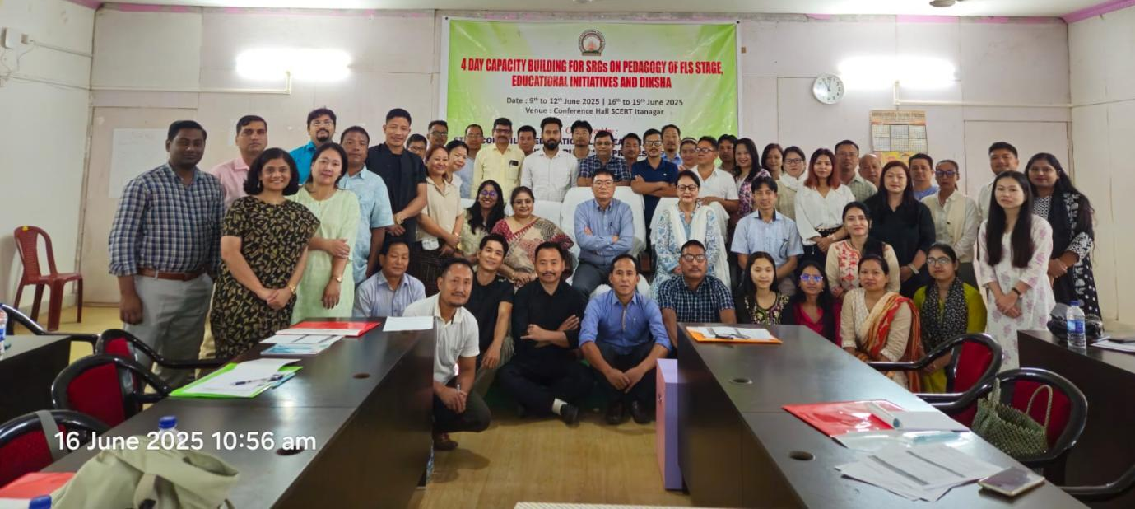

ITANAGER, June 19: In a significant step towards transforming early grade education in the state, the State Council of Educational Research and Training (SCERT), Arunachal Pradesh, successfully conducted a four-day capacity-building programme aimed at developing Key Resource Persons (KRPs)/Master Trainers on the pedagogy of foundational grades. The training was organised in two phases—from June 9 to 12 and June 16 to 19, and brought together over 87 participants, including DIET faculty members and practicing teachers from across the state.
This initiative was designed to equip DIETs and selected teachers with the knowledge, tools, and competencies required to lead foundational learning reforms from Early Childhood Care and Education (ECCE) to Grade 3 at the grassroots level. It reaffirmed the state’s commitment to ensuring equitable access to high-quality early education across all districts of Arunachal Pradesh.
The programme was inaugurated by Toko Babu, Director, SCERT. In his address, he underscored the importance of Early Childhood Care and Education (ECCE) and foundational classes, emphasizing that a strong start in the early years sets the stage for lifelong learning and success. He encouraged the KRPs to lead with purpose by mentoring and motivating teachers to work towards achieving Foundational Literacy and Numeracy (FLN) outcomes in a mission-oriented manner.
The training was facilitated by SCERT and its knowledge partner, Reach to Teach Foundation. Anchored in the frameworks of the National Education Policy (NEP) 2020, the National Curriculum Framework for the Foundational Stage (NCF–FS), and the national mission of NIPUN Bharat, the programme aimed to align classroom practices with the goal of achieving FLN for all children by the end of Grade 3.
Key topics of the Training Programme were:
- In-depth sessions on NEP 2020, NCF–FS, and NIPUN Bharat objectives
- Pedagogical strategies to support early language and numeracy development, including the use of teaching-learning materials (TLMs) such as Jaadui Pitara
- Orientation on state-specific educational initiatives and priorities
- Use of digital learning platforms such as DIKSHA and PM eVidya for blended learning
- Sessions on competency-based assessments and action planning for the 2025–26 academic year
The training followed a blended learning model, integrating conceptual clarity with hands-on activities, group work, reflective discussions, and strategic planning exercises. This approach aimed to foster deep engagement and practical understanding among participants.
With this programme, SCERT has taken a crucial step toward building a cadre of well-prepared resource persons who will now cascade the training at the district level. These KRPs are expected to act as catalysts for change—strengthening classroom practices and improving learning outcomes in ECCE to Grade 3 across State.
This milestone marks a renewed commitment to foundational learning, ensuring that every child in the state has access to joyful, meaningful, and developmentally appropriate education from the very start.

