GOVERNOR’S SECRETARIAT
ARUNACHAL PRADESH
ITANAGAR

Press Communiqué
Dated June 18th, 2025

Dy CM Chowna Mein Inaugurates New Sub-Divisional Office of WRD at Chongkham and JE Office at Wakro

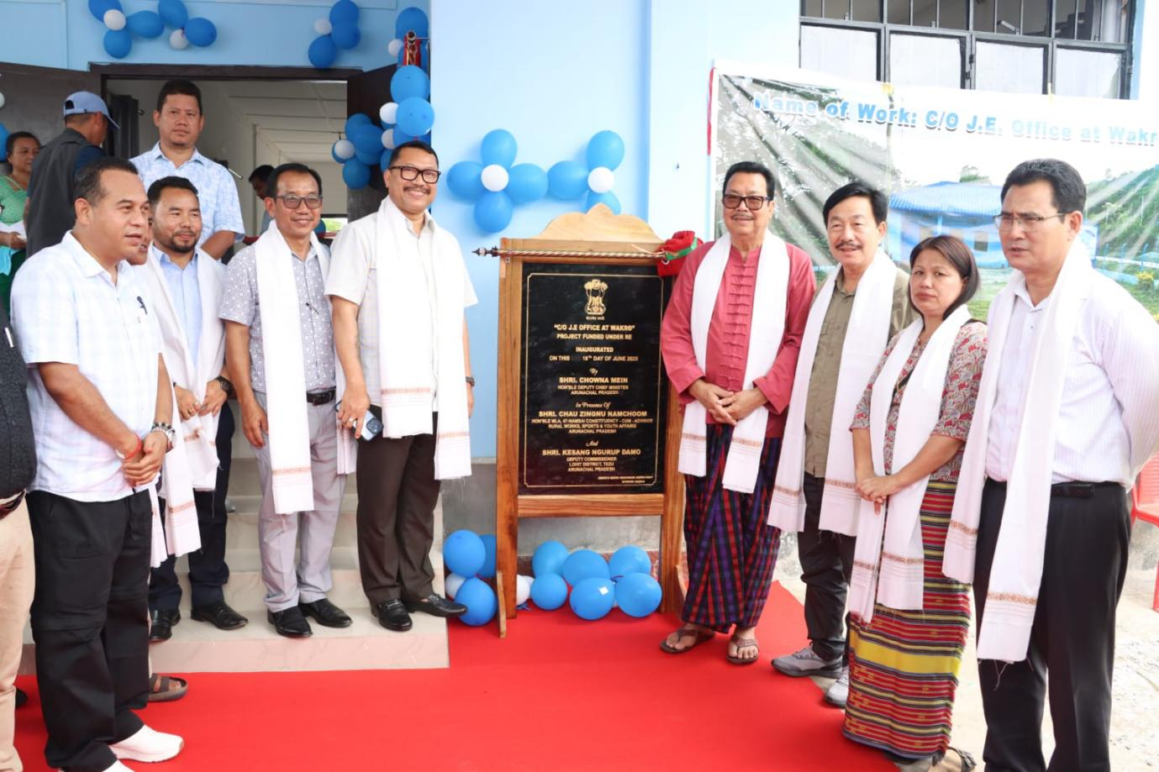

CHOWGKHAM, June 18: Deputy Chief Minister Chowna Mein today inaugurated the Sub-Divisional Office of the Water Resources Department (WRD) at Chongkham and the Junior Engineer Office of WRD at Wakro in his home constituency.
Funded under RE, the new office building will facilitate better coordination and effective field survey and will boost morale of the officials.

Speaking on the occasion, the Deputy Chief Minister emphasized the need for a robust and responsive administrative framework to meet the aspirations of a rapidly developing Arunachal Pradesh. “Decentralization is the key to ensuring that development reaches the last mile. By empowering field offices with better infrastructure, we are accelerating the pace of execution and responsiveness,” he stated.
During the visit, the Deputy CM also reviewed the progress of ongoing projects under WRD. Executive Engineer, WRD made a detailed presentation of various projects.
Mein urged the District Administration and Heads of Departments to adopt an output-oriented, professional work culture—marked by discipline, efficiency, and a service-driven mindset.
On the occasion were also present Member of Parliament, Tapir Gao, MLA Namsai Zingnu Namchoom, ZPC Lohit Dasulu Krishikro, Deputy Commissioner of Namsai C.R. Khampa, ZPM Jenia Namchoom, Superintendent of Police Namsai S. Thinley, and govt officials.

