GOVERNOR’S SECRETARIAT
ARUNACHAL PRADESH
ITANAGAR

Press Communiqué
Dated June 12, 2025
DC Vishakha Yadav Chairs First District-Level Stop Diarrhoea Campaign Steering Committee Meeting in Papum Pare
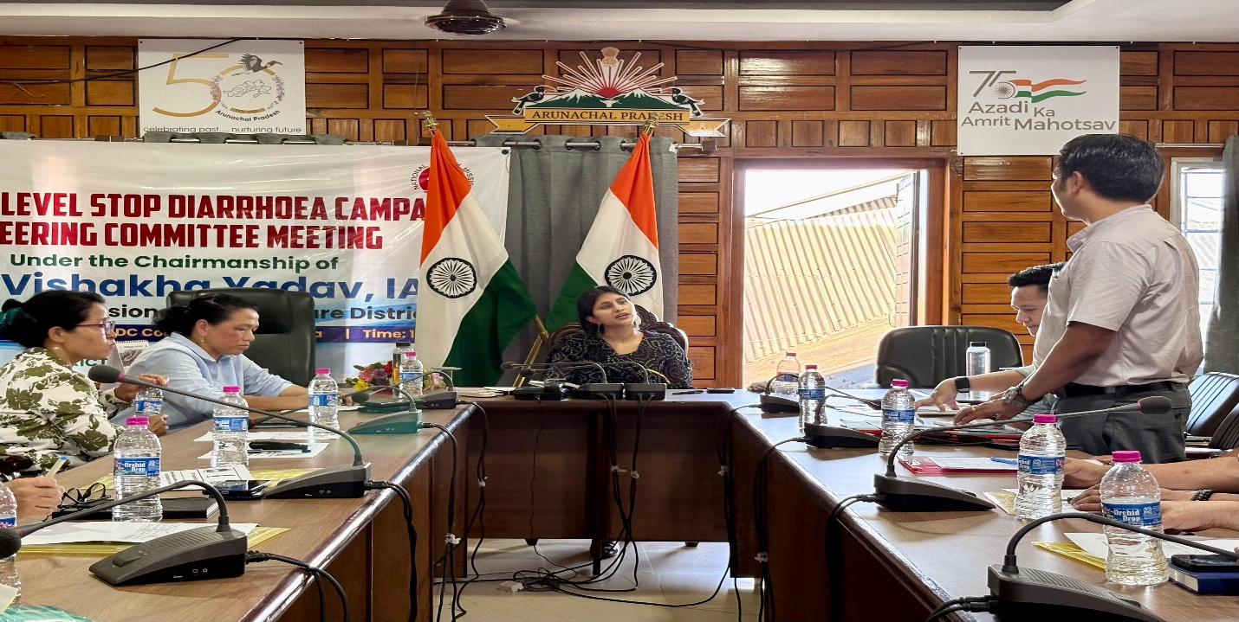

Yupia, 12th June 2025:
The first District-Level Steering Committee meeting for the Stop Diarrhoea Campaign 2025 was convened on Thursday at the Deputy Commissioner’s Conference Hall, Yupia, under the chairmanship of Ms. Vishakha Yadav, IAS, Deputy Commissioner-cum-Chairperson, District Health Society Papum Pare.
As the monsoon season approaches—a time when cases of diarrhoeal disease often surge—Ms. Yadav stressed the need for early preventive actions. She urged all key departments, including Public Health Engineering (PHED), Education, and Women and Child Development (WCD), to remain alert and prepared to handle any potential outbreaks.
Emphasizing a coordinated response, she stated, “We have to work as a cohesive team to improve the health parameters of the district.” Ms. Yadav encouraged the medical fraternity to innovate and collaborate in addressing healthcare challenges. She also took stock of infrastructure gaps and operational challenges faced by the Health Department and assured her full support to overcome them.
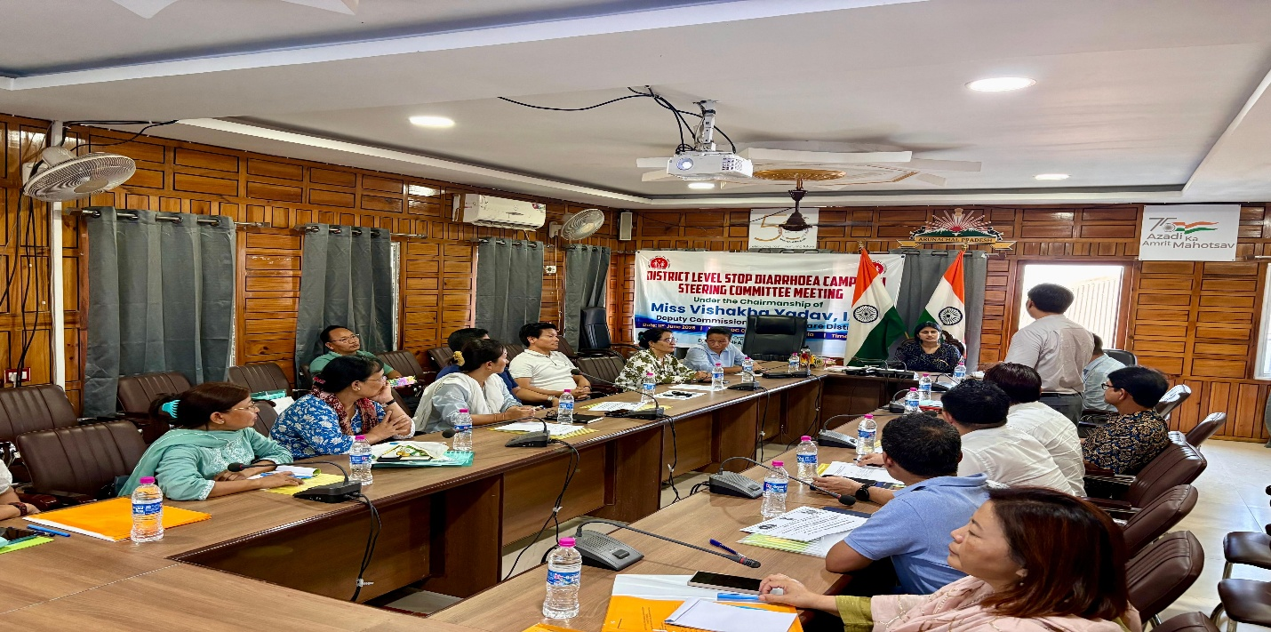
District Medical Officer (DMO), Dr. Reena Ronya, briefed the committee on key health initiatives currently underway in the district, including Immunization programmes; Non-Communicable Disease (NCD) management;TB Mukt Bharat Abhiyan :National Tobacco Control Programme (NTCP) etc.
Dr. Taniya Raju, District ASHA Nodal Officer, presented a comprehensive PowerPoint overview of the Stop Diarrhoea Campaign 2025, outlining its core objectives Including zero child deaths due to diarrhoea; Promoting the use of ORS and Zinc; Strengthening hygiene, sanitation, and handwashing practices; Ensuring access to safe drinking water and Increasing public awareness and improving health system responsiveness.
He further informed that the campaign will target a total of 3,611 children under the age group of 0–5 years across the district.
The campaign will be executed in two phase Preparatory Phase: 2nd – 15th June 2025 and Implementation Phase from 16th June – 31st July 2025
Among others DD ,ICDS Jaya Taba, PHED EE Shawang Riang, representative from DDSE office, MO i/cs attended the meeting.

