GOVERNOR’S SECRETARIAT
ARUNACHAL PRADESH
ITANAGAR

Press Communiqué
Dated June 4, 2025
Governor urges BRO to ensure uninterrupted road connectivity during monsoon
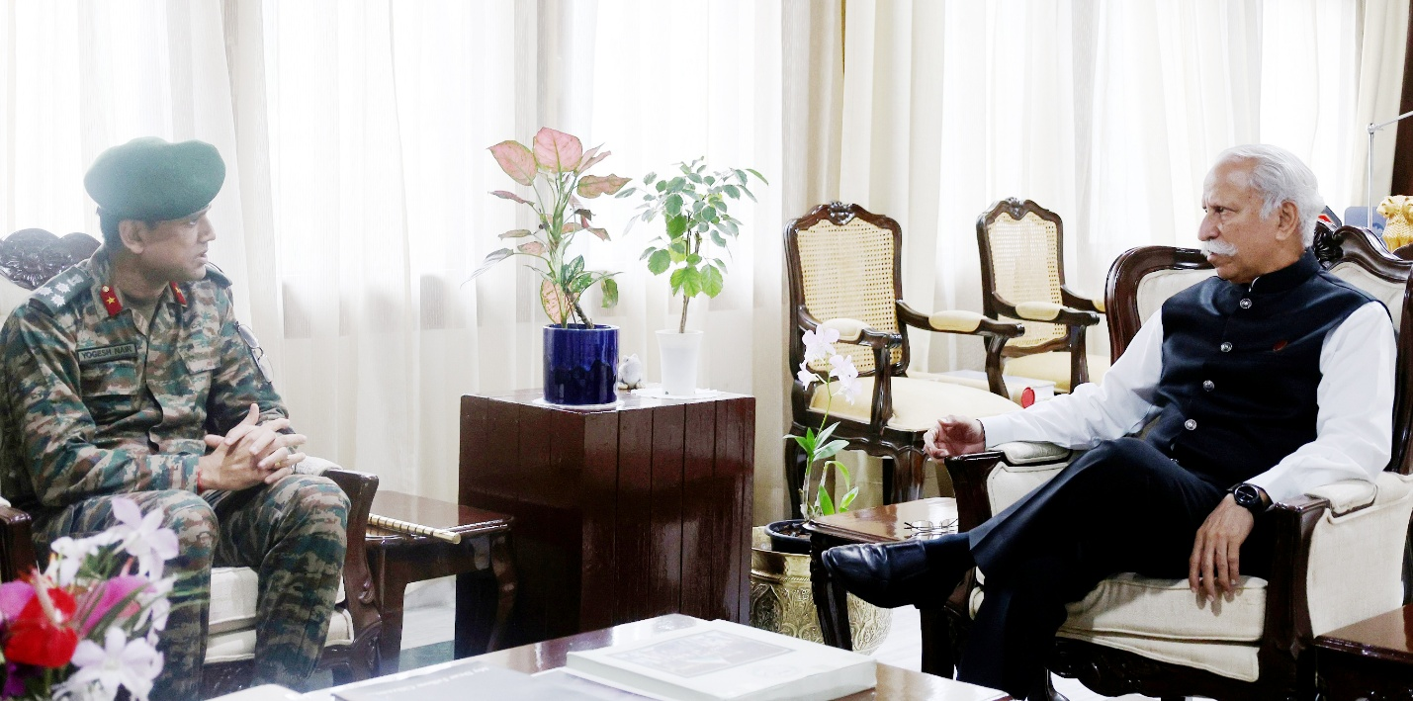

ITANAGAR, Jun 4:
With the onset of heavy monsoon rains severely impacting road connectivity across various parts of Arunachal Pradesh, the Governor of Arunachal Pradesh,
Lt. General KT Parnaik, PVSM, UYSM, YSM (Retd.), has called upon the Border Roads Organization (BRO) to ensure the smooth and safe movement of vehicles, especially in vulnerable and remote regions.
Expressing concern over reports of several villages being cut off due to landslides and water logging, the Governor emphasized the urgent need for preparedness. He said that with the forecast indicating more heavy rainfall in the coming days, the BRO must remain alert and work in close coordination with district administrations to swiftly clear blockages and maintain vital road links.
Chief Engineer of Project Arunank, Brig. Yogesh Nair, VSM, and his successor Brig. H. Bhattacharjee, interacting with the Governor at Raj Bhavan, Itanagar on 4th June 2025, assured the Governor that they have deployed men and machinery in critical and slide-prone zones proactively.
The Governor emphasized the importance of remaining vigilant and prepared to respond to any emergency at a moment's notice.
The Governor also advised all district administrations to stay on high alert, especially in areas susceptible to landslides and flash floods. He underscored the importance of taking timely precautionary steps, including issuing alerts and temporarily relocating people if necessary, to safeguard lives and property.
The Governor, who has been closely monitoring the evolving situation in the State, reiterated the need for fully equipped rescue and relief teams to be stationed at the district, sub-divisional, and circle levels. He said that these teams must be ready to respond immediately to any natural calamity triggered by the current weather conditions.
The Governor commended the Indian Air Force, Assam Rifles, State Police, and district authorities for their dedicated rescue and relief efforts in affected areas. He said that their coordinated action and prompt response have been crucial in mitigating the hardships faced by the people.
The Governor assured the people of Arunachal Pradesh that the State Government is taking all necessary steps to address the challenges posed by the monsoon and to ensure their safety and well-being.

