GOVERNOR’S SECRETARIAT
ARUNACHAL PRADESH
ITANAGAR

Press Communiqué
Dated June 4, 2025
Pune-based NGO donates oxygen plant to Indian army field hospital in Tawang
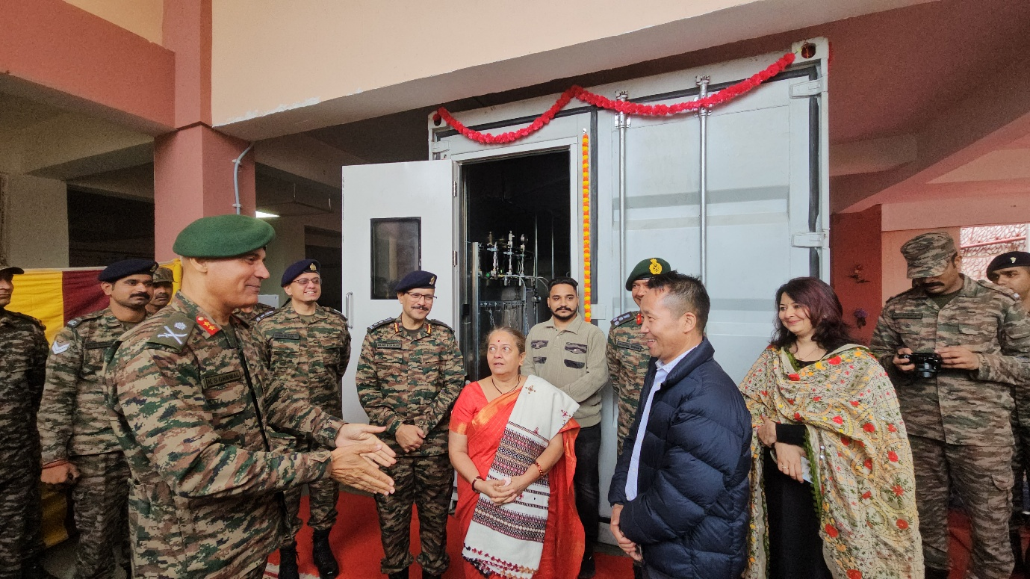
Tawang June 4: In a significant gesture of support to India’s armed forces and the local community, Pune-based NGO Soldiers Independent Rehabilitation Foundation (SIRF) has gifted a 200-litre capacity oxygen plant and refilling facility to the Military Field Hospital at Teli Village, under the Tawang circle.
The oxygen plant was formally dedicated to the Indian Army soldiers serving in the Tawang sector by Major General KS Grewal, SM, VSM, General Officer Commanding (GOC) 5 Mountain Division. The dedication ceremony was graced by Ms. Sumedha Yogesh Chithade, President of SIRF, along with executive members of the foundation.
Speaking at the occasion, Major General
Grewal expressed heartfelt gratitude on behalf of the Army and the people of Tawang. “This noble gesture by the SIRF foundation is deeply appreciated. The oxygen plant will serve not only our soldiers but also the civilians of Tawang, as all facilities of the Army are shared equally with the local population,” said the GOC. He further lauded the foundation for their tireless efforts, traveling to Tawang twice to accomplish this mission, and encouraged them to continue their yeoman service across the country.
He also extended special thanks to the engineers and technical team for the successful installation of the oxygen plant, which significantly strengthens the emergency medical infrastructure in the strategically important region.
During the ceremony, the GOC felicitated the President and executive members of SIRF, along with the technical team and all military personnel who contributed to the installation

of the plant.
The event was attended by several dignitaries including EAC Tawang, Sangey Wangmu Mosobi , Dy. SP Tasso Kato, DMO Dr. Rinchin Neema, President of NGO Monyul Tenzin Jorden, ex-servicemen, Commander Tawang Brigade Brigadier Bhupal Singh, SM, Colonel Milind Sawant, other senior officers, and ladies from the Tawang Brigade.
This initiative stands as a shining example of civil-military cooperation and reinforces the shared commitment toward national service and community welfare.

