GOVERNOR’S SECRETARIAT
ARUNACHAL PRADESH
ITANAGAR

Press Communiqué
Dated: June 3, 2025
Indian Army distributes stationeries, mobile toilets, GYM equipments to people of Ziro
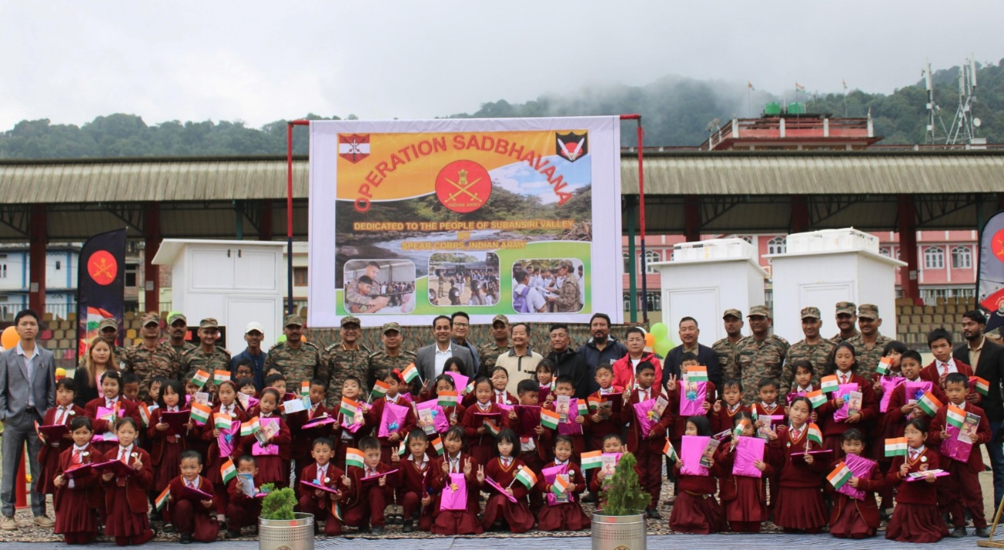
Hapoli, June 3:
The Indian Army's Spear Corps carried out a major civic outreach initiative under Operation Sadbhavna in the picturesque valley of Ziro, Arunachal Pradesh, reaffirming its commitment to holistic development, community welfare, and nation-building.

With the motto “We Serve Beyond Borders”, the initiative is a blend of compassion, empowerment, and connection — reaching out to the hearts of the local population and addressing grassroots needs.

In the program, essential stationery items were distributed to school children of Ziro Valley Primary School, aiming to support education and inspire young
minds to pursue their dreams.To improve public hygiene and sanitation, three mobile toilet units were set up — ensuring dignity and basic facilities in remote area.
Also, in a move to promote fitness and community well-being, open-air gym equipment were gifted to the Ziro Town encouraging a culture of health and strength.
Through this initiative, Indian Army’s Spear Corps emphasized that the Army's role extends far beyond defence — encompassing social upliftment, public service, and human connection.
The people of Ziro Vally responded with heartfelt appreciation, reaffirming the strong civil-military bond that continues to thrive in the Northeast.
Among others Tage Taki, Former MLA, Vivek H.P (IAS), DC Lower Subansiri, Pura Dollo, ZPC, Tasso Butung, District Agriculture Officer and other PRI Members also attended the program.

