GOVERNOR’S SECRETARIAT
ARUNACHAL PRADESH
ITANAGAR

Press Communiqué
Dated June 3, 2025
VKSA Day 6: Campaign conducted at Chowkham, Namsai, and Lekang
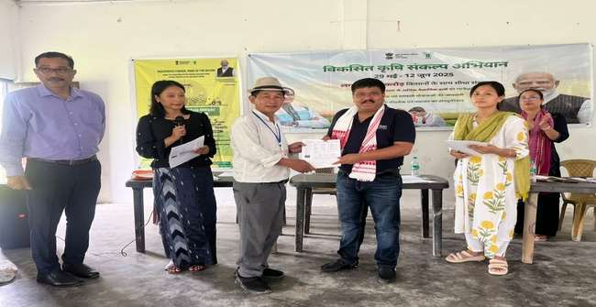
Namsai, June 3:
The nationwide pre-kharif campaign “Viksit Krishi Sankalp Abhiyan” entered its sixth day with a series of programs organized at Kherem, Adi Ningroo, and New Mohong in Chowkham, Namsai, and Lekang blocks, respectively. At Kherem, the event was graced by C.R. Khampa, Deputy Commissioner, Namsai, who motivated farmers to adopt scientific farming practices for enhancing productivity and sustainability. At Adi Ningroo, the program was attended by District Planning Officer (DPO), Namsai. He urged farmers to take advantage of government schemes and adopt integrated approaches for better income and livelihood security. At New Mohong, Dr. Theja Angami, Scientist from ICAR–AP Centre, Basar, encouraged farmers to adopt scientific vegetable cultivation and utilize low-cost polyhouse technology for improved productivity. He emphasized the importance of maintaining proper plant spacing and promoting intercropping systems in arecanut plantations. A farmer–scientist interaction session was also held, where farmers raised queries regarding the planting methods of arecanut. At New Mohong, the District Horticulture Officer (DHO) advised farmers to avoid the use of glyphosate in plantation crops and promoted the use of farm implements for safe and sustainable cultivation.
From KVK Namsai, Dr. Utpal Barua, Senior Scientist and Head, Dr. Madhumita Sonowal Bora SMS (Plant protection), and K. Nithinkumar, SMS (Agronomy), spoke on the scientific cultivation of paddy and maize, the significance of organic and natural farming, crop diversification, and the integrated farming system. They stressed the need for natural resource conservation to ensure long-term sustainability in agriculture. Officials from the State Departments of Agriculture, Horticulture, Fisheries, and Veterinary briefed farmers on various central and state-sponsored schemes. They encouraged farmers to avail themselves of the subsidies and benefits available under these programs for enhancing agricultural growth and rural livelihoods. The programme ended with playing of VKSA theme song with a strong message to work together for agricultural development to achieve Viksit bharat.

