GOVERNOR’S SECRETARIAT
ARUNACHAL PRADESH
ITANAGAR

Press Communiqué
Dated June 14, 2025
Deputy Chief Minister Chowna Mein Attends World Blood Donor Day Celebration in Itanagar
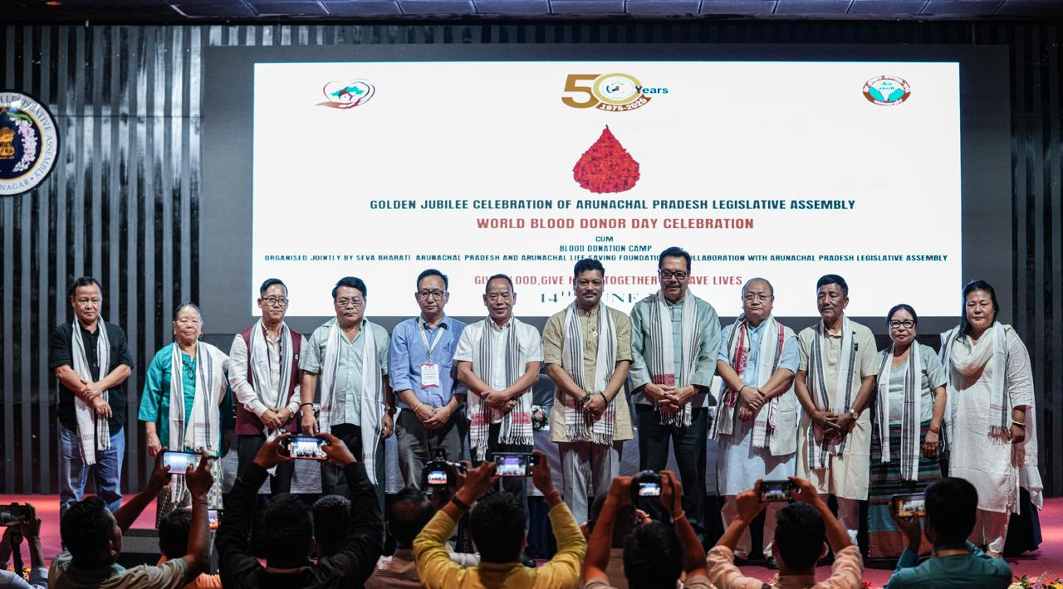

ITANAGAR, JUNE 14: Deputy Chief Minister of Arunachal Pradesh, Chowna Mein, today attended the World Blood Donor Day celebration jointly organised by Seva Bharati Arunachal Pradesh and Arunachal Life Saving Foundation at Arunachal Pradesh Legislative Assembly today.
Speaking on the occasion, the Deputy Chief Minister termed blood donation as one of the highest forms of humanitarian service and lauded the selfless efforts of individuals who donate blood to save lives. "It was a humbling experience to honour and appreciate those engaged in this noble mission of saving lives through blood donation," he remarked.
He urged citizens, particularly the youth, to come forward and donate blood regularly, underscoring the life-saving impact of this simple yet profound act of service.
Highlighting the Government’s commitment under the leadership of Chief Minister Pema Khandu, he informed that Trauma Centres and Blood Banks have been set up in District Hospitals across the State to reduce mortality caused by lack of timely access to blood units.
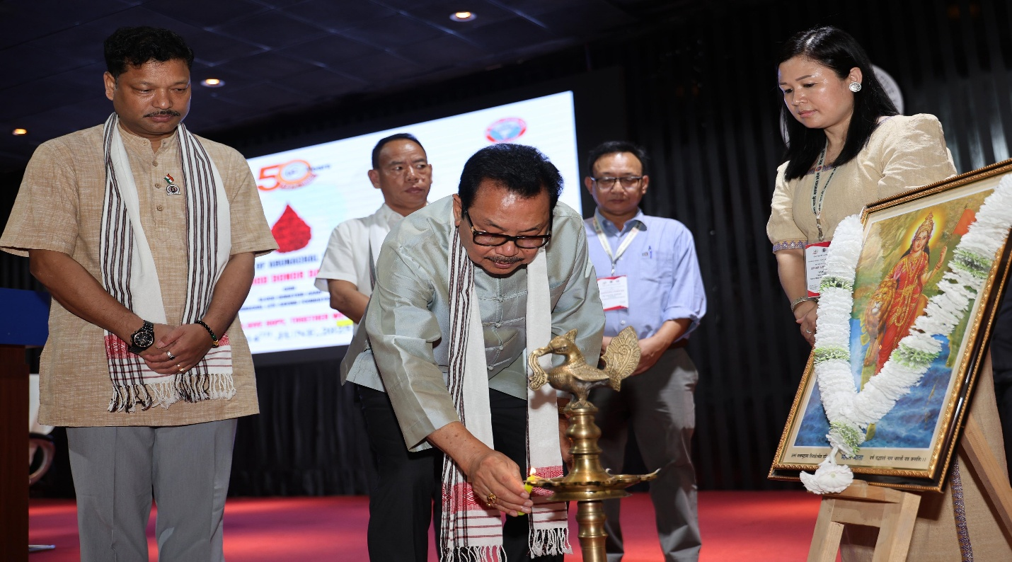
Marking the significance of the day, Mein announced three key initiatives - to institutionalise blood donation drives by incorporating them into the Government’s official calendar of events, to establish a dedicated Blood Bank facility in the State Capital, and to launch a Mobile Blood Bank to enhance accessibility and outreach across the State.
Mein commend Seva Bharati Arunachal Pradesh and Arunachal Life Saving Foundation for successfully organising a mass blood donation camp in the State Capital, and thank healthcare workers, Armed forces personnel, all organisations and individuals involved in the campaign.
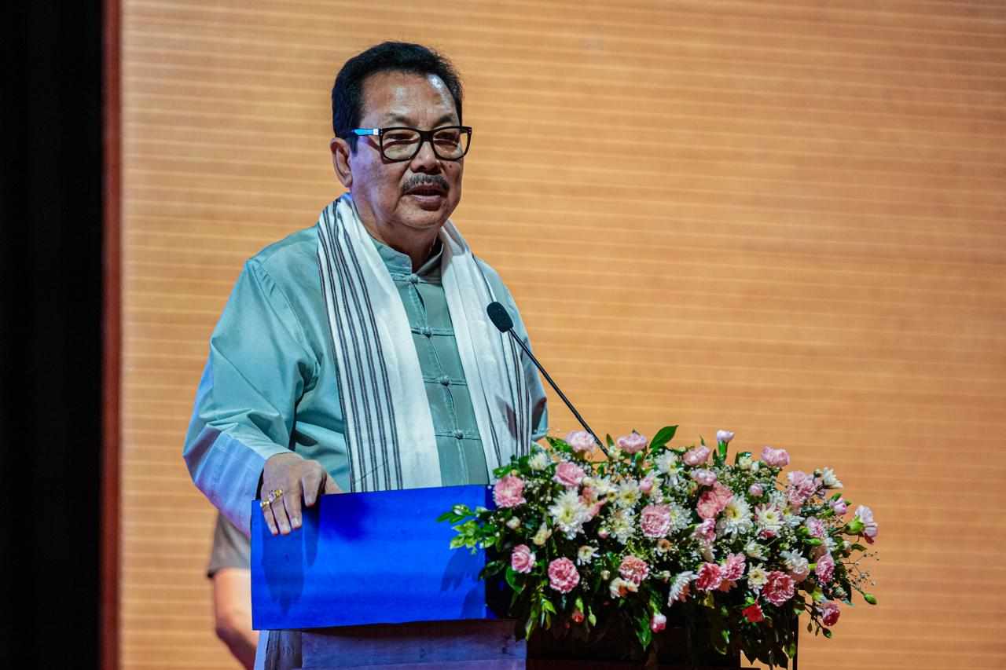
The Deputy Chief Minister specially acknowledged the contributions of Ramesh Jeke, Chairman of the Arunachal Life Saving Foundation, for his commitment to the cause of voluntary blood donation.
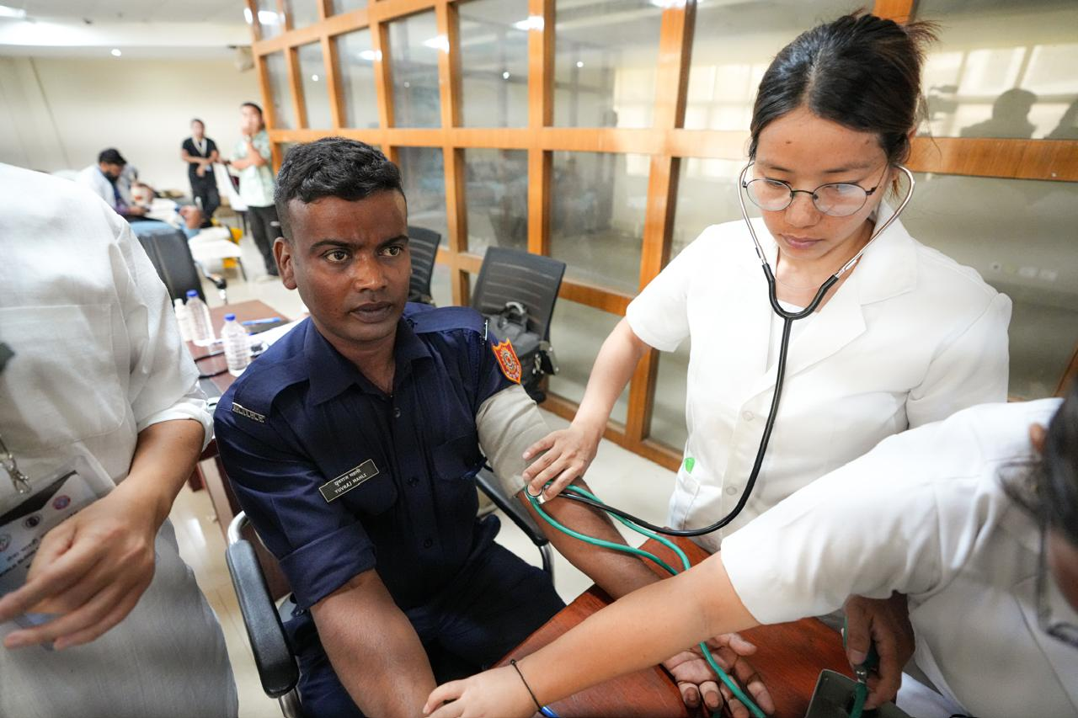
Speaker Tesam Pongte, Minister Wangki Lowang, Deputy Speaker Kardo Nyigyor, and several MLAs were also present on the occasion. The event also witnessed the participation of a wide cross-section of society, including healthcare professionals, members of the armed forces, NGOs, CBOs, volunteers, and dignitaries.

