GOVERNOR’S SECRETARIAT
ARUNACHAL PRADESH
ITANAGAR

Press Communiqué
Dated June 12, 2025
DCM chaired meeting on up gradation of WWII Memorial Museum at Jairampur
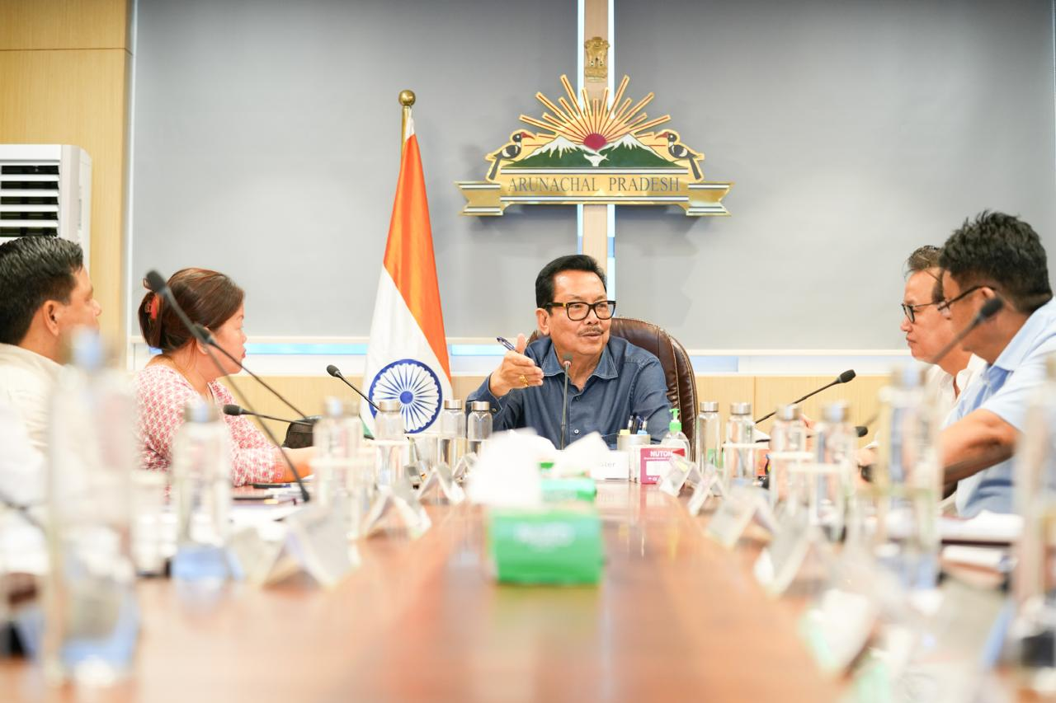

ITANAGAR, June 12:
DCM Chowna Mein, chaired an important meeting at his Secretariat Office today to discuss the up gradation of the World War-II Memorial Museum at Jairampur in ChanglangDistrict.
Highlighting the historical significance of the Pangsau Pass and the Stilwell Road connecting India to China via Myanmar, a strategic World War II route, Mein emphasized the region’s deep-rooted legacy in the Burma Campaign. He said, “This area is of immense historical value, and we aim to develop a one-of-its-kind museum to preserve and showcase this legacy while transforming it into a major heritage-cum-tourism hub.”
The Deputy Chief Minister called upon the committee members to initiate the collection of artifacts and to design a dedicated gallery for local tribal contributions. He acknowledged the significant role played by members of the Singpho, Khamti, Adi, Nocte, Mishmi, and Naga tribes, who served as soldiers and porters during what is popularly known among locals as the Burma War.
As part of the 80th commemoration of World War II, Mein proposed grand celebrations during the upcoming Pangsau Pass Winter Festival, including a Willy Jeep Rally from the Hump WWII Museum in Pasighat to Pangsau Pass and a Super Car Rally to draw attention from tourists and history enthusiasts alike.
A dedicated committee has been constituted under the Chairmanship of Minister of Research. Dasanglu Pul, with the Deputy Chief Minister as Chief Advisor, and MLAs Laisam Simai and Oken Tayeng as Advisors. The Secretary (Research) has been designated as the Member Secretary.
Minister Dasanglu Pul, MLAs Laisam Simai and OkenTayeng, and Secretary (Research) B. J. Duai actively participated in the deliberations. Lt Col T. C. Tayum presented a detailed PPT on the artifacts collected so far for the museum.
Also present were Director (Research) Sangeet Dubey and other senior officers from the Department of Research.

