GOVERNOR’S SECRETARIAT
ARUNACHAL PRADESH
ITANAGAR

Press Communiqué
Dated June 11, 2025
Deputy Chief Minister reviewed the activities of the Power Department
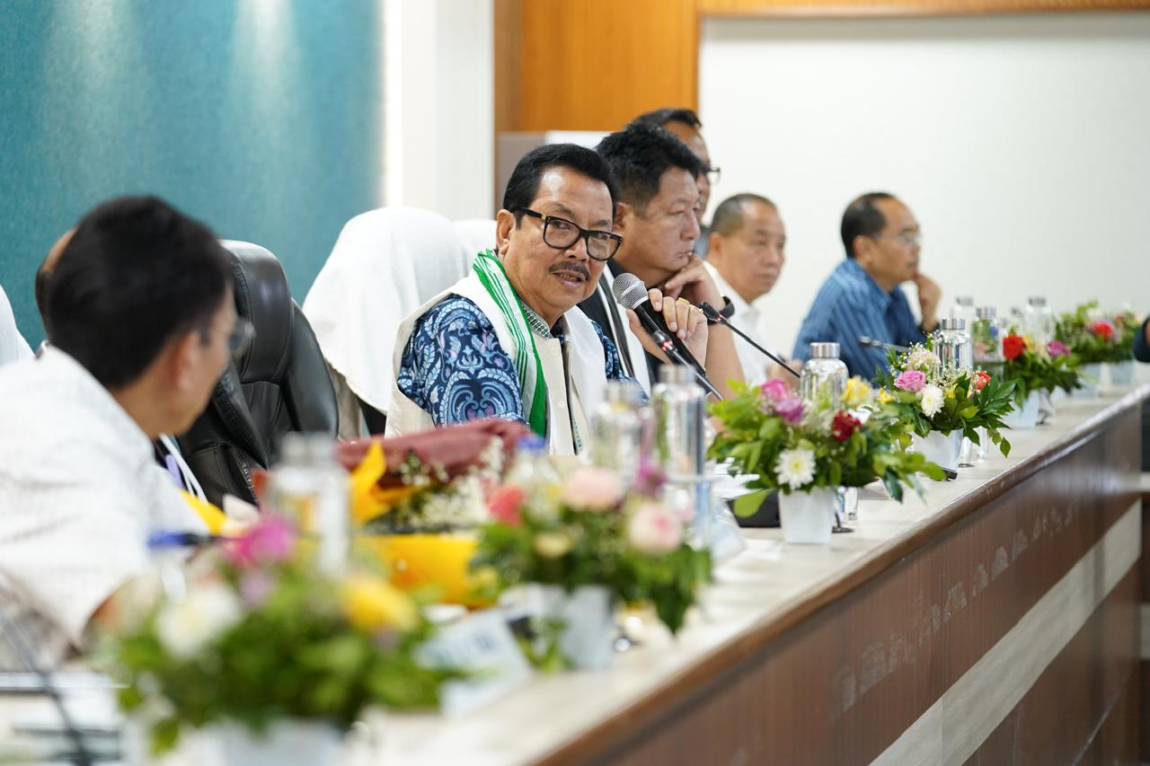

ITANAGAR, JUNE 11: Deputy Chief Minister and the Minister-In-Charge of Power, Chowna Mein took a detailed review on the activities of the Department of Power, Govt of Arunachal Pradesh at DK Convention Centre at Itanagar today.

In his address to the officers of the Power Department, Mein said that the Department of Power has come a long way in the last 33 years since it was separated from CPWD in the year 1992. However, with the growing number of consumers with the increased population over the years, requirement of powerhas grown over the years because of which there is an urgent need to restructure the department to cope with the growing numbers of consumers. In order to meet the growing demand of power supply, the Department has to function effectively and need to augment the transmission system, strengthen distribution infrastructure and address residual gaps from the comprehensive Schemes and RDSS for ensuring a seamless power supply, he added.
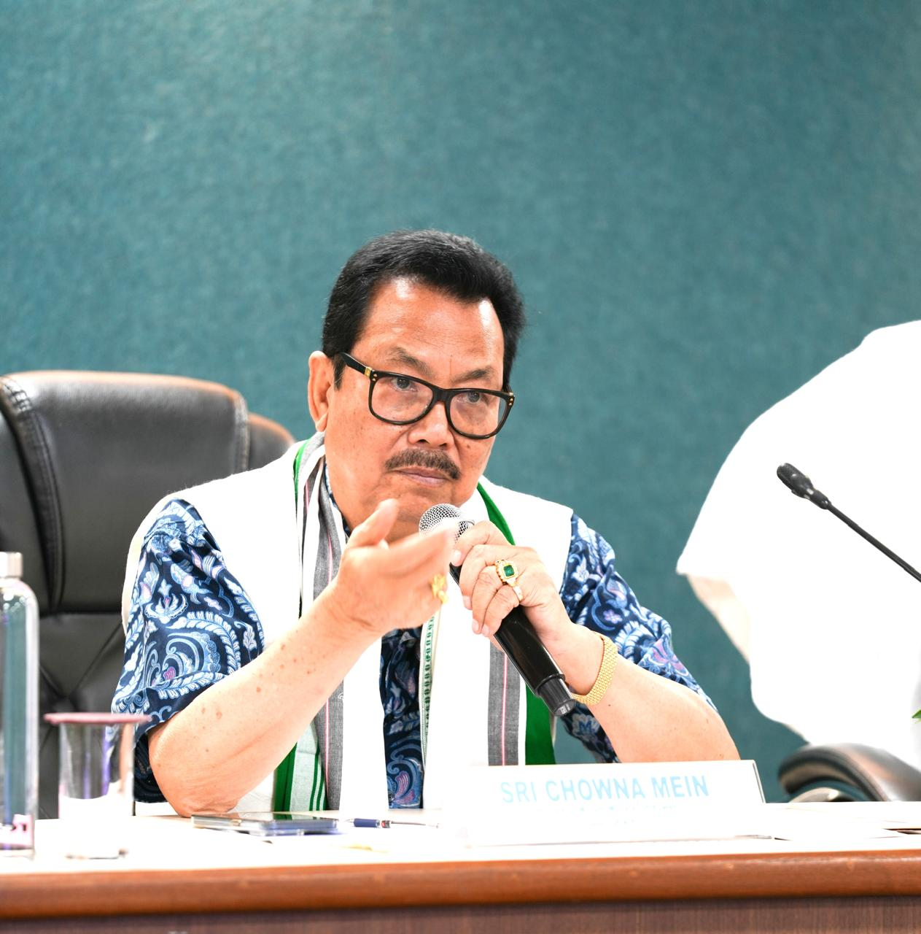

He said that the Govt will fully revamp the Power Department which was overdue for the last many years. He said that with a view to develop a robust sub-transmission & distribution system in urban & high-density areas and to extend electricity access to newly created districts and remote rural habitations that remain unelectrified, Chief Minister’s Comprehensive State Power Development Program has been announced in this year’s Budget 2025 with a budget allocation of Rs 2000 Cr which will be implemented in four years-time. He also urged the department to establish connectivity for Mini-Hydro Electric Plants to facilitate integration of local generation into the grid and to minimize AT&C losses below 15% through system strengthening and operational improvements. He also said to enhance reliability in urban areas through targeted infrastructure modernization with the strict implementation of pre-paid smart metering system and upgrades. He further urged the department to come up with safety-guidelines and to ensure that every line man and electric fitters abide by the safety measures in order to prevent any kind of casualties while discharging their duty. After giving patient hearing to the grievances from the Officers of the Department, he urged the department to come up with a restructuredproposal which will be placed before the Cabinet for approval. He further announced to provide a utility vehicle to every division of the power department.
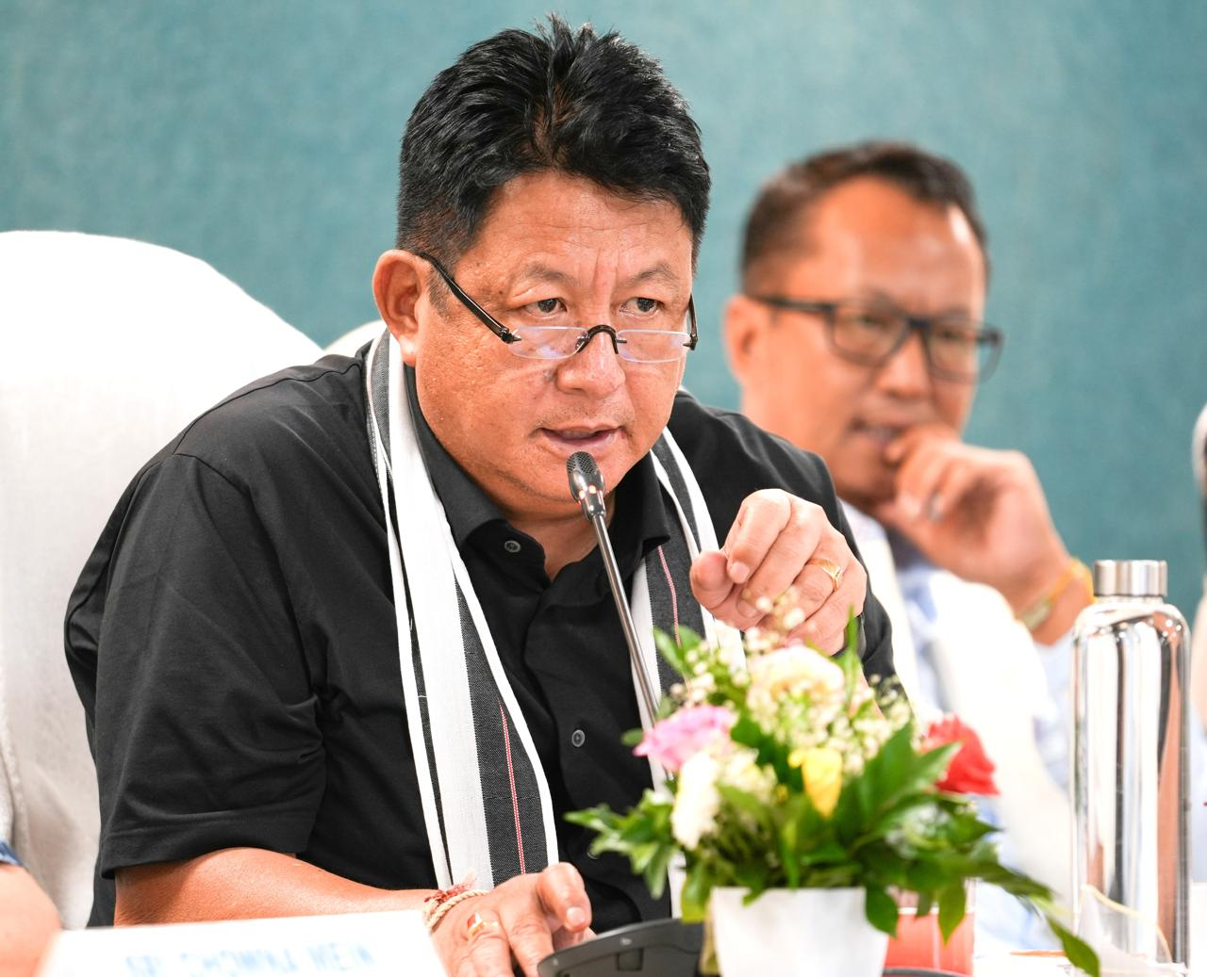

In the meeting, the activities under APEDA were also discussed including generation of Solar power by installing rooftop solar panel, micro hydroelectric project, etc. Issues in the Circles, Divisions and regarding service connection to the industrialist were also discussed. Activities under IT Division of the Power Department were also discussed forfacilitating seamless onlinebill payment, prepaid recharge and immediate dissemination of information to the public.

Present in the meeting were Secretary (Power), R K Sharma, Advisor to DCM, Captain Anupam Tangu, Chief Engineer (Transmission), T K Tara, Chief Engineer (Central Zone), Ginko Lingi, Chief Engineer (Commercial), DuyuTaso, Director (APEDA), Marbom Bam, OSD to DCM, Tseng Tsing Mein, Superintending Engineers and Executive Engineers.

