GOVERNOR’S SECRETARIAT
ARUNACHAL PRADESH
ITANAGAR

Press Communiqué
Dated June 10, 2025
Department of Skill Development& Entrepreneurship sends trainees to Drone Training Academy, Hyderabad
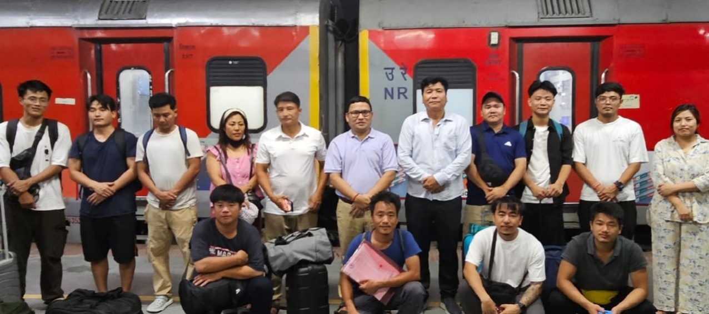

ITANAGER, June10 :
The Department of Skill Development and Entrepreneurship Govt. of Arunachal Pradesh has sent 14 trainees to Drone Training Academy Hyderabad, Telangana, which is the fourth batch of trainees being sent to the premier drone training academy of the country under the Chief Minister’s Yuva Kaushal Yojana (CMYKY). A total of 42 nos. of trainees has already completed drone training and has been given certificate/drone flying permit by the academy through the Ministry of Civil Aviation on sponsorship under CMYKY by Department of Skill Development and Entrepreneurship. Under the scheme the Department of Skill Development and Entrepreneurship gives free drone training and bears the cost of training /boarding and lodging/fooding support/transportation of the trainees under Chief Minister’s Yuva Kaushal Yojana (CMYKY) which envisions to provide high end skill development training in new age technology.
The trainees will undergo a week-long drone training consisting of theory as well as practical sessions on drone and on last day of the training will be given certificate/ drone flying permit by Drone Academy, Hyderabad recognized by Ministry of Civil Aviation.
. Sibo Passing, Director of Skill Development and Entrepreneurship along with Jumbom Riba AD, SDE sent off the fourth batch from Naharlagun railway station. Passing advised the youth to take maximum benefit of the programme and build self-confidence through such exposure training. He said that as the trainees are representing the entire state they should be discipline and should not do anything which will create a bad image of the state.
Jumbom Riba dealt on the ‘‘dos and don’ts” of the training course, need for maintaining a team spirit and steps to be taken for safety and comfortable train journey as many of the trainee were travelling outside the state for the first time. He asked the candidates to go for self-employment using drone after the training and bring the government sponsored practical drone training into maximum usage.
The Drone training of Department of Skill Development & Entrepreneurship has been a continuous process for some years and trainee in the age group of 18 to 65 years having passed Class X are eligible for training. Candidates can visit the Directorate of Skill Development & Entrepreneurship, Udyog Sadan, C-sector, Itanagar for further details.

