GOVERNOR’S SECRETARIAT
ARUNACHAL PRADESH
ITANAGAR

Press Communiqué
Dated: June 1, 2025
Assam Rifles extends timely assists in vehicle recovery near Khonsa
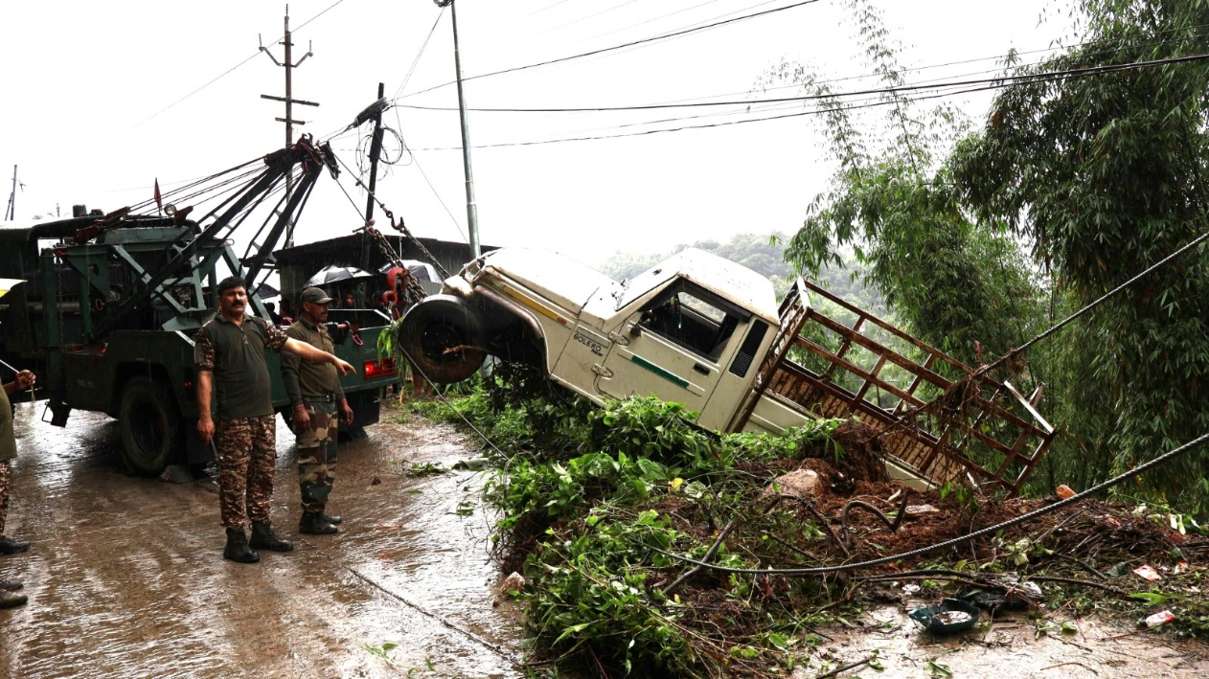
A Bolero Camper belonging to a local civilian skidded off a rain-slicked road near Khonsa town in Tirap district, Arunachal Pradesh, and plunged into a deep gorge. The incident occurred due to persistent heavy rains, which had rendered the road dangerously slippery and impassable in certain stretches.

Despite sincere and determined efforts by local residents to recover the vehicle, the operation proved highly risky due to the unstable terrain and the possibility of the vehicle sliding further down the gorge. Recognizing the urgency and potential danger, the villagers approached the 44th Assam Rifles Battalion, Khonsa, for assistance. Responding swiftly and in keeping with their ethos of being the “Friends of the North East,” the Assam Rifles team, with support from the 36th Battalion of the CRPF, immediately mobilized a recovery unit to the site. Through a combination of professionalism, teamwork, and technical skill, the joint effort successfully recovered the vehicle without causing further damage or risking lives.

The timely and selfless assistance provided by the security forces was met with heartfelt gratitude from the local community. Their appreciation stands as a testament to the enduring bond between the Assam Rifles and the people of the North East.The Assam Rifles remains steadfast in its commitment to support the local population not only during times of conflict but also in moments of humanitarian need and natural adversity.

