GOVERNOR’S SECRETARIAT
ARUNACHAL PRADESH
ITANAGAR

Press Communiqué
Dated June 3, 2025
MLA and DA conduct ground assessment of Flood and Landslide-Affected Villages in Etalin Circle
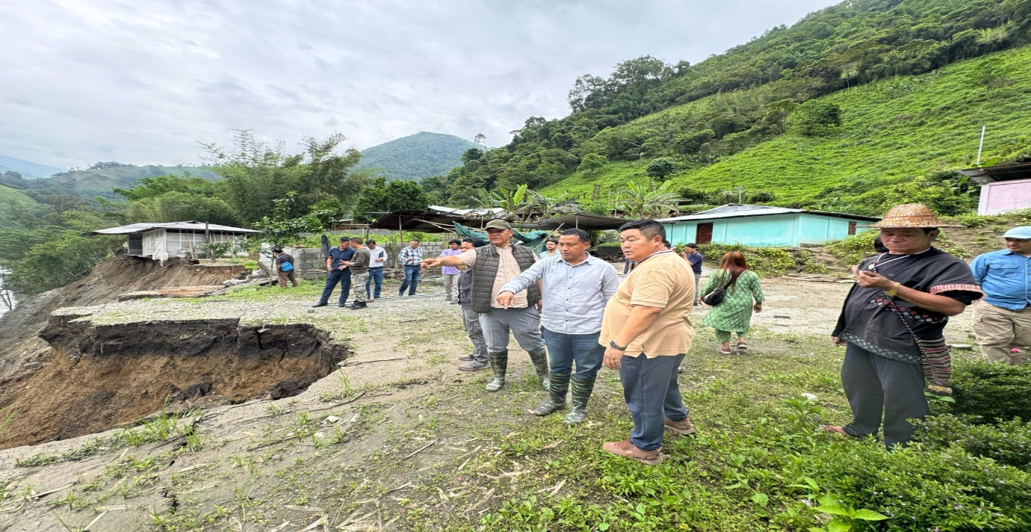
Anini, June 3:
Mopi Mihu, MLA, 41st Assembly Constituency, Dibang Valley, conducted a joint visit to the severely flood and landslide-affected villages of Etalin Circle, accompanied by Pagli Sora, Deputy Commissioner, Dibang Valley , Theko Tayu, Chairperson Zilla Parishad, and Heads of Departments. The team undertook this visit to assess ground realities, extend moral support to the affected populace, and coordinate immediate relief operations.
Continuous heavy rainfall over the past several days has triggered large-scale flooding and landslides, causing widespread destruction to infrastructure and private property. Athunli village was identified as the worst-affected area, where multiple houses, agricultural fields, were completely washed away. The disaster has rendered several families homeless and displaced.Preliminary assessments indicate that approximately 16 houses have been completely washed away in Athunli village, while 3 houses have been lost in Echanli village. However, due to the complete breakdown of connectivity in several remote areas, detailed reports of damage from other villages are still awaited.
The Emu hanging bridge over the Dri River has also been washed away, cutting off all access to Emuyi village. The loss of this critical bridge has further hampered relief efforts and isolated residents from essential supplies and assistance. All the hanging bridges connecting villages across the river have been washed away, effectively cutting off connectivity. Road connectivity has been severely compromised at multiple points due to landslides and sections of roads being completely washed away, hampering rescue and relief efforts.
6 (Six) individuals including 3 (Three) children remain stranded in Mawali village, across from Athunli, with all access routes blocked. Multiple rescue efforts had to be suspended due to the dangerously high river currents and persistent rainfall. In a desperate attempt to reach the stranded villagers, a drone was deployed to deliver emergency food supplies. However, after successfully delivering four fast food packets , the drone malfunctioned and crashed on return—its propeller entangled by the rope used for the drop.
Assistance from the Indian Army has been assured to support ongoing rescue and relief operations. A drone will be redeployed to airdrop essential supplies to the 6 (Six)stranded individuals in Mawali village, as conventional access routes remain cut off. Additionally, a dedicated team from the District Administration will expedite efforts to reach the stranded villagers by taking an alternative detour route, despite the difficult terrain and weather conditions.
The District Disaster Management Officer (DDMO), Anini, ensured the delivery of essential relief items to the villagers of Athunli and Echanli.
The Hon’ble MLA, while taking stock of the damage and interacting with local residents, assured full government support and promised that all necessary assistance would be extended promptly. He emphasized the need for rapid restoration of connectivity, provision of temporary shelters, and long-term mitigation planning to reduce vulnerability in such high-risk zones.
The district administration continues to monitor the situation closely and is working in coordination with disaster response teams, local authorities, and community leaders to ensure timely relief and safety of all affected persons.
The general public is advised to remain alert, avoid riverbanks and unstable slopes, and strictly adhere to safety advisories issued by the administration.

