GOVERNOR’S SECRETARIAT
ARUNACHAL PRADESH
ITANAGAR

Press Communiqué
Dated: June 4, 2025
Indian army conducts Cycling rally at Aalo
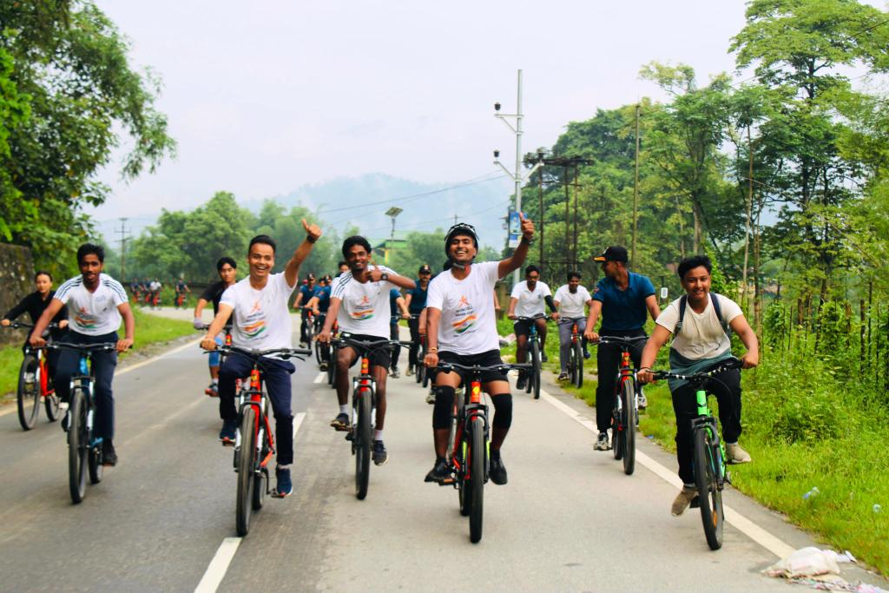
Aalo June 4 : The Spear Corps of the Indian army in collaboration with local cycling clubs organized a 30Km cycling rally from Aalo to Logum Jini and back to Aalo in West Siang District to mark the World Bicycle Day on 4th June 2025.

The event witnessed enthusiastic participant from over 70 cyclers including 25 army personnel and 45 Civilians, who pedaled together across the scenic terrain of Aalo. The rally aimed to promote physical fitness, environment awareness and a culture of healthy living.

This initiative of cycling rally not only encouraged a culture of cycling and sustainable practices but also served to strengthen the bonds of mutual trust and respect between the Civil - Military in the region.

