GOVERNOR’S SECRETARIAT
ARUNACHAL PRADESH
ITANAGAR

Press Communiqué
Dated May 7th, 2025

Governor extends World Red Cross Day greetings
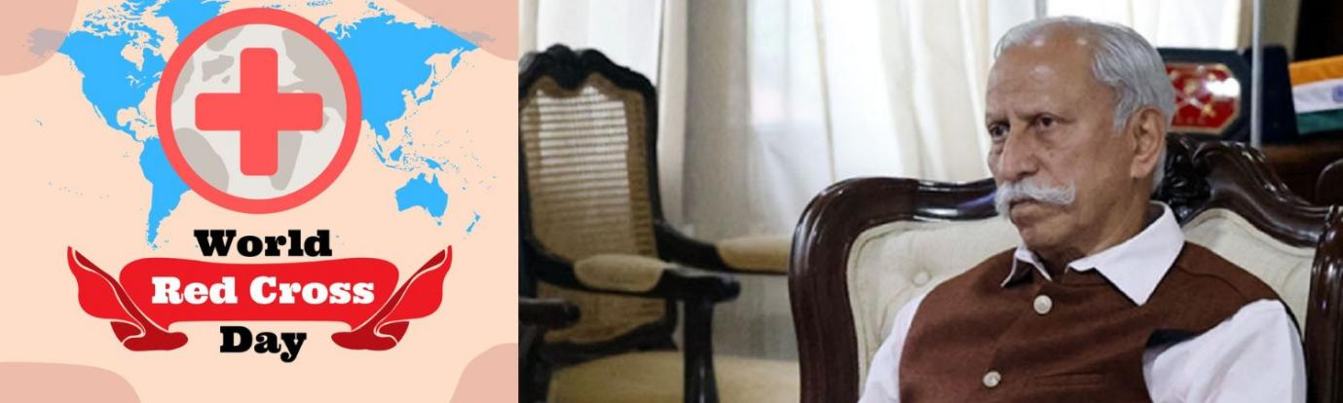

The Governor of Arunachal Pradesh Lt. General K.T. Parnaik, PVSM, UYSM, YSM (Retd.) has extended his warm greetings to the people of the State, especially to the dedicated Red Cross volunteers, on the occasion of World Red Cross Day, which commemorates the birth anniversary of Jean Henry Dunant, founder of the Red Cross and Nobel Peace Prize laureate. He expressed his hope that the celebration would inspire all to serve society with action, compassion, and commitment to humanity.
In his message, the Governor said that the day reminds all of Dunant’s noble vision that gave rise to the world’s largest humanitarian network, the Red Cross and Red Crescent Movement, now active in 192 countries, committed to saving lives, upholding dignity, and promoting peace without discrimination. He said that in India, the Red Cross continues this mission with commendable dedication.
The Governor said that as the President of the Indian Red Cross Society, Arunachal Pradesh State Branch, he takes immense pride in the efforts of our volunteers. Their steadfast commitment, particularly during emergencies, disasters, and natural calamities, has been exemplary. I am confident that the Red Cross volunteers of Arunachal Pradesh will continue to uphold these values and provide invaluable service to those in need, especially the underprivileged and vulnerable sections of our society, he said.
On this World Red Cross Day, I appeal to my dear brothers and sisters across Arunachal Pradesh to come forward and join this noble cause. Let us strengthen the Red Cross movement by becoming active participants in its mission to alleviate human suffering, whenever, wherever, and however it may arise, the Governor appealed in his message.

