GOVERNOR’S SECRETARIAT
ARUNACHAL PRADESH
ITANAGAR

Press Communiqué
Dated May 7th, 2025

Governor Commends BRO For Completion Of Vital
Infrastructure Projects
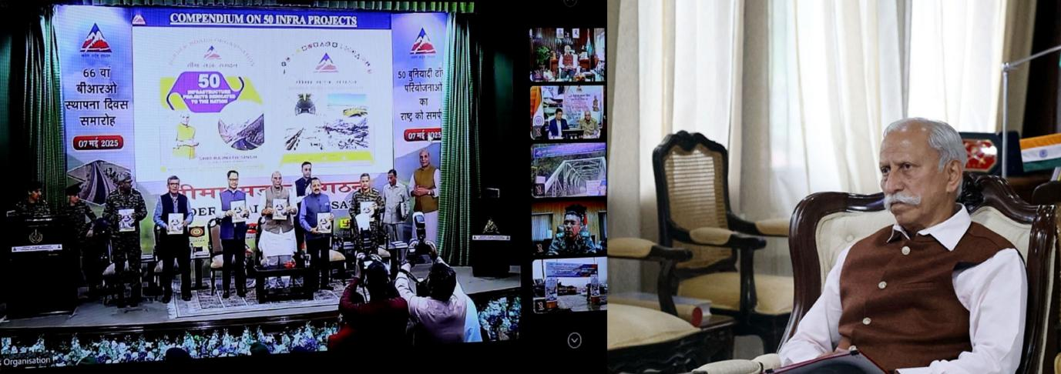

- Governor conveys the heartfelt appreciation of the people of Arunachal Pradesh to the Prime Minister and the Defence Minister for their unwavering commitment to the State’s infrastructure growth and national integration
- BRO infrastructures will greatly contribute to uplifting people living in border regions and support sustained development and integration with the rest of the country: Governor
- Governor greets BRO on its 66th Raising Day
- Governor congratulates 752 BRTF, Roing, 1446 BCC, Anini and CMIR 761 BTTF, Yingkiong on being awarded with ‘Awards of Excellence for the year 2024-25 on the BRO Day 2025

The Governor of Arunachal Pradesh, Lt. General K.T. Parnaik, PVSM, UYSM, YSM (Retd.), has expressed his profound gratitude to the Central Government and lauded the Border Roads Organization (BRO) for the successful completion of 21 critical infrastructure projects in the State.
Participating virtually from Raj Bhavan, Itanagar on 7th May 2025 in the inauguration ceremony of 50 BRO infrastructure projects spread across Jammu & Kashmir, Ladakh, Sikkim, Rajasthan, West Bengal, and Arunachal Pradesh, which was led by Defence Minister Shri Rajnath Singh, the Governor highlighted the strategic importance of these initiatives. He said that the projects will significantly bolster national security and catalyze socio-economic development in the region.
The Governor said that the 21 completed projects in Arunachal Pradesh will further enhance connectivity and bring prosperity to remote border areas. The projects include four strategically important border roads: from Assam Hill to Lungro GG and from Lungrola to Vasu Rok in Tawang District; from Lee to Huri in Kra Daadi District; and from Tama to Taksing in Upper Subansiri District and 17 new bridges.
The Governor said that the projects are a major step toward realizing the Hon’ble Prime Minister Shri Narendra Modi’s vision of Viksit Bharat. He said that it will greatly contribute to uplifting people living in border regions and support sustained development and integration with the rest of the country.
The Governor, while extending greetings to the BRO on its 66th Raising Day, acknowledged the exemplary efforts of BRO’s regional projects, i.e, Project Vartak, Project Arunank, Project Brahmank, and Project Udayak, for their commitment to high-quality infrastructure development in Arunachal Pradesh. He stated that these projects have been pivotal in the State’s overall progress.
The Governor congratulated 752 BRTF, Roing, 1446 BCC, Anini and CMIR 761 BTTF, Yingkiong on being awarded with ‘Awards of Excellence for the year 2024-25 on the BRO Day 2025. 752 BRTF, Roing of Project Udayak received the Best Task Force Award, while 1446 BCC, Anini of Project Udayak received the Best Construction Company Award. CMIR 761 BTTF, Yingkiong of Project Brahmank, received the Best Medical Establishment Award.
The Governor conveyed the heartfelt appreciation of the people of Arunachal Pradesh to the Prime Minister and the Defence Minister for their unwavering commitment to the State’s infrastructure growth and national integration.
