GOVERNOR’S SECRETARIAT
ARUNACHAL PRADESH
ITANAGAR

Press Communiqué
Dated May 7th, 2025

District Administration Papum Pare Conducts Successful Civil Defense Mock Drill Simulating Air Strike Scenario
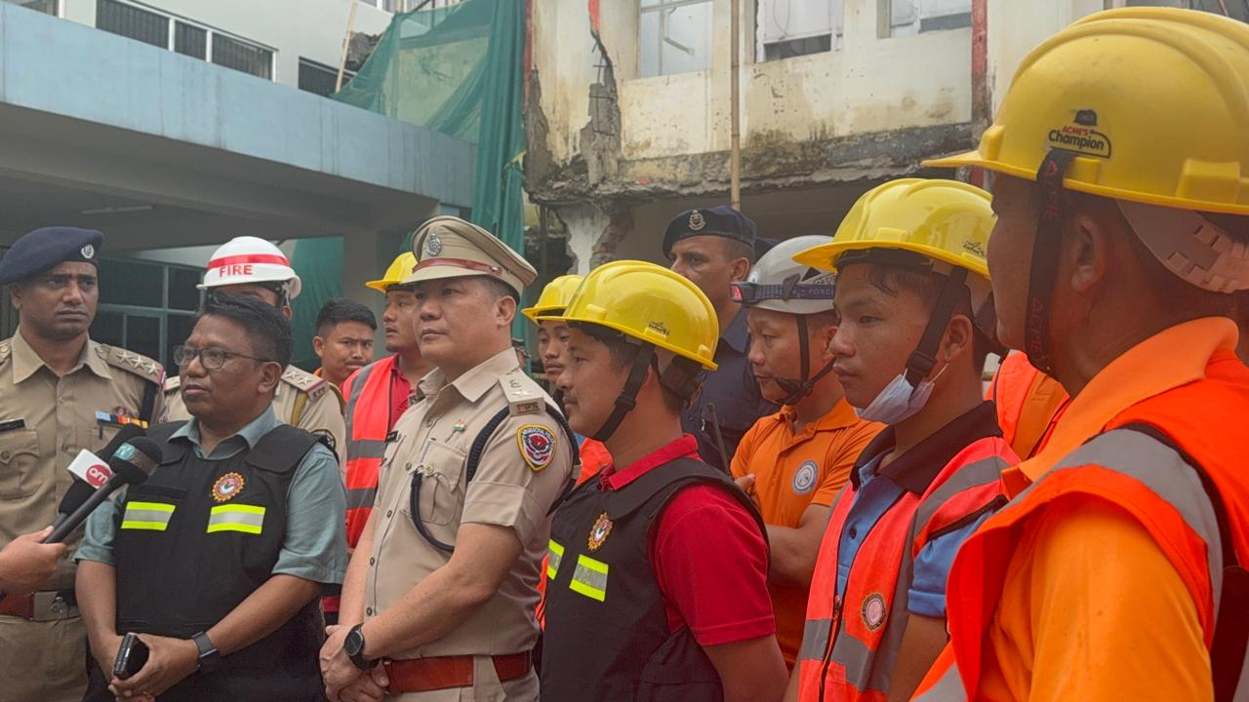

Papum Pare, 7th May,2025: The District Administration of Papum Pare, under the guidance of the Civil Defense Department, conducted a comprehensive Civil Defense Mock Drill on [Insert Date], simulating an air strike scenario across multiple key locations in the district. The drill aimed to assess the preparedness, coordination, and public response mechanisms in the event of an aerial threat.
The mock drill was conducted at the DC Office Complex, Papum Pare, IOCL Depot, Emchi, Pare Hydro Project, Jampa and Emchi Market Area
At exactly 7:00 PM, warning sirens were activated across these locations to simulate an airstrike alert. Following prior instructions issued by the District Administration, the public promptly switched off all lights and electrical appliances, closed windows, and remained calm and silent as per the guidelines of blackout protocol.
The DC Office Complex served as the central staging area for coordination and communication. In addition, a mock evacuation and rescue operation was carried out at the DC Office premises, demonstrating emergency response and inter-agency coordination under simulated threat conditions.
Speaking on the occasion, Deputy Commissioner, Papum Pare Shri Jiken Bomjen stated that such drills are crucial for enhancing disaster response capabilities and public awareness. “Preparedness is the key to saving lives. The public’s cooperation and the swift action of emergency responders today reflect the strength of our community and system,” he added
SP Papum Pare Shri Taru Gusar also appealed all to actively participate in the mock drills and learn the skills to survive in disaster situations.
The exercise saw the active participation of civil defense teams, local law enforcement, medical units, fire services, and volunteers, along with positive cooperation from the public, who followed the blackout and safety protocols as directed.

