GOVERNOR’S SECRETARIAT
ARUNACHAL PRADESH
ITANAGAR

Press Communiqué
Dated May 7th, 2025

8th Hangpan Dada Memorial Trophy Kicks Off at Yingkiong
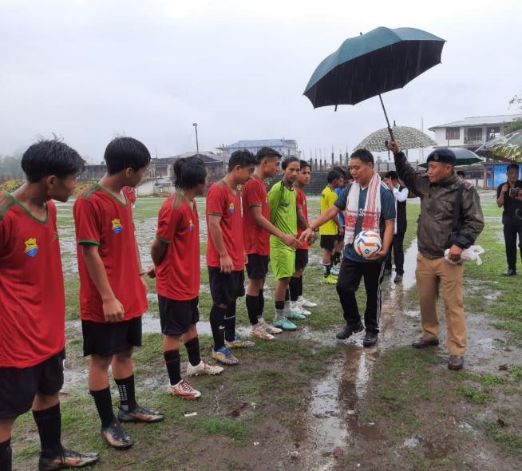 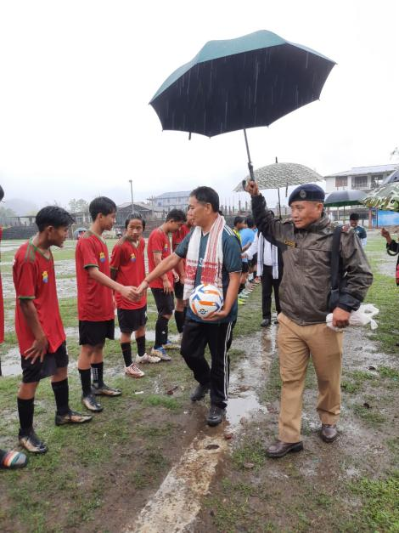

Yingkiong, May 7: The 8th edition of the District Level Hangpan Dada Memorial Trophy’2025 of Upper Siang for U-16 boys and girls in football and volleyball was officially inaugurated at General Ground, Yingkiong.
Hon’ble MLA Shri Alo Libang graced the occasion as Chief Guest and declared the tournament open in the presence of Guest of Honour Deputy Commissioner Talo Jerang, Superintendent of Police Token Saring, senior administrative officers, heads of departments, public leaders, and a large gathering of enthusiastic participants. In his address, Shri Alo Libang paid heartfelt tribute to the supreme sacrifice made by martyr Hangpan Dada for the sake of the nation. He said that Dada’s legacy continues to inspire and benefit hundreds of young sportspersons across the state by providing them a platform to nurture and showcase their talents through sports.
The Deputy Commissioner Shri Talo Jerang, who also spoke on the occasion, encouraged the participants to compete with true sportsmanship, discipline, and dedication. He highlighted various government facilities available to meritorious sportspersons, including job reservation opportunities and support schemes aimed at promoting sports development in the state.
Altogether, 6 teams are participating in the tournament representing Tuting, Yingkiong, Geku, Mariyang, and Jengging, showcasing their skills in football and volleyball.vThe tournament kicked off with the inaugural boys’ football match between Yingkiong and Tuting, where Tuting edged out Yingkiong with a 1-0 victory. In the girls’ match, Yingkiong triumphed over Tuting by 1-0.
The three-day tournament will culminate on May 9, 2025, with final matches and a prize distribution ceremony.

