GOVERNOR’S SECRETARIAT
ARUNACHAL PRADESH
ITANAGAR

Press Communiqué
Dated May 7th, 2025

Soulful Strings and Cultural Harmony: Carnatic Recital Enchants Namsai
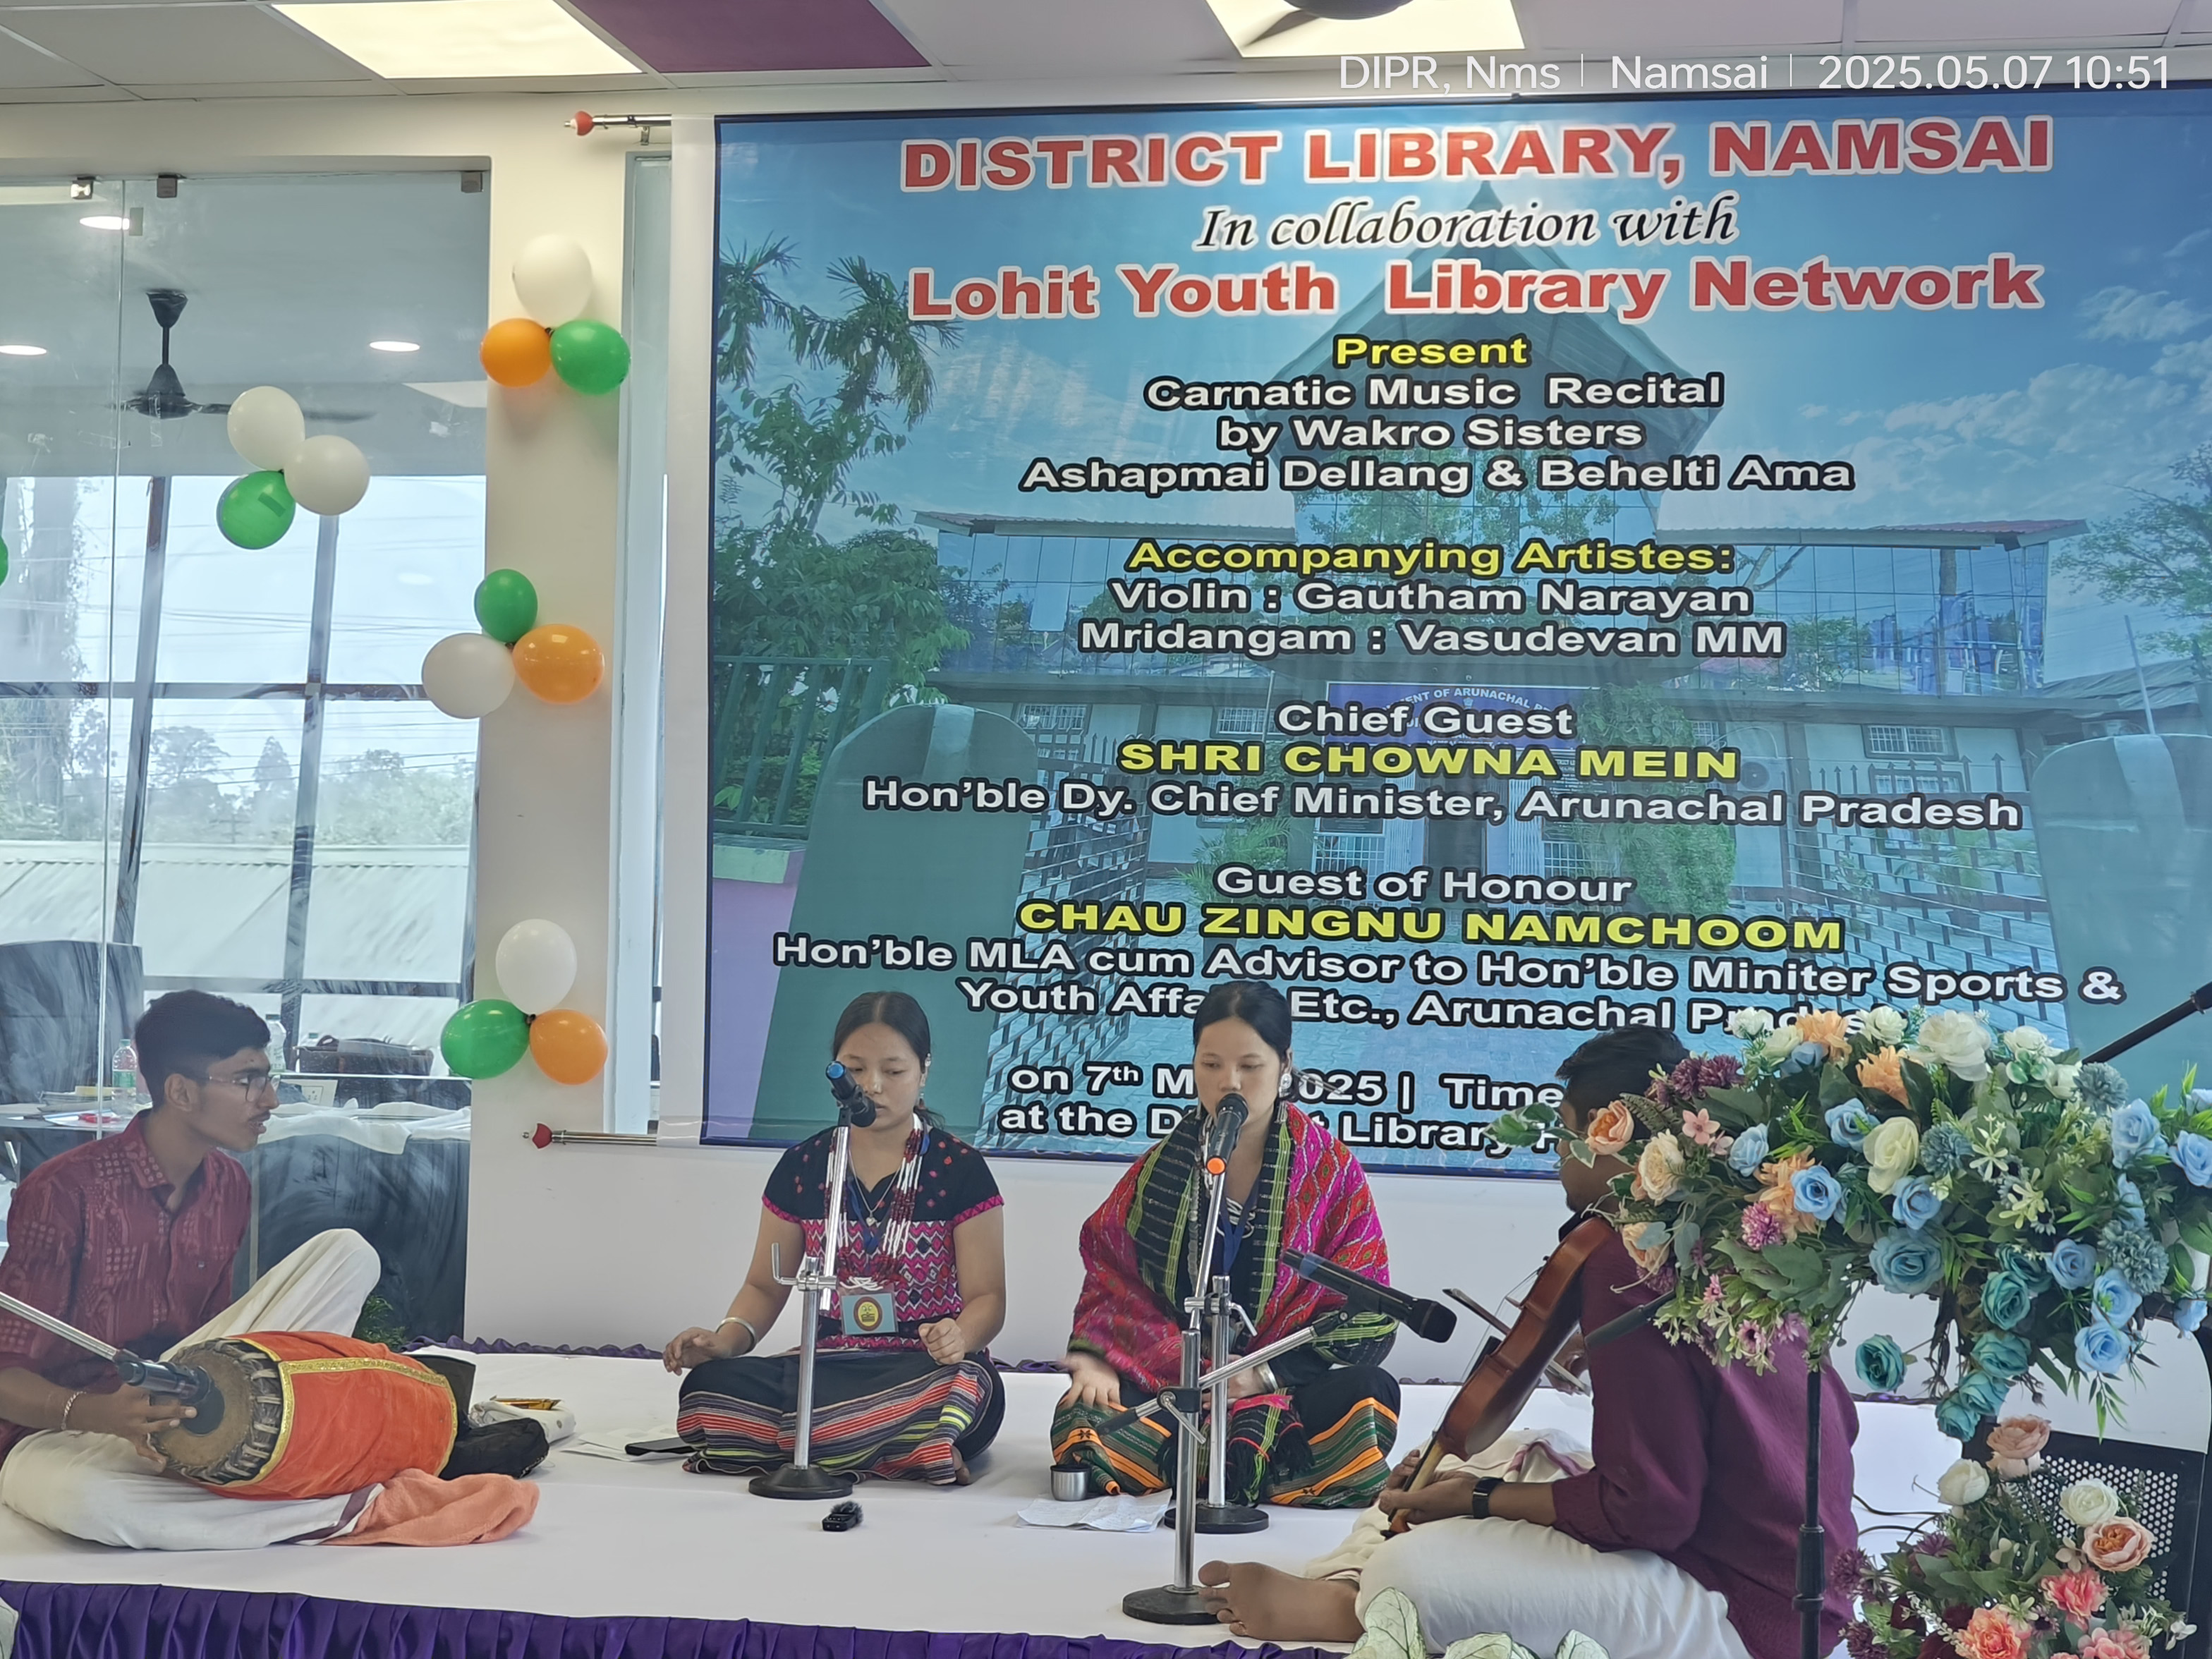 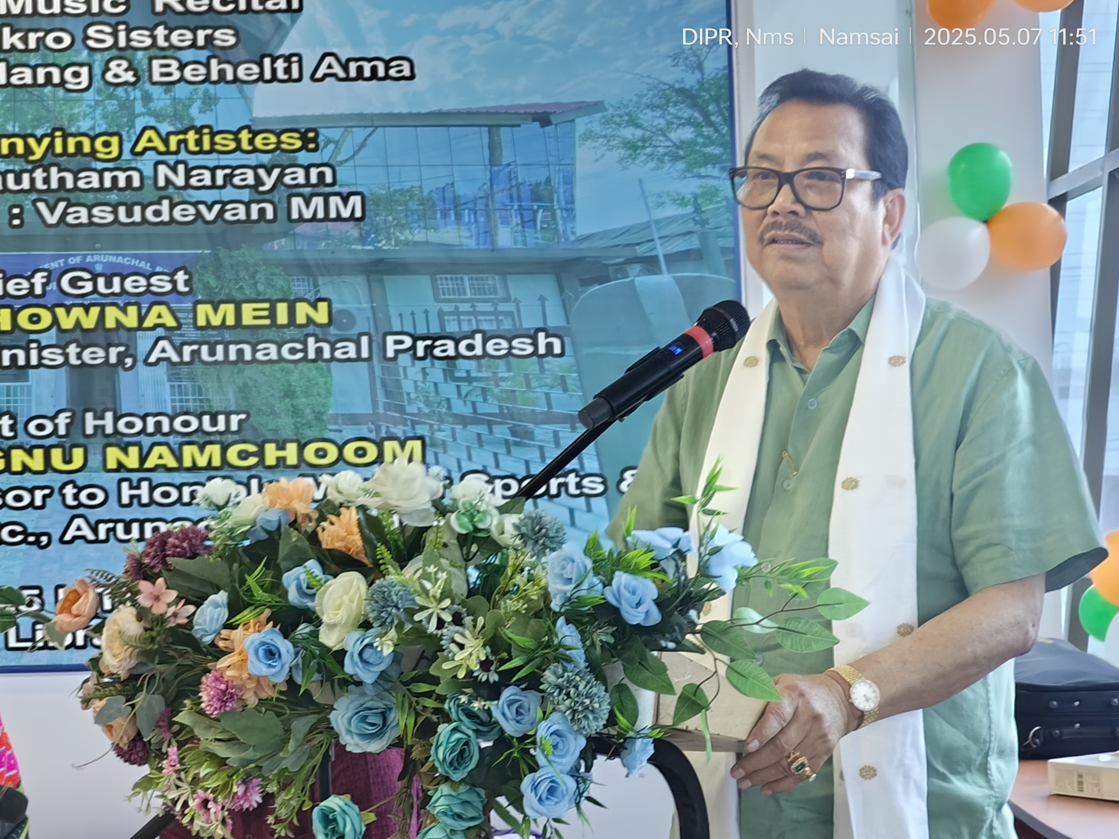

A Carnatic music recital was held today at the District Library, Namsai organised by the District Library in collaboration with Lohit Youth Library Network.
The event was graced by Shri Chowna Mein, Hon’ble Deputy Chief Minister of Arunachal Pradesh as the Chief Guest, Chau Zingnu Namchoom, Hon’ble MLA, Namsai as the Guest of Honour alongwith PadmaShri awardee Sathyanarayanan Mundayoor, IGP (Eastern Range), Shri P N Khrimey, DC Namsai, ZPC, SP, HoDs and students from Blooming Birds school.

Addressing the gathering, Deputy Chief Minister Shri Chowna Mein emphasized the importance of preserving one’s rich cultural heritage and traditional art forms. He praised the performers and called them an inspiration for many aspiring artists in Arunachal Pradesh. He highlighted the growing talents in various fields emerging across the state and stressed the importance of platforms and proper grooming to nurture such skills.
He also appreciated the District Library Namsai, Bamboosa Library and the Lohit Youth Library Network for their persistent efforts in cultivating reading habits among youth. Further, he expressed his aspiration for Namsai to become one of the cleanest districts in the state and stressed the need to spread awareness about cleanliness alongside reading culture.

The musical performance featured the talented Wakro sisters, Ashapmai Dellang and Behelti Ama, with instrumental support from Gautam Narayan on the violin and Vasudevan M.M. on the Mridangam. The recital left the audience mesmerized with its soulful renditions.

