GOVERNOR’S SECRETARIAT
ARUNACHAL PRADESH
ITANAGAR

Press Communiqué
Dated May 7th, 2025

DCM Chowna Mein Inaugurates New IGP Office Building for Eastern Range in Namsai, Attends Carnatic Music Recital by Wakro Sister
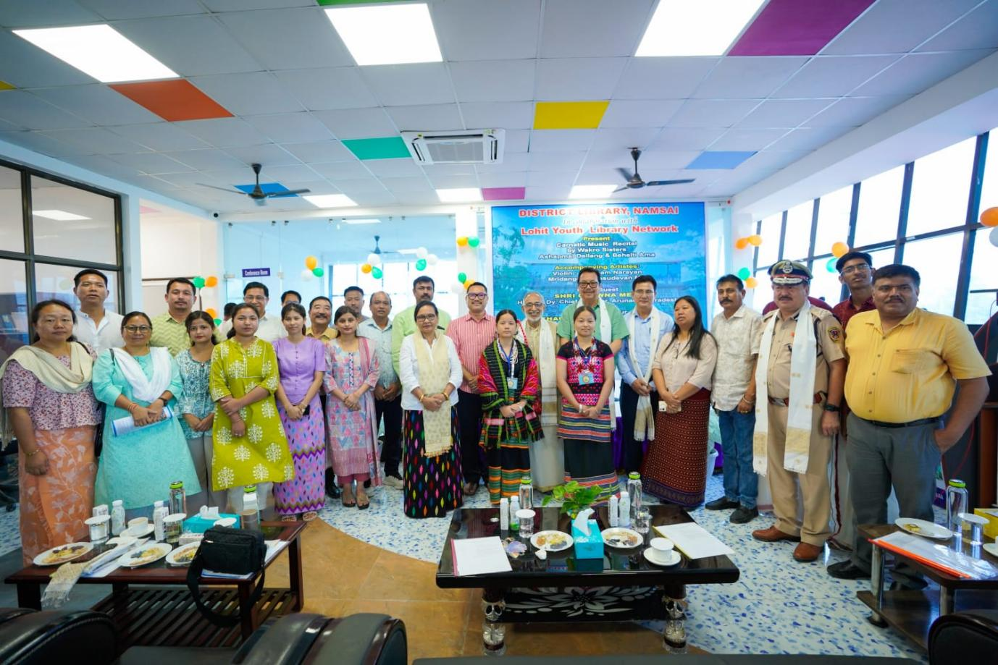
Namsai, May 7: Deputy Chief Minister, Chowna Mein, today inaugurated the newly constructed Office building of the Inspector General of Police, Eastern Range, and the Office of the Superintendent of Police, Namsai District, marking a major step forward in the district’s administrative and policing infrastructure.
The new facilities will significantly enhance the operational efficiency of civil police, strengthen inter-departmental coordination, and ensure quicker response to public concerns. DCM Mein commended the PWD team for the timely execution of the project. He was joined by MLA Chau Zingnu Namchoom, ZPC Urmila Mancheykun, IGP (Eastern Range) P.N. Khrimey, DC C.R. Khampa, SP Sange Thinley, and others. Later, Deputy Chief Minister also graced the captivating Carnatic Music Recital held at the District Library, Namsai. The event was organised in collaboration with the Lohit Youth Library Network and featured a stirring performance by the Wakro Sisters – Ms. Ashapmai Dellang and Ms. Behelti Ama – the first Arunachali women to pursue Carnatic music professionally.
Hailing from Medo and Pukhuri villages, the young artistes are trained at the prestigious Kalakshetra Foundation in Chennai and are committed volunteers of the Lohit Youth Library Network. Accompanied by a team of accomplished instrumentalists from Kerala, their performance reflected the profound cultural ethos of the region and the enduring relevance of India’s classical traditions.
Addressing the gathering, DCM Mein lauded the dedication and artistic excellence of the Wakro Sisters, noting their achievement as a significant milestone in the cultural journey of Arunachal Pradesh. He stressed the importance of nurturing creativity and embracing diverse professional pathways, especially in the fields of art, culture, and music.
Mein reflected on his longstanding association with the Youth Library Movement, initiated by Padma Shri awardee Sathyanarayanan Mundayoor and the then Deputy Commissioner of Lohit, Prashant Lokhande. Recalling its humble beginnings with mobile book exhibitions in 2006 and the establishment of the Bamboosa Library in Tezu in 2007, when he was the Minister In-charge of Education, Mein noted that over the past 18 years, the movement has blossomed into a platform for learning, creativity, and community engagement across the region.
Reaffirming the government’s commitment to youth empowerment, the DCM highlighted ongoing initiatives under skill development, digital learning, and women’s empowerment. He assured to provide a Van (vehicle) for mobile library service in Namsai to further enhance access to reading and educational materials. He also spoke about the expansion of New Age Learning Centres in all districts across the State, which aim to bridge digital divides and promote equitable access to modern education. He added that we must continue to inculcate reading habits amongst the children.
Mein expressed happiness in the increasing participation of women in leadership and creative fields, noting that the success of the Wakro Sisters stands as a testament to the transformative progress being made in Arunachal Pradesh.
Also present at the event were Advisor to Minister of RWD, Sports & Youth Affairs and Namsai MLA Chau Zingnu Namchoom, Padmashri Awardee Sathyanarayanan Mundayoor, ZPC, Urmila Mancheykun, IGP (Eastern Range), P N Khrimey, Deputy Commissioner C.R. Khampa, and others.
The event concluded with a renewed call for youth to embrace reading, creativity, and continuous learning, reaffirming the government’s vision for a culturally enriched, empowered, and future-ready Arunachal Pradesh.
