GOVERNOR’S SECRETARIAT
ARUNACHAL PRADESH
ITANAGAR

Press Communiqué
Dated May 7th, 2025

Arunachal Bags Two Judo Bronze and One Esports (Demo) Silver at Khelo India Youth Games 2025
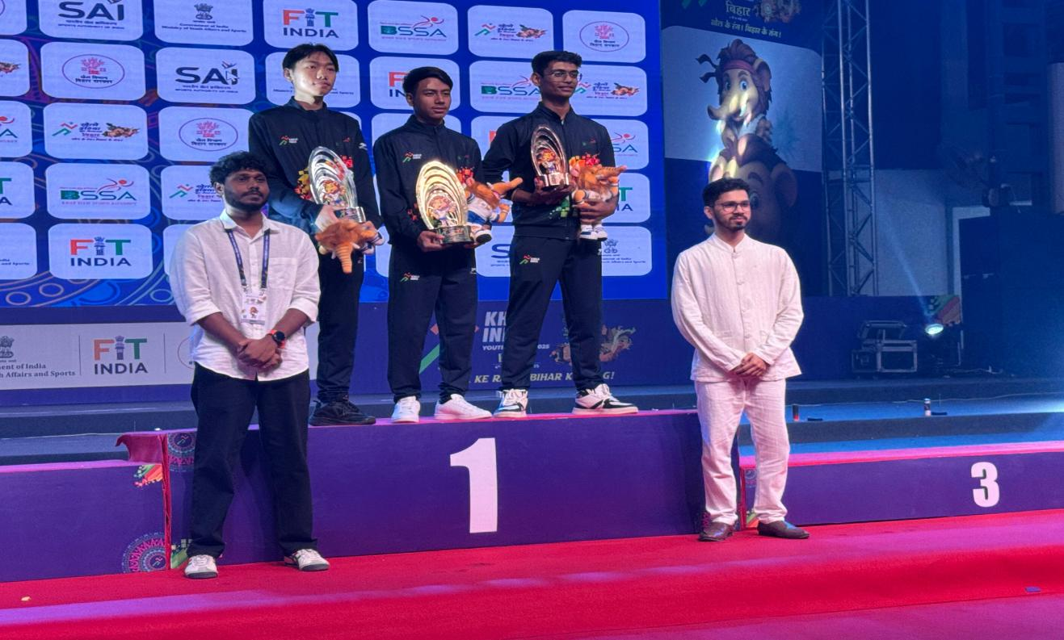
Arunachal Pradesh made a strong impression on Day 3 of the 7th Khelo India Youth Games 2025 in Bihar, with two of its talented Judokas, Tersu Tali and Taba Titung, earning Bronze medals in their respective events. These victories highlight the state's rising potential in the national sporting arena.
In the men’s -66 kg Judo category, Tersu Tali showcased grit and excellence. A former trainee of Sangay Lhaden Sports Academy and now training at SAI NCOE Shillong, he delivered commanding wins over Jharkhand and Kerala in the early rounds. Though he narrowly missed the final after a semifinal loss to Uttar Pradesh, Tali displayed remarkable resilience, defeating Meghalaya in the Bronze medal match. This historic medal is Arunachal Pradesh’s first in the -66 kg Judo category at the Khelo India Youth Games.

In the men’s -60 kg event, Taba Titung opened his campaign with a victory over Telangana. He fought hard in a tightly contested Golden Score round but was edged out by Maharashtra. However, Titung was later awarded the Bronze after receiving a walkover, as his opponent from Bihar was unable to compete due to injury. In the women’s -48 kg division, Tunu Gamlin gave her best effort but faced a challenging opponent in Delhi and exited in the opening round.
With this Arunachal Stands 21st in National Medal tally while 3rd in North East after Manipur and Assam. In the Esports Demonstration Event, Arunachal’s Jipin Gongo brought home a Silver medal in eFootball Mobile. Gongo performed exceptionally throughout the tournament, ultimately finishing second after a thrilling final against a strong contender Lamgouhao kipgen from Nagaland. His achievement brings well-deserved attention to the emerging Esports scene in the state.
Leading the Arunachal Pradesh contingent is Shri Karbia Dodum, Assistant Director of Sports and Chef de Mission. His active presence on the ground has been instrumental in managing the team’s operations, motivating athletes, and ensuring that all logistics and support systems are in place. His encouragement and leadership are playing a key role in boosting team morale and performance.
A new group of athletes—15 weightlifters, 5 wrestlers, 2 boxers, and 5 supporting staff—will depart from Itanagar tomorrow with two additional athletes and one staff member set to join the squad the following day.
With two Bronze medals already in hand and more events to come, Arunachal Pradesh’s young athletes are proving their mettle on the national stage, inspiring the next generation of sports talent across the region.

