GOVERNOR’S SECRETARIAT
ARUNACHAL PRADESH
ITANAGAR

Press Communiqué
Dated May 31, 2025
DC Daporijo Inspects PMGSY Road Blockages and School Construction Following Heavy Rainfall Damage
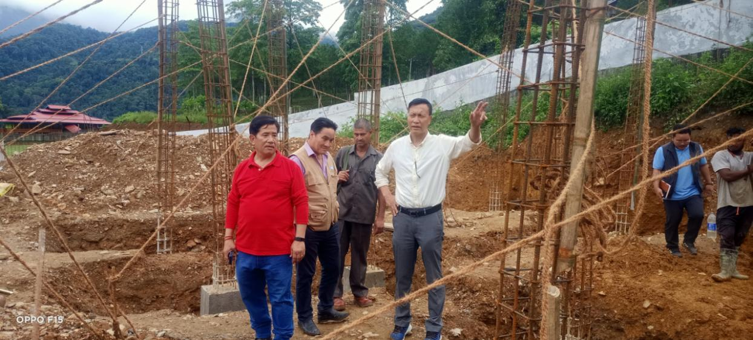
Daporijo 31/5/25 ,Tasso Gambo D.C alongwith Taluk Jeram EE RWD and Lardik Kare EE PWD visietd blockade points of Chetam- Nilling PMGSY road. The PMGSY road has reportedly multiple blockages due major landslide and Singking of raod in last night due to heavy rainfall.
While visiting the road DC directed concerned Department to clear the blockade as possible manner,where the road is life line of Nilling-Chetam administration centres and public of nearby areas he directed.
Further, DC inspected construction Site of school of building Soki primary, said that building should be as per DPR and quality works be mantain.
