GOVERNOR’S SECRETARIAT
ARUNACHAL PRADESH
ITANAGAR

Press Communiqué
Dated May 31, 2025
Governor presents Citations to Armed Forces Units
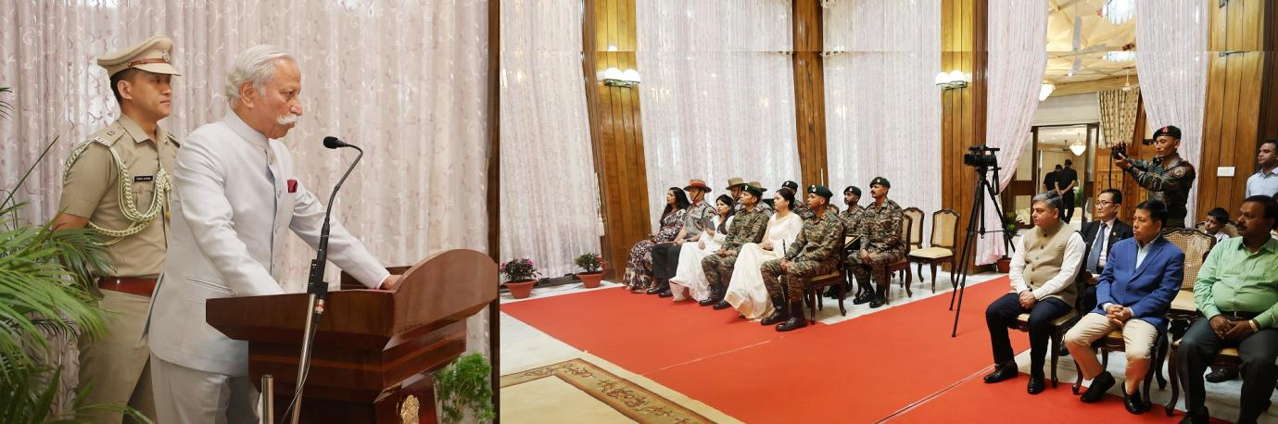
- Governor presents Citations to Armed Forces Units
- Governor commends the dedication and professionalism of the units for their steadfast commitment to operational duties
- Governor lauds the Units for their tireless efforts in safeguarding the sanctity of the Line of Actual Control and ensuring effective border management along the sensitive Indo-Myanmar frontier
- Operation Sadbhavana has fostered a deep sense of trust and affection between the locals and the forces: Governor
- Under the guidance of strong political and military leadership, Operation Sindoor has shaped a new and robust doctrine of deterrence: Governor
- Governor urges the units to keep exploring innovative uses of technology and to remain ever-vigilant in their duties
The Governor of Arunachal Pradesh, Lt. General KT Parnaik, PVSM, UYSM, YSM (Retd.) presented Governor’s Citation to 13 Rajputana Rifles, 9 Grenadiers and 31 Assam Rifles in the Vivekananda Hall, Raj Bhavan, Itanagar on 31st May 2025 for their exceptional professionalism, operational acumen, and spirited élan and for building a strong synergy with the District Administration and the local population of the State.
Colonel Sangam Kumar, Commanding Officer, along with Subedar Major Bhom Singh Rathore and Agniveer Vibin A, received the Governor’s Citation for the 13th Battalion of The Rajputana Rifles (Thundering Thirteen). Colonel Saurabh Sharma, Commanding Officer, along with Subedar Major Mahaveer, Sena Medal, and Grenadier Dharamveer, received the Governor’s Citation for the 9th Battalion of The Grenadiers Regiment (Mewar). Colonel Dushyant Singh Lamba, Commanding Officer, along with Subedar Major Banwari Lal Sharma and Rifleman K. I. Singh, received the Governor’s Citation for the 31st Battalion of the Assam Rifles (THIRSTYONES).
Speaking on the occasion, the Governor commended the dedication and professionalism of the units for their steadfast commitment to operational duties. He lauded their tireless efforts in safeguarding the sanctity of the Line of Actual Control and ensuring effective border management along the sensitive Indo-Myanmar frontier, which have yielded visible and meaningful results.
The Governor expressed his deep appreciation for the armed forces’ contributions beyond their core duties. He appreciated their initiatives in building essential infrastructure such as community halls, school buildings, classrooms, and playgrounds, facilities that have brought real value to the lives of people in border villages. He also acknowledged their efforts in organizing district-level sports tournaments, fostering a spirit of unity and healthy competition among the youth.
The Governor noted with special admiration the army’s mentorship programs for local youth, including coaching for UPSC exams, Sainik School admissions, and, most importantly, pre-recruitment training. These efforts, he said, have touched hearts and inspired hope among young people, creating new pathways for their future.
Recalling his interactions with residents during visits to remote border villages, the Governor shared that the goodwill generated by the armed forces through their Sadbhavana (goodwill) operations has fostered a deep sense of trust and affection, which he described as a ‘special bonhomie’ between the locals and the forces. He expressed his strong faith that the armed forces would continue to uphold and expand these good works, thereby strengthening the bonds they had built.
The Governor also highlighted the positive impact of the armed forces’ collaborative efforts in the Vibrant Villages Programme, especially their spirit of service and assistance. He said the success of the programme has even led to instances of reverse migration, which, in turn, has enhanced the security and vitality of border areas.
Reflecting on Operation Sindoor, he stated that the initiative, under the guidance of strong political and military leadership, has shaped a new and robust doctrine of deterrence. He urged the units to keep exploring innovative uses of technology and to remain ever-vigilant in their duties.
The Governor hosted a High Tea for the Unit officers, special guests, and other ranks.
