GOVERNOR’S SECRETARIAT
ARUNACHAL PRADESH
ITANAGAR

Press Communiqué
Dated May 31, 2025
World No Tobacco Day Observed Across Tawang District with a Strong Message Against Tobacco Use
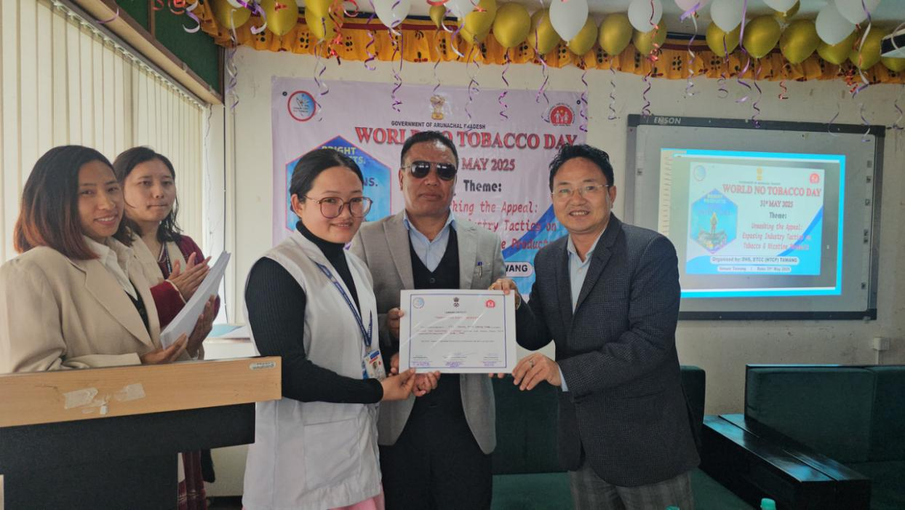
Tawang 31/05/2025 : The World No Tobacco Day (WNTD) 2025 was observed with great fervor and commitment across all Community Health Centres (CHCs), Primary Health Centres (PHCs), Health and Wellness Centres, and selected schools in Tawang district today. This year's theme, "Unmasking the Appeal: Exposing Industry Tactics on Tobacco and Nicotine Products," served as a rallying call to raise awareness against the manipulative marketing strategies of tobacco industries.
The main district-level event was held at Khandro Drowa Zangmo District Hospital, Tawang, where local legislator Namgey Tsering graced the occasion as the Chief Guest. The programme was organized by the District Health Society and District Tobacco Control Cell (DTCC) under the National Tobacco Control Programme (NTCP).
Prominent attendees included DDSE Tawang Hridar Phuntso, Medical Superintendent Dr. Tenzin Kunga, MMT Tawang Unit President Pema Chowang, senior medical officers, teachers, health workers, and other dignitaries.
In a significant initiative, MLA Namgey Tsering administered the ‘No Tobacco Pledge’ and felicitated 62 educational institutions of the district with certificates declaring them Tobacco-Free Zones. In his keynote address, the MLA emphasized the importance of preventing tobacco use before it becomes a habit and lauded the efforts of Dr. Sangey Thinlay, Programme Officer, DTCC, and his team for their dedication in spreading awareness and conducting enforcement drives under the COTPA Act, especially around school zones.
He further appealed to Panchayati Raj Institution (PRI) members, religious leaders, and intellectuals to play a proactive role in educating the community about the dangers of tobacco, alcohol, and drug use. “These substances not only destroy individuals but also families and society at large,” he remarked, highlighting health issues like lung cancer and respiratory disorders linked to tobacco consumption.
Earlier, Dr. Sangey Thinlay informed the gathering that tobacco consumption in Tawang district has witnessed a significant decline. “Our initial estimates showed annual tobacco sales worth ₹12 crore, which has now reduced to approximately ₹6 crore,” he said. He also delivered a detailed presentation on the health hazards of tobacco.
Guest of Honour, DDSE Hridar Phuntso, and Psychologist Lobsang Yuten (DTCC Tawang) also addressed the participants, underlining the importance of education and mental health support in anti-tobacco initiatives.
The MLA also visited the ICU, trauma center, and inpatient wards of the hospital, distributed fruits to the patients, and interacted with healthcare workers, appreciating their service and dedication.
Simultaneously, CHC Jang observed World No Tobacco Day under the leadership of Dr. Kevi Meru, In-charge Medical Officer. Shopkeepers and local stakeholders participated actively. Dr. Tenzin Lhamu conducted a session on the ill effects of tobacco and sensitized attendees about the provisions of the COTPA Act and administered No Tobacco Pledge.
The observance of World No Tobacco Day across Tawang reflects the district's united stand against tobacco use and its commitment to building a healthier, tobacco-free district.
