GOVERNOR’S SECRETARIAT
ARUNACHAL PRADESH
ITANAGAR

Press Communiqué
Dated May 31, 2025
HDMT’s: Leparada to face East Siang in boys’ football final
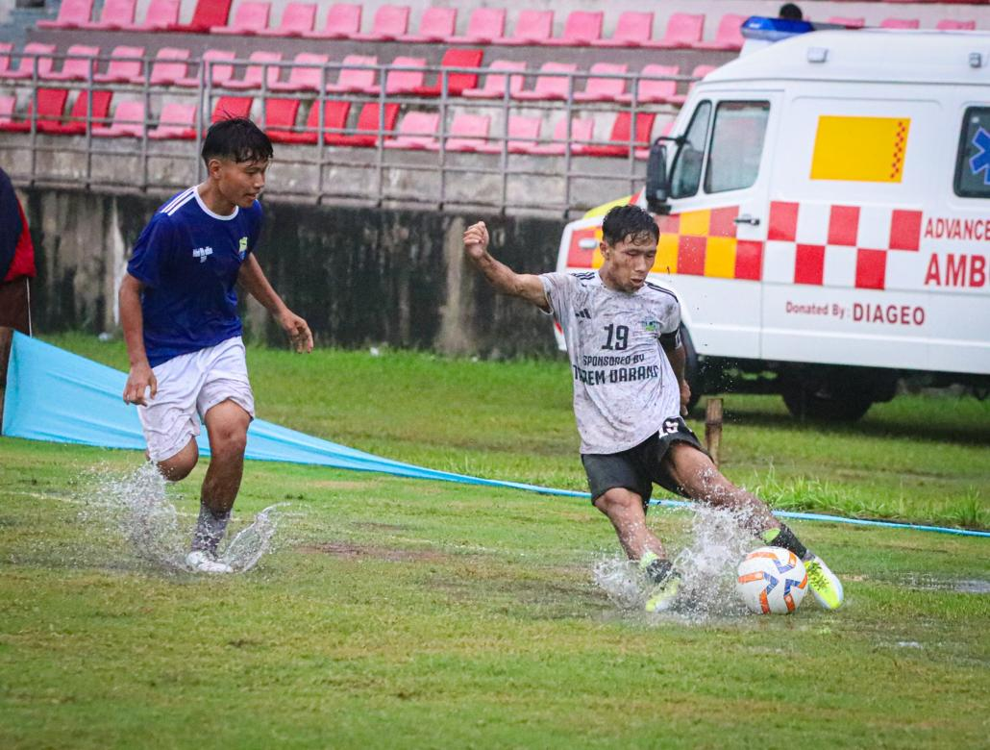
PASIGHAT, 31 May: Leparada and East Siang secured final spots in the boys’ football of the Hangpan Dada Memorial Trophy (HDMT) after defeating major contenders Kra Dadi and Siang respectively, in semi-final matches on Saturday.
The match between Leparada and Kra Dadi was fans favorites’ semi final match as it brought excitements and full of entertainment to the match. The goal for Leparada came when Tomar Basar edge past the opponent and put the goal inside the net in 37 Minutes. The match was neck-to-neck between two team. Both team’s potential and effort shown in the match was spectacular. The goal in scored board 1-0 remains same till the referee blown the final whistle.
In the second semi-final match, East Siang edged out Team Siang by 7-1. During the match, Karsing Yirang in an extraordinary feat scored four goals for East Siang in 7, 34, 36 & 67 minutes. With one goal in 26 minutes from Mohon Bori and brace from Panny Tasung in 13 and 26 minutes secured the deal in final spot for East Siang. Meanwhile, consolation goal for Siang came in 35+2 Minutes from Hanu Tari.
Meanwhile, in the girls’ volleyball event, Kra Dadi and Kamle comes up as victorious in Semi-final matches after defeating East Siang and Capital Complex respectively and moves to the final.

