GOVERNOR’S SECRETARIAT
ARUNACHAL PRADESH
ITANAGAR

Press Communiqué
Dated May 31, 2025
Deputy Chief Minister Chowna Mein Attends 300th Birth Anniversary Celebration of Lokmata Devi Ahilyabai Holkar in Itanagar
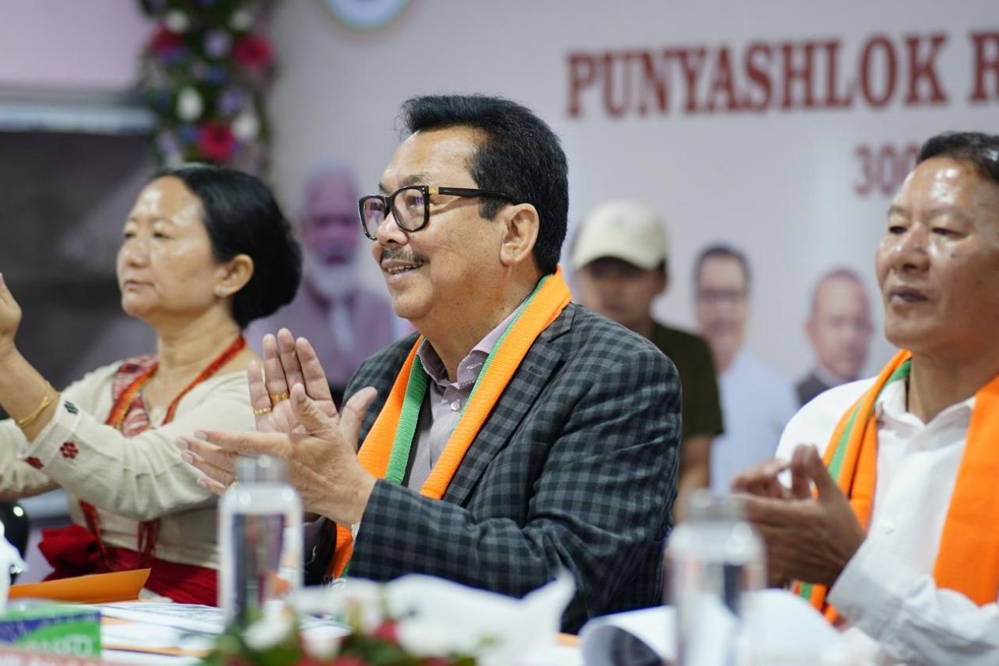
ITANAGAR, May 31: Deputy Chief Minister of Arunachal Pradesh, Chowna Mein, participated in the 300th birth anniversary celebration of Lokmata Devi Ahilyabai Holkar in Itanagar today. Speaking in the solemn program, Mein described Ahilyabai Holkar as a timeless icon of justice, wisdom, and compassionate governance. He highlighted how her contributions have remained under-represented in mainstream history, despite her profound influence as a ruler. Citing the titles ‘Punyashloka’ by poet Moropant and ‘The Philosopher Queen’ by British historian John Keyas, he emphasized the enduring relevance of her ethical leadership in today’s times.
Mein praised Prime Minister Narendra Modi’s leadership for reviving the legacies of such inspirational figures while driving India toward inclusive and sustainable development. He spoke about key initiatives like Lakhpati Didi, Rising North East, Startup support, and Skill Development Programs that are empowering rural communities and youth. He also acknowledged Operation Sindoor as a powerful example of India’s firm stance on national security and its zero-tolerance approach to terrorism. He said that through the collective efforts under the Mantra of ‘Sabka Saath, Sabka Vikas, Sabka Vishwas, and Sabka Prayas’, India has emerged as the world’s fourth-largest economy.
DCM further highlighted Arunachal Pradesh’s vast potential, with abundant land resources, mineral wealth, and growing sectors like agriculture, horticulture, and hydropower. He noted that industrialists such as Mukesh Ambani, Gautam Adani, and Anil Agarwal have committed over ₹1.75 lakh crore investments in the Northeast, signaling a new era of industrial growth. Arunachal Pradesh is poised to generate 10,000 MW of hydropower in the next 5–10 years and up to 25,000 MW in the next three decades, which could make it the richest State in India in terms of per capita income.
However, he pointed out that the biggest challenge now is skill development. There is a need for a mindset shift, from a dependence on government jobs to embracing entrepreneurship, tourism, and private-sector opportunities. To strengthen grassroots governance, he added that the State government is also devolving 10% of its tax revenue from State Own Resources to Panchayati Raj institutions. As Arunachal stands on the threshold of transformation, he called for collective preparedness to welcome the wealth and opportunity that lies ahead by building a skilled and empowered workforce.
The event was also attended by Minister of Urban Affairs, Land Management and Civil Aviation, Balo Raja and rank & file of the Bharatiya Janata Party.
