GOVERNOR’S SECRETARIAT
ARUNACHAL PRADESH
ITANAGAR

Press Communiqué
Dated May 25th, 2025

Minister Dasanglu Pul Honors Ahilyabai Holkar, Reviews Vatsalya Sadan in Namsai
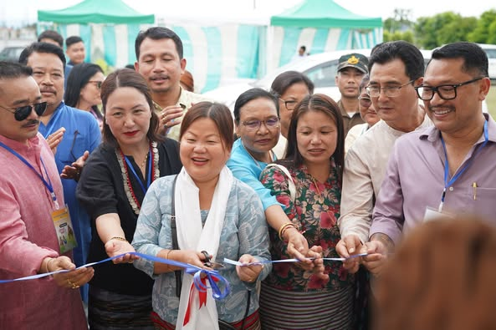
Namsai, May 25, 2025 : Women and Child Development Minister Dasanglu Pul on Sunday paid a heartfelt tribute to the legacy of Maharani Ahilyabai Holkar during a state-level seminar held in Namsai. Describing Holkar as “one of India’s greatest women leaders,” Minister Pul praised her life of courage, wisdom, and service, noting that it continues to inspire generations.
“Maharani Ahilyabai Holkar’s life is a timeless example of fearless leadership, compassion, and empowerment. Her story should be part of every child’s education,” the Minister said in her address to the gathering.
On the sidelines of the seminar, Minister Pul inaugurated a cultural exhibition showcasing Arunachal Pradesh’s indigenous craftsmanship and rich cultural traditions. The stalls highlighted the creativity and resilience of local communities.
“I am glad to inaugurate the exhibition showcasing the creativity and resilience of our communities. It reflects the unique traditions that we must preserve and promote,” she stated.
The event was graced by several dignitaries including Namsai MLA Chau Zingnu Namchoom, state BJP vice president Tarh Tarak, and BJP Mahila Morcha president Kohman Lungphi Ngemu. Minister Pul expressed her gratitude to all participants and stakeholders for making the seminar a success.
Earlier in the day, the Minister visited the under-construction Vatsalya Sadan in Namsai — a shelter home project aimed at providing care and protection to children in need. During her visit, she reviewed the construction progress and reaffirmed the state government’s commitment to child welfare and social infrastructure.
“Vatsalya Sadan (Home of Parental Love) is envisioned as a safe, nurturing space where children in distress can find security, healing, and dignity,” she said. “The welfare of our most vulnerable citizens, especially children, must be at the heart of our development efforts. We are committed to building compassionate infrastructure that truly uplifts lives.”
The Minister was accompanied by MLA Zingnu Namchoom, Namsai Deputy Commissioner C. R. Khampa, Superintendent of Police S. Thinley, and other senior officials.
