GOVERNOR’S SECRETARIAT
ARUNACHAL PRADESH
ITANAGAR

Press Communiqué

Dated May 15th, 2025

ECI's Ongoing Political Party Interactions: Meeting with Aam Aadmi Party Delegation Led by Shri Arvind Kejriwal
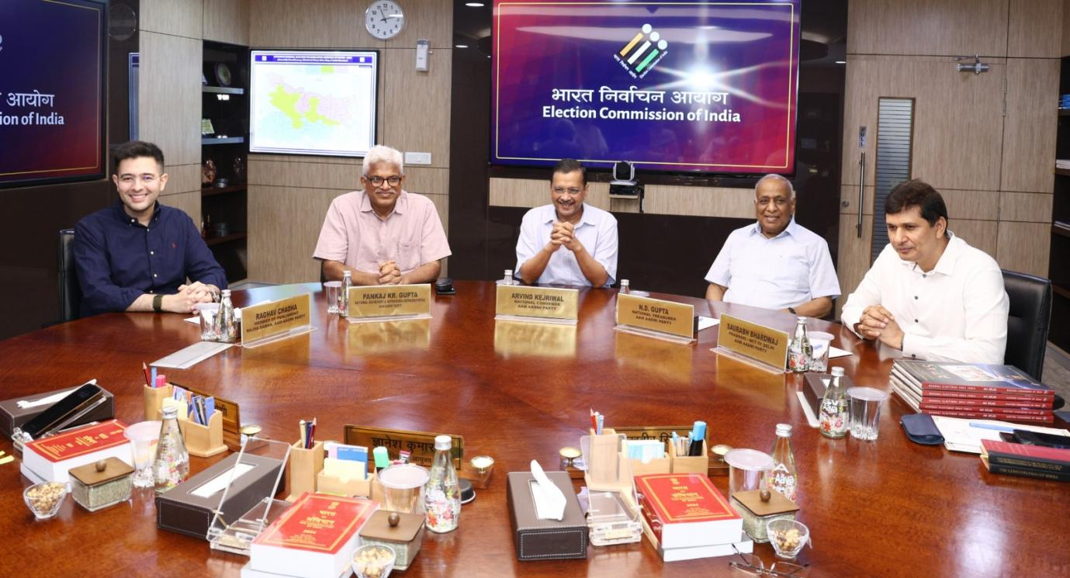

Chief Election Commissioner Shri Gyanesh Kumar and Election Commissioners Dr. Sukhbir Singh Sandhu & Dr. Vivek Joshi had an interaction with the Aam Aadmi Party led by its National Convener, Shri Arvind Kejriwal at Nirvachan Sadan today. The meeting is in continuation of the interactions being held by ECI with the Presidents of various National and State Political Parties.

Background

These interactions provide for a long-felt need of constructive discussions which enable National and State Party Presidents to share their suggestions and concerns directly with the Commission.

This initiative aligns with the Commission’s broader vision of further strengthening the electoral process in accordance with the existing legal framework with all stakeholders.

The Commission had earlier met with the delegations of the Bahujan Samaj Party (BSP), led by the Party President Km. Mayawati, on May 06, 2025; the Bharatiya Janata Party (BJP), led by the Party President Shri. Jagat Prakash Nadda, on May 08, 2025, the General Secretary of the Communist Party of India (Marxist), Shri M.A. Baby on May 10, 2025 and the Party President of the National People’s Party, Shri Conrad Sangma on May 13, 2025.
Earlier, a total of 4,719 all-party meetings have been conducted including 40 meetings by CEOs, 800 by DEOs, and 3879 by EROs engaging over 28,000 representatives of various political parties.
