GOVERNOR’S SECRETARIAT
ARUNACHAL PRADESH
ITANAGAR

Press Communiqué
Dated May 14th, 2025

Coordination Meeting on Vibrant Villages Programme-II
Held at Khonsa
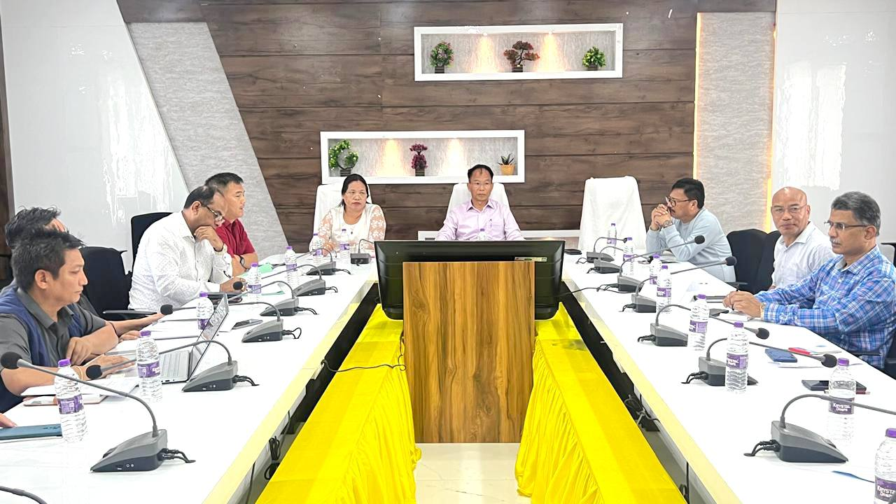
Khonsa, May 14, 2025 – A coordination meeting to brief stakeholders on the Vibrant Villages Programme-II (VVP-II) was held today at Khonsa under the chairmanship of Deputy Commissioner Tirap, Shri Techu Aran. The meeting was attended by Hon’ble MLA of Khonsa West and Adviser to the Minister of Transport, Smti Chakat Aboh, along with heads of all line departments. The meeting commenced with a welcome address by the Deputy Commissioner, Shri Techu Aran. District Planning Officer (DPO), Shri L. R. Roy, provided an overview of the aims and objectives of the Vibrant Villages Programme. He highlighted that while VVP-I focused on villages along the Indo-China border, VVP-II targets villages along the Indo-Myanmar and Indo-Bhutan borders.

The Executive Engineer (Power) informed the gathering about ongoing and planned electrification works in schools and hospitals. Meanwhile, the Deputy Director of School Education (DDSE) raised concerns about the lack of electricity in several schools across the district.
The Extra Assistant Commissioner, Lazu proposed the adoption of cluster farming methods as a sustainable agricultural practices. This initiative involves forming Farmers' Producer Organizations (FPOs) to enhance agricultural productivity and ensure better market access for local farmers. Additionally, EAC emphasized the importance of identifying and developing local tourist sites to boost the region's economy through socio- cultural and eco-tourism.
Hon’ble MLA Smti Chakat Aboh proposed the inclusion of Moktowa village under Dadam Block and other left-out villages under Lazu Border Block under Vibrant Villages Programme -II. All HoDs were instructed by the Deputy Commissioner to submit a comprehensive gap analysis report for the 11 identified VVP villages within one week. The DC reiterated the importance of timely submission of these reports to ensure effective implementation of the programme.
