GOVERNOR’S SECRETARIAT
ARUNACHAL PRADESH
ITANAGAR

Press Communiqué
Dated May 14th, 2025

South-West Monsoon Preparedness Meeting held in Likabali
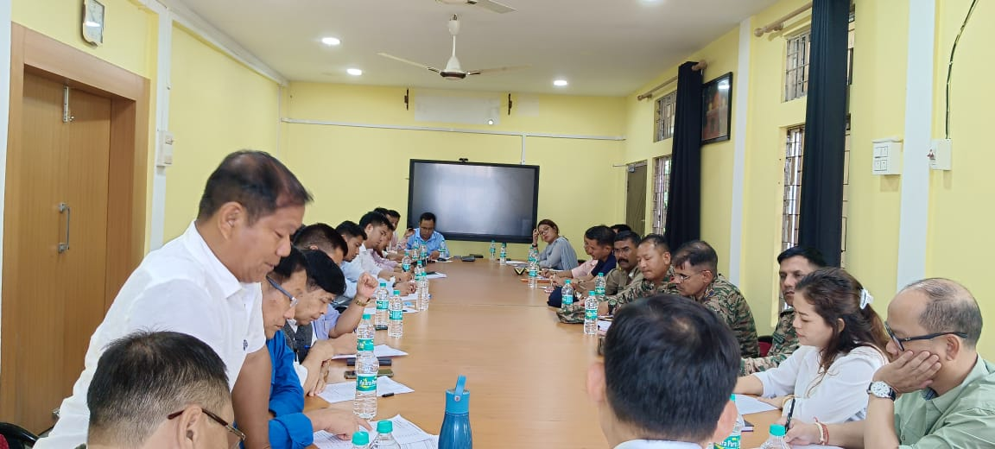
The Lower Siang District Deputy Commissioner-cum- Chairman DDMA Rujjum Rakshap has taken a meeting with the Administrative Officers, Heads of Departments of the district including the officials of the Indian Army, ITBP and BRTF stationed within Likabali to take stock of the preparedness of the district for the ensuing South-West Monsoon 2025 and also to work out a vibrant DMP. He has directed all concerned departments and the stakeholders to remain updated and prepared to mitigate any eventuality during and after disaster or disaster like situations in the district and coordinate with the administration in updating contingency plan and prepare list of resources and inventory as a part of the process of preparedness. While terming Likabali in particular and the lower Siang District as one of the vulnerable disaster prone places, he said that the DDMA has crucial role to play with a planned and meticulous advance preparations compatible enough to functionalise automatically at call of hour during disasters, and disaster like situations. Shri Rakshap further appealed to the members to synchronise the activities of all departments & agencies to cope up with any kind of situation for the safety of the people.
The District Disaster Management Officer Alokong Perme has been directed to coordinate with all other departments of the district for ensuring prompt and adequate delivery of services during such circumstances affecting life and property of the people.
In another crucial meeting of the District Executive Committee (DEC), the damage reports of the last monsoon 2024 which were received from various administrative officers under Lower Siang District were scrutinised for extending relief assistance as per the guidelines of SDRF.

