GOVERNOR’S SECRETARIAT
ARUNACHAL PRADESH
ITANAGAR

Press Communiqué
Dated May 14th, 2025

ECI launches capacity building programme for new batch of field-level electoral officers from Bihar, Haryana and NCT of Delhi
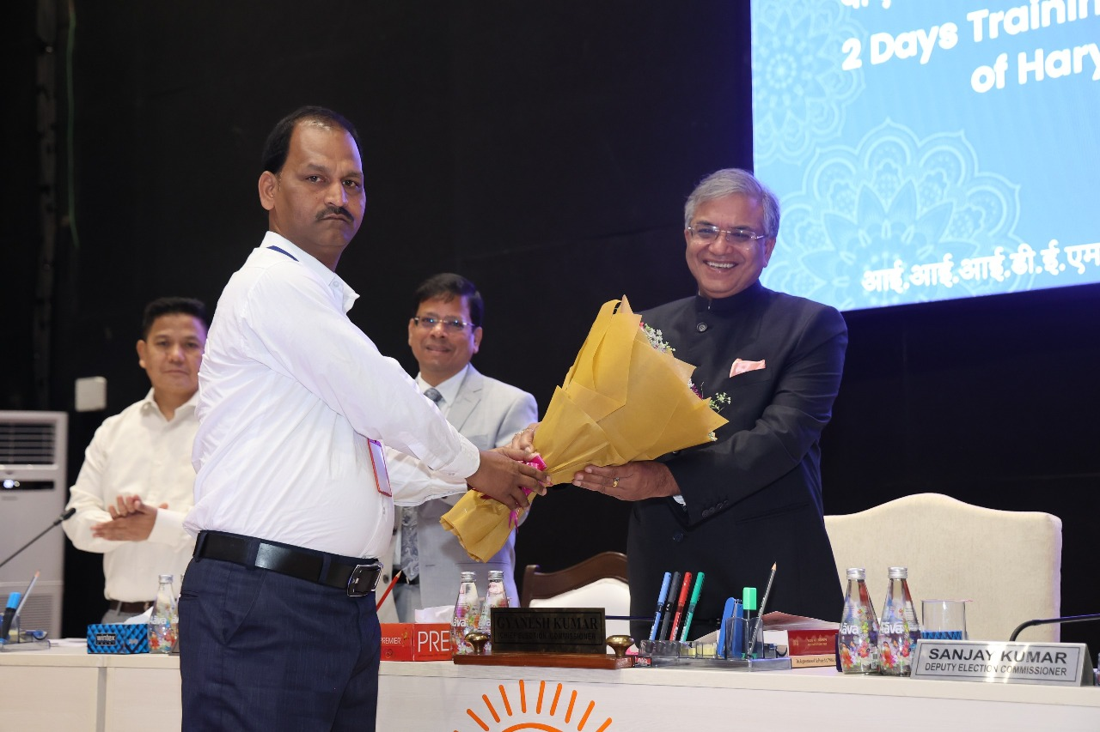
Chief Election Commissioner (CEC) of India Shri Gyanesh Kumar inaugurated a two-day capacity-building training programme for Booth Level Officers (BLOs), BLO Supervisors, Electoral Registration Officers (EROs) from Haryana and NCT of Delhi at the India International Institute of Democracy and Election Management (IIIDEM), New Delhi today.

2. A total of 371 grassroots election officials (306 BLOs from Bihar; 30 EROs and BLO Supervisors from Haryana; 35 EROs and BLO Supervisors from NCT of Delhi) are taking part in the training programme. Including the current batch, over 2,600 field officials have been trained in the last two months by ECI in New Delhi.

3. In his inaugural address, CEC Gyanesh Kumar said that the BLOs will soon be issued standard Identity cards so as to facilitate their functioning during door-to door verifications. He added that these participants will further train other BLOs in their respective States/UTs. The CEC impressed upon the participants that they are to function strictly as per the Representation of the People Act 1950, Registration of Electors Rules 1960, Conduct of Election Rules, 1961 and the instructions issued by the ECI from time to time.

4. The training is designed to enhance participants’ practical understanding especially in the areas of voter registration, Form handling, and field-level implementation of electoral procedures. The participants will be familiarised with the provisions of first and second appeals against the final electoral rolls as published with the DM/District Collector/Executive Magistrate under section 24(a) of RP Act 1950 and the Chief Electoral Officer (CEO) of the State/UT under section 24(b) respectively.

5. It may be recalled that no appeals were filed from Bihar, Haryana and NCT of Delhi after the completion of the Special Summary Revision (SSR) exercise as of 6th-10th of January 2025.

- The curriculum of the programme includes interactive sessions, role plays, simulating house-to-house surveys, case studies, and hands-on exercises for filling Forms 6, 7 and 8. Additionally, participants will receive practical training on the Voter Helpline App (VHA) and the IT tools. The officials will also be provided technical demonstrations and training of EVMs and VVPATs including mock polls.

