GOVERNOR’S SECRETARIAT
ARUNACHAL PRADESH
ITANAGAR

Press Communiqué
Dated May 14th, 2025

Seva Aapke Dwar Held at Kaho: Ministers Emphasize Last-Mile Governance and Inclusive Development
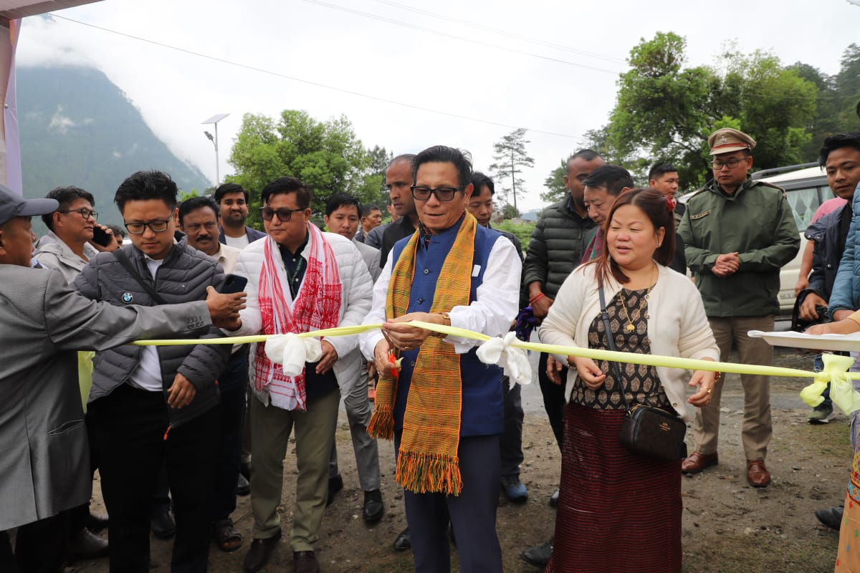
Kaho, Anjaw District | May 2025 : As part of the ongoing effort to ensure last-mile delivery of government services, the Seva Aapke Dwar (SAKD) camp was successfully conducted at Kaho, one of the easternmost villages of India. The event saw the presence of several dignitaries and departmental representatives, reinforcing the government’s commitment to accessible and transparent governance.
Hon’ble Minister for Commerce & Industries, Labour & Employment, and IPR, Shri Nyato Dukam, graced the occasion as the Chief Guest and formally inaugurated the program. He was joined by Hon’ble Minister Smt. Dasanglu Pul, who holds the portfolios of Women & Child Development, Science & Technology, and Cultural Affairs.
Shri Dukam inspected all departmental stalls set up during the camp, interacted with the officials and public, and emphasized the need for sincere service delivery. In his address, he underlined the vision behind Seva Aapke Dwar: “to bring governance to the doorsteps of citizens in remote areas.” He noted that such outreach programs minimize the need for villagers to travel long distances for essential services and welfare benefits.
He further remarked that Anjaw district holds immense potential in terms of natural resources and the tourism sector, and emphasized the importance of harnessing these opportunities through sustainable development and community participation. He also highlighted recent key announcements made during the Cabinet Aapke Dwar program, including the introduction of the "Sunrise Festival" at Walong, aimed at promoting tourism and showcasing the unique cultural vibrancy of the region. Shri Dukam urged all departments to continue proactive awareness generation about government schemes so that no eligible citizen is left behind.
Speaking on the occasion, Deputy Commissioner of Anjaw, Shri Millo Kojin, expressed gratitude to the ministers and lauded the collaborative spirit of all departments. “The district administration is committed to inclusive development and delivering timely services to every corner of the district,” he said.
During the camp, various essential services such as health check-ups, Aadhaar updates, issuance of certificates (like ST, PRC), pension and banking assistance, registration under welfare schemes, and agricultural support were provided to the people. Cultural performances by local troupes also added vibrancy to the event, reflecting the rich heritage of the region.
The SAKD initiative continues to receive wide appreciation from the public, especially in remote border villages like Kaho, where accessibility has historically been a challenge.
