GOVERNOR’S SECRETARIAT
ARUNACHAL PRADESH
ITANAGAR

Press Communiqué
Dated May 12th, 2025

KDS ANM School Celebrates International Nurses Day with Spirit and Dedication
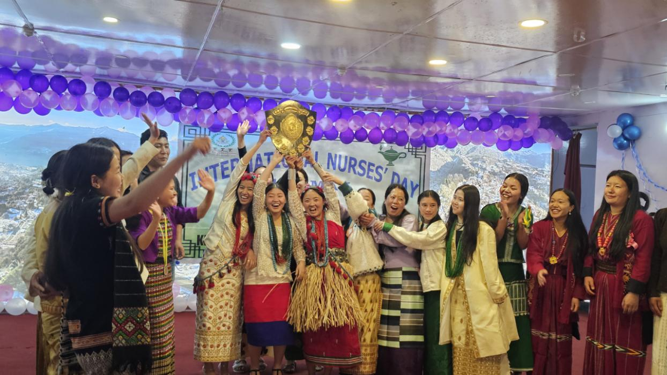
Tawang | 12 May 2025 — The Khandro Drowa Sangmo (KDS) Government ANM School, Tawang, celebrated International Nurses Day with enthusiasm and reverence at Zomkhang Hall, Tawang. The occasion was graced by Brigadier Bhupal Singh, Sena Medal, Commander of the Tawang Brigade, who attended as the Chief Guest.
The event began with the ceremonial lighting of candles by dignitaries and trainee nurses in front of a portrait of Florence Nightingale, symbolizing the solemn oath of sincerity and dedication to humanitarian service.

Distinguished Guests in Attendance:
Shri Taso Kato, Dy.SP, Tawang
Dr. Tenzin Kunga, Medical Superintendent, KDS District Hospital
Captain Srada Subash, Military Nursing Service (MNS)
Lady Inspector N. Angu, OC, Police Station Tawang
Members of the Women’s Welfare Association, Tawang
In his keynote address, Brigadier Bhupal Singh extended heartfelt wishes to all nurses and praised the students of KDS ANM School for their active participation in community activities.
“Nursing is a noble profession where a nurse’s healing touch eases suffering — a service often unnoticed but deeply valued by those in need,” he remarked. He encouraged the students to continue improving their skills in service to humanity.
Dy.SP Taso Kato highlighted the vital contribution of nurses, referring to them as the “backbone of the healthcare system” and “angels of mercy.” He added that “having a nurse in the family is a blessing.”

Special Address by Military Nursing Service
Captain Srada Subash, special invitee from MNS, shared insights on this year’s International Nurses Day theme:
“Our Nurses. Our Future. Caring for Nurses Strengthens Economies.”
She encouraged students to consider a career in Military Nursing and elaborated on the qualifications and recruitment process.

Remarks from Other Guests
Dr. Tenzin Kunga and Lham Chotten, representing the Women’s Welfare Association, expressed their deep appreciation for the commitment and compassion demonstrated by nurses.

Welcome and Cultural Highlights
The event began with a welcome address by Principal Thutan Sangmo, who extended best wishes and heartfelt thanks to all guests and participants.
The celebration featured vibrant cultural performances by the students and concluded with the distribution of prizes for various literary and sports activities held earlier as part of the Nurses Day observance.
