GOVERNOR’S SECRETARIAT
ARUNACHAL PRADESH
ITANAGAR

Press Communiqué
Dated May 12th, 2025

8th Edition Hangpan Dada Under 16 Football & Vollyball Boys & Girls Begins

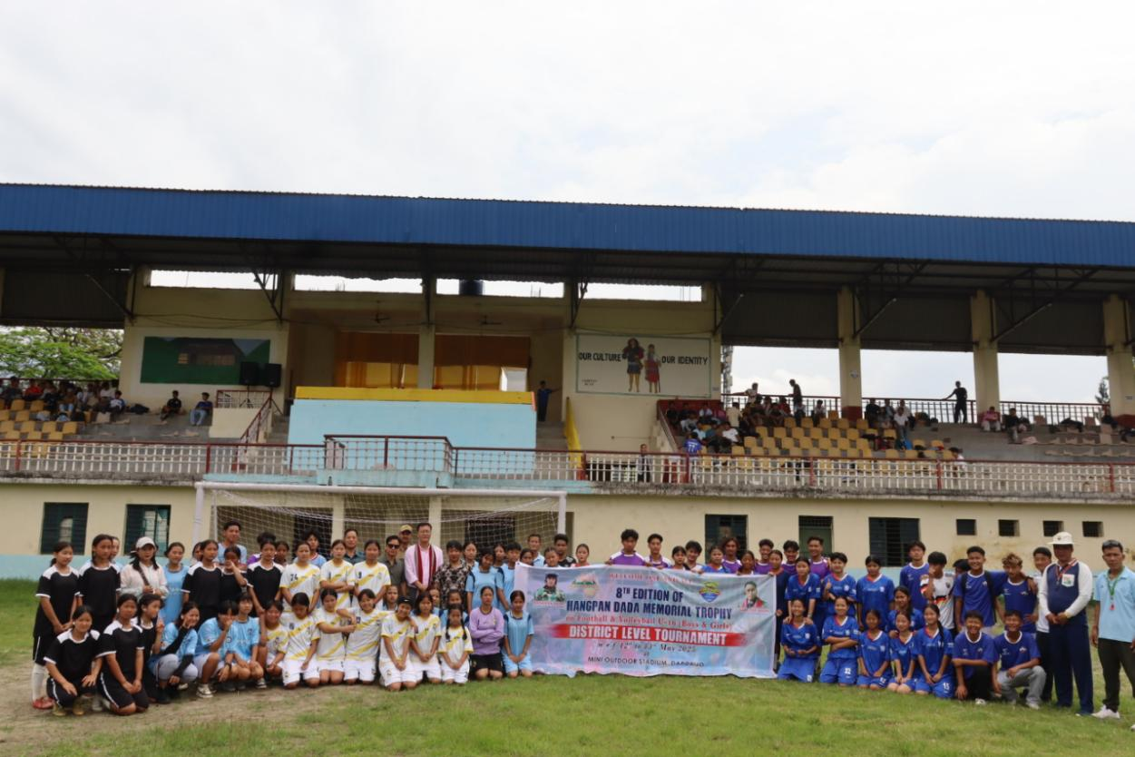
Daporijo 12/5/25, the 8th edition football & Vollyball Hangpan Dada tournament under 16 category boys & Girls begins here in Upper Subansiri.
Shri Tasso Gambo DC Upper Subansiri kick off the tournament here in Rijo Outdoor Mini Stadium,Daporijo.
Addressing the function Gambo stressed on game & sports events and urged to young talented players to come forward,so as to haunt a good players for the betterment of sports carrier he said.

Further, he urged the players to maintain good sport spirit and put his/ her best effort, to reach the goal for the interest of district and state as a whole.
Shri J.Jeram Dubi DSO, spoke well come address, said that he is doing his best effort adhering the directives and guidelines of government and would select the players based on performances with free & fair manner.
Shri Taw Ekke DACO, Shri Margo Hai APO and other officers and officials were attended during the innaugrual function.
