GOVERNOR’S SECRETARIAT
ARUNACHAL PRADESH
ITANAGAR

Press Communiqué
Dated May 12th, 2025

DCM Inaugurates Lungchaseng Buddha Vihara at Nampong during Poi-Lu-Chong cum Buddha Jayanti Celebration 2025

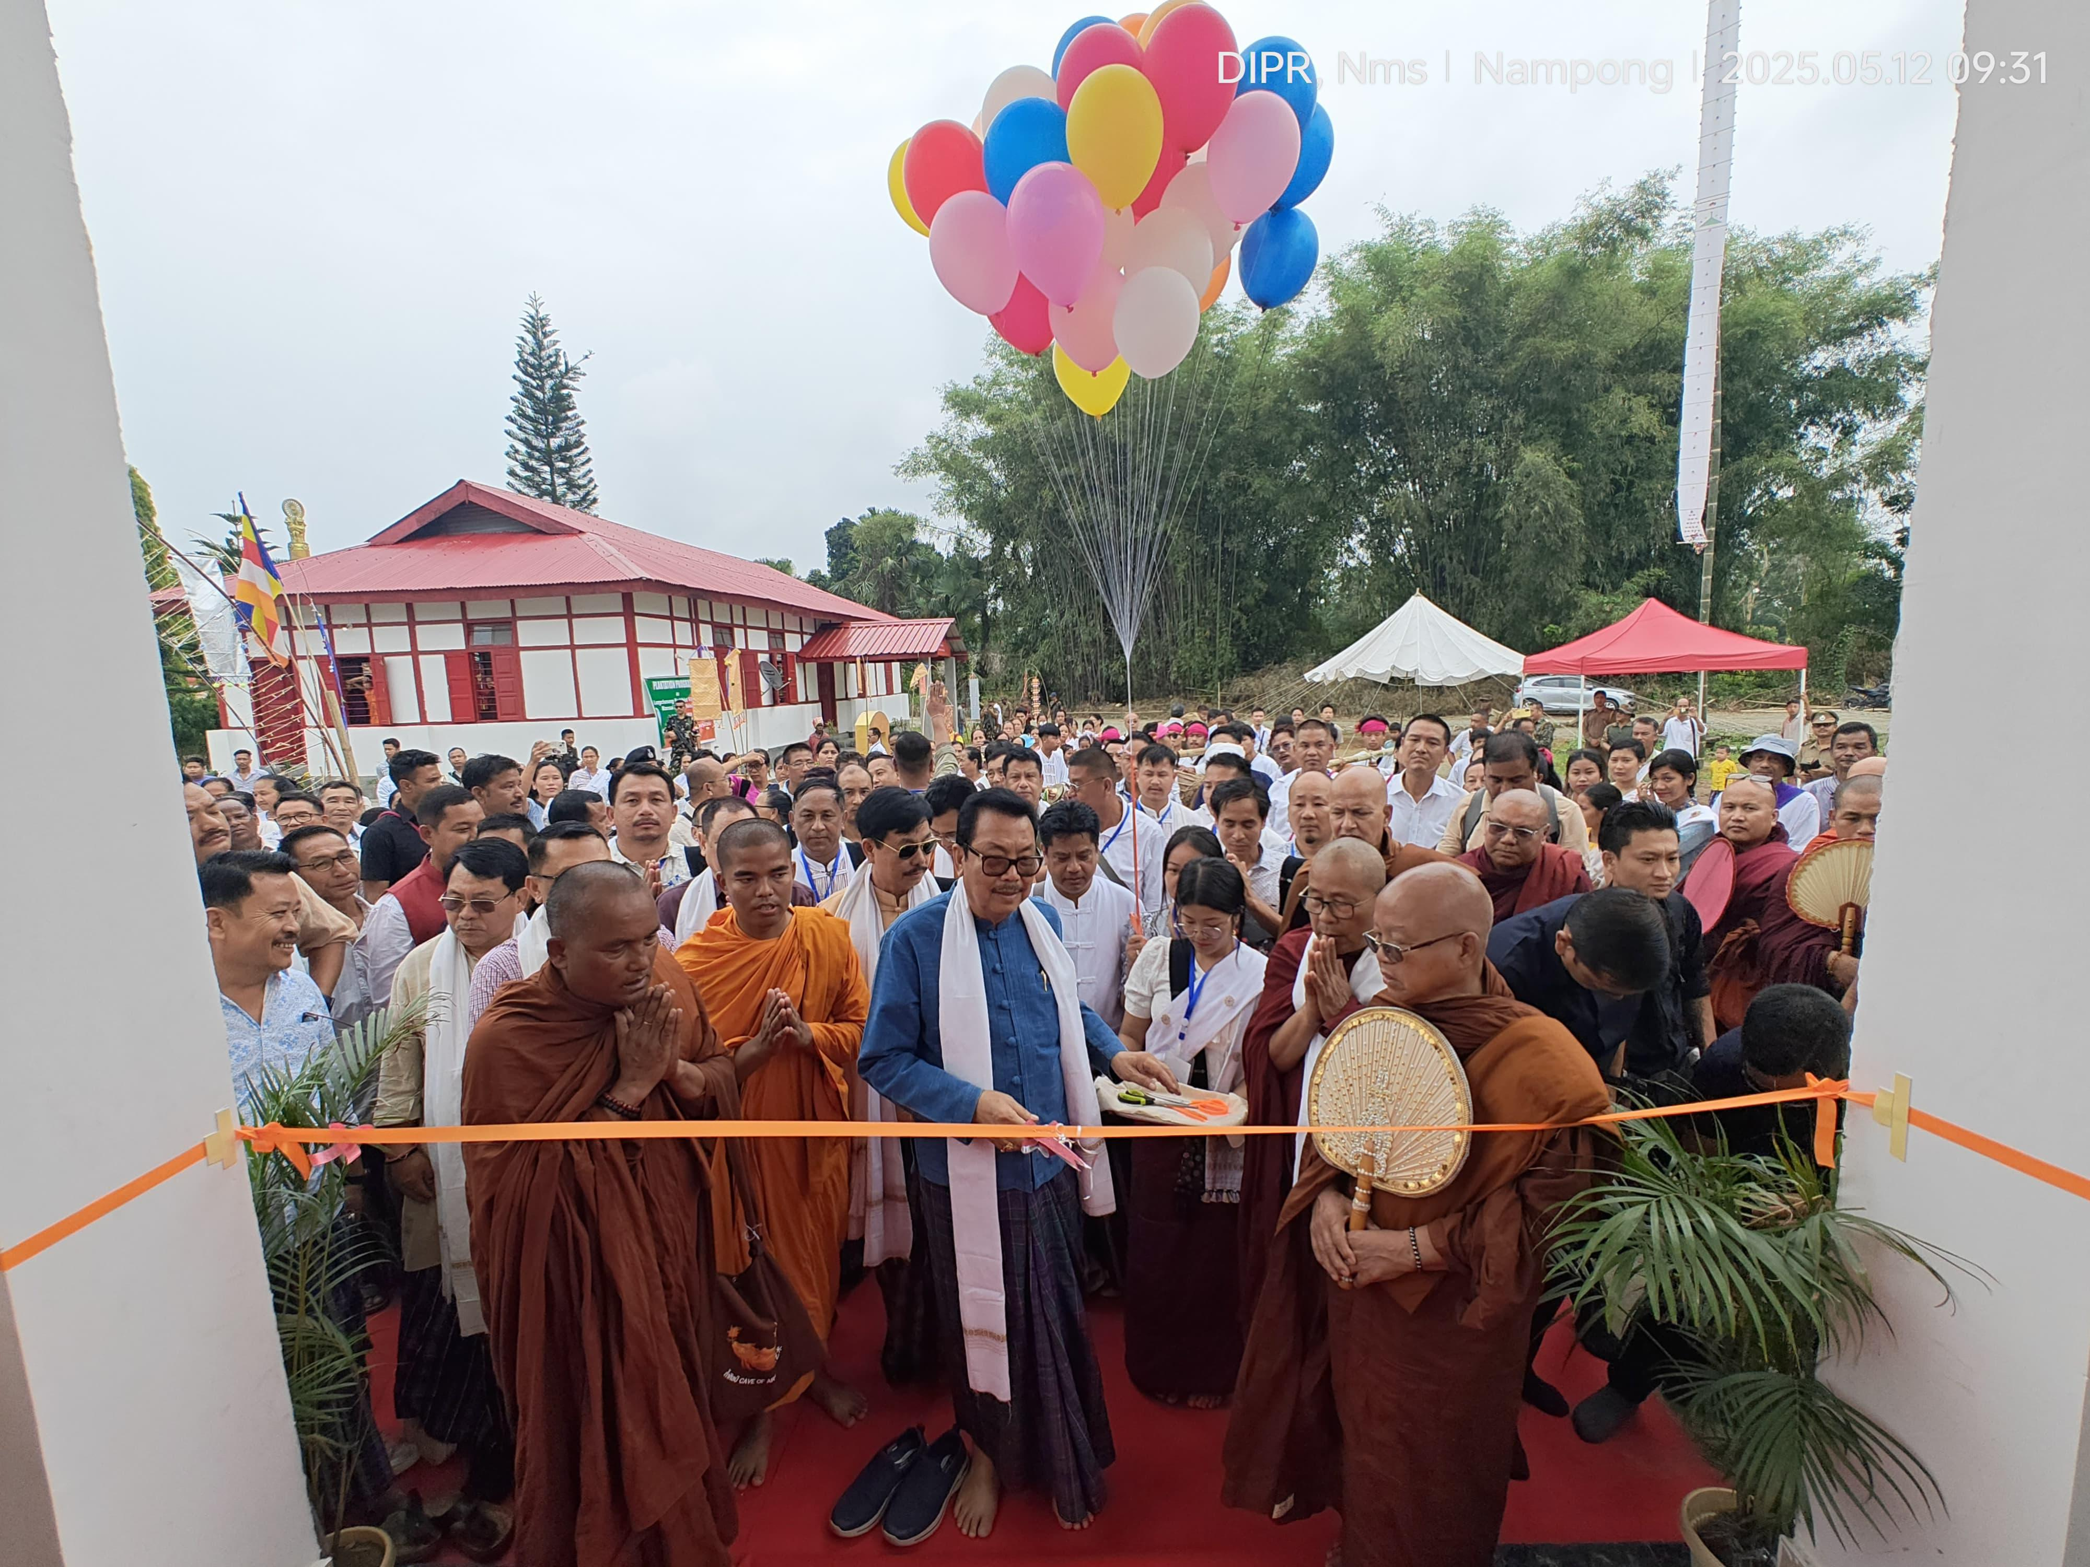
Namsai, May 12, 2025: Deputy Chief Minister, Chowna Mein participated in the 2025 Poi-Lu-Chong cum Buddha Jayanti Celebration held at Nampong village in Namsai district today. The vibrant celebrations reflected the deep spiritual and cultural ethos of the Buddhist community, bringing together devotees and dignitaries from across the region.

In his address, DCM emphasized the importance of preserving cultural heritage while fostering inclusive development. He stated, “Education is the foundation of empowerment. Without it, society remains in darkness. Let us invest in our youth, value the voices of both women and men, and build a society where all can grow together”.

On the auspicious occasion, Mein inaugurated the Lungchaseng Buddha Vihara, envisioned as a centre for spiritual growth, reflection, and communal harmony. A souvenir was also released to commemorate the occasion.

The day also marked the traditional Tang Thi Kongma procession, followed by devotional chanting, Dhamma discourses, and cultural presentations that highlighted the message of peace, harmony, and unity espoused by Lord Buddha.

Prominent attendees included MP Tapir Gao, Ministers Wangki Lowang and Biyuram Wahge, MLA Zingnu Namchoom, Ven. Udhaya Baadra, Ven. Kitisara Bhikkhu, Ven. Agga Dhamma (Herd Mont, Namsai Pariyati Sesinga Buddha Vihara), and revered members of Bhikku Sangha & others.
