GOVERNOR’S SECRETARIAT
ARUNACHAL PRADESH
ITANAGAR

Press Communiqué
Dated May 13th, 2025

CM Leads Tiranga Yatra at Walong Ahead of Historic Cabinet Sitting
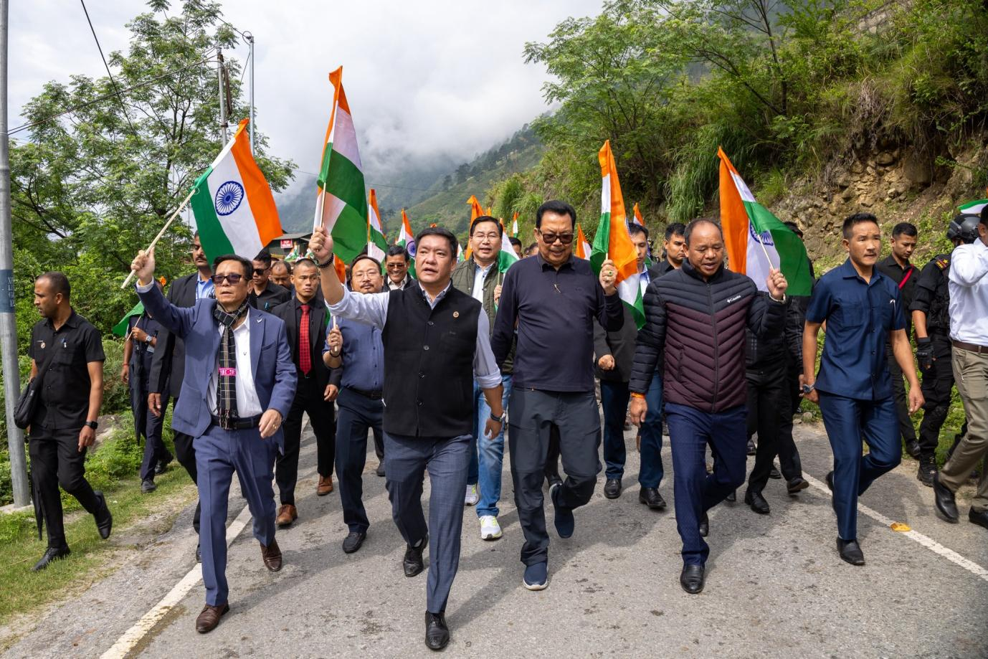
Walong, Anjaw District | May 13th 2025 — In a powerful display of patriotism and unity, Arunachal Pradesh Chief Minister Pema Khandu led the Tiranga Yatra at Walong, the easternmost frontier of India, ahead of the historic Cabinet Aapke Dwar session scheduled at Kibithoo. Accompanied by Cabinet colleagues, local leaders, personnel of the Indian Army, and members of the vibrant local community, the Chief Minister paid a heartfelt tribute to the spirit of nationalism and the sacrifices made in service of the nation.
“The patriotic fervour at Walong has rekindled our deep love for the country and reinforced our unwavering support for our brave defence forces,” said Chief Minister Khandu during the Yatra. The Tiranga Yatra culminated at the revered Walong War Memorial, a solemn site that commemorates the heroism of Indian soldiers who laid down their lives while defending the motherland during the 1962 India-China war. The Chief Minister and accompanying dignitaries offered floral tributes and observed a moment of silence in memory of the martyrs. “This sacred ground reminds us of the ultimate sacrifice made by our valiant jawans. Their courage and commitment to the nation must continue to inspire generations to come,” CM Khandu added. The event served not only as a remembrance of India’s military history but also as a reaffirmation of the people’s solidarity with the armed forces and the sovereignty of the nation.
