GOVERNOR’S SECRETARIAT
ARUNACHAL PRADESH
ITANAGAR

Press Communiqué
Dated May 13th, 2025

CM Chairs Historic Cabinet Sitting at Kibithoo –
India’s First Village
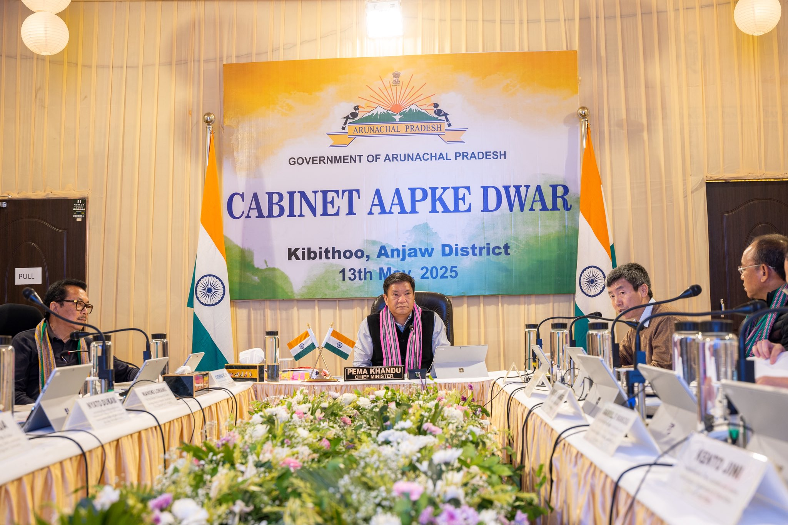
Kibithoo, Anjaw District | May 13, 2025 — In a landmark move aimed at bringing governance closer to the people, Chief Minister Pema Khandu chaired the historic sitting of the Arunachal Pradesh Cabinet under the initiative Cabinet Aapke Dwar at Kibithoo, India’s easternmost village in Anjaw district.
Joined by his Cabinet colleagues, the Chief Minister led deliberations on several key issues, with a strong focus on improving service delivery, strengthening departmental efficiency, enhancing state revenue, and accelerating the state’s self-reliance mission — Atmanirbhar Arunachal.
“This Cabinet sitting at Kibithoo symbolizes our commitment to inclusive governance. By reaching the remotest corners of our state, we aim to ensure that government decisions are informed by grassroots realities,” said Chief Minister Khandu.
The Cabinet Aapke Dwar initiative is part of the state government's broader effort to decentralize governance, engage directly with citizens, and take forward developmental priorities in line with local needs. Discussions at the session emphasized welfare-oriented policymaking and bolstering the administrative machinery to serve people more efficiently.
The historic meeting also reaffirmed the government’s resolve to empower border villages like Kibithoo through sustained investment in infrastructure, livelihood, and essential services.
This session of the Cabinet marks a significant step in Arunachal Pradesh’s governance journey and highlights the administration’s dedication to transparency, outreach, and inclusive development.
