GOVERNOR’S SECRETARIAT
ARUNACHAL PRADESH
ITANAGAR

Press Communiqué
Dated April 9th, 2025

Training on summary Revision for Panchayat Raj Election
held at Aalo
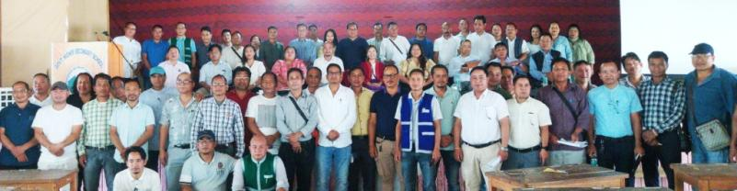
Aalo the 9th April 2025: The training and briefing session of summary revision for Panchayat Raj Election 2025 for two constituencies of West Siang 30 Aalo West and 31st Aalo East Assembly constituencies was conducted at Govt Hr Sec School Jubilee Hall here at Aalo on 9th April 2025. The training programme was conducted by District Election Officer West Siang.
Shri Koj Tacho EAC welcome all the officers and highlighted about the summary revision. He informed all the designated Officers, AERO's, ERO's to prepare the summary revision error free E-rolls.
Smty Mabi Taipodia ADC cum Dy.DEO (PR) highlighted the Arunachal Pradesh Panchayat Raj Act 1997and on preparation of summary revision and preparation of E-Rolls.
She informed that the schedule of summary Revision Programme 2025 as
1. Draft Publication of Electoral Rolls on 17th April 2025.
2. Period of filling of claims and objection 17th April to 8 May 2025
3. Reading of relevant part/section of electoral rolls in Gram Sabha 19th April to 21st April 2025.
4. Special Campaign date with booth level agent of all political parties for receiving claims and objection - 24th April 2025 to 25 April 2025
5. Disposal of claims and objection - 8th May 2025 to 29th May 2025.
6. Preparation and printing of supplementary list - 10th June 2025.
7. Final Publication of Electoral rolls- 16th June 2025.
She further informed the designated Officers to prepare one voters in one constituency and cross check the double entry voters during the preparation of summary revision.
Shri Tamo Riba ADC Kamba highlighted duties and responsibilities of EROs/AEROs/Designated Officers. He urged the officers to complete the process in time.
Ms Mamu Hage, IAS, DC West Siang cum DEO informed the EROs, AEROs, and Designated Officers that state Election Commission is going to conduct the PR Election 2025, for this update of E-Rolls is required. The PR E-Roll which was prepared 5 years back needs revision. She informed the Designated Officers to follow the time line. While preparing summary Revision, ensured transparency, coordination and fairness she said. Senior Citizens, transgender and other to be take care while preparing the summary revision.
The PR Election training was attended by DC cum DEO West Siang Ms Mamu Hage IAS, Smty Mabi Taipodia ADC cum Dy DEO, Shri Tamo Riba ADC Kamba, EROs, AERO's and Designated Officers. Around 80 Officers and Officials participated during the training programme.

