GOVERNOR’S SECRETARIAT
ARUNACHAL PRADESH
ITANAGAR

Press Communiqué
Dated April 9th, 2025

SHAURYA DIWAS CELEBRATED BY 36 Bn CRPF AT KHONSA
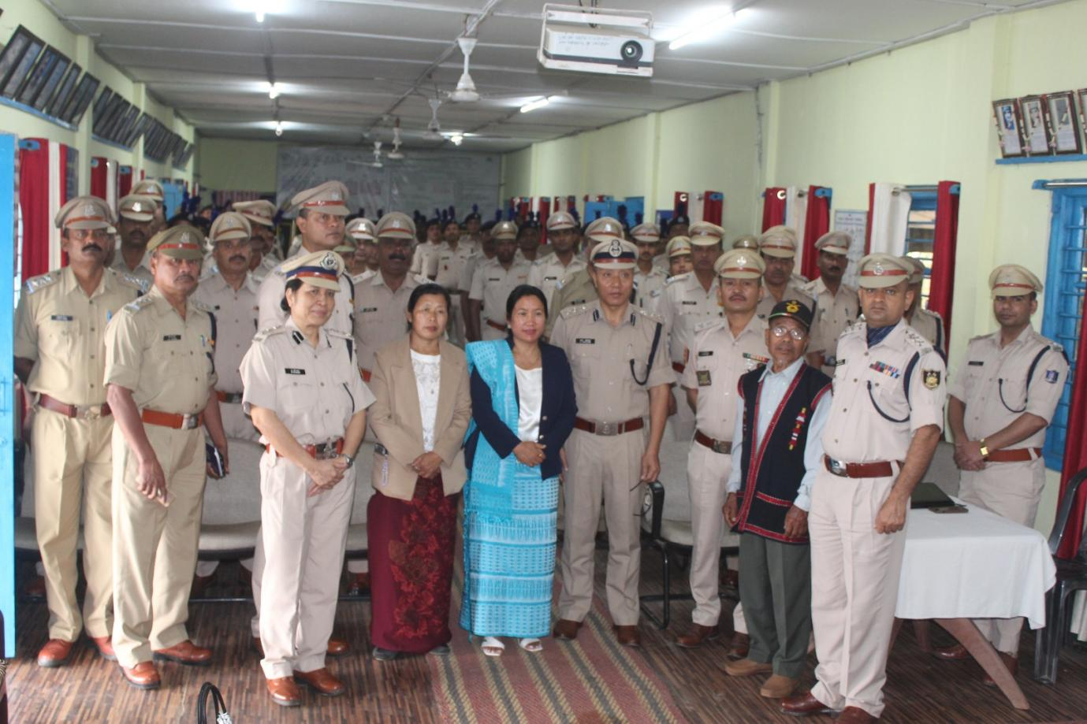
Khonsa, 9th April 2025: Shaurya Diwas, also known as Valour Day, was celebrated by the 36 Bn CRPF at Khonsa, in unison with the rest of the country. Observed every year on 9th April, the day commemorates the brave force personnel courage, patriotism, and supreme sacrifice of our brave forces personnel—especially the soldiers who stand fearless in the face of danger to protect the motherland, India.

On this solemn occasion, Shri L. Lhoujem, Commandant, 36 Bn CRPF, felicitated Veer Nari Chasan Dada, wife of Martyr Hangpan Dada, Ashok Chakra (Posthumously), of 3 Para SF, Assam Regiment, and the father of Martyr Hugu Chimyang of 4 Assam Regiment, with traditional shawls as a mark of honour and respect.

A floral tributes was conducted at the Martyr’s memorial where Commandant Lhoujem addressed the troops. He highlighted the gallant actions of the brave hearts during the battle at Sardar and Tak Post, reminding all personnel of their heroic legacy and inspiring them to uphold the same spirit of dedication and valour.
