GOVERNOR’S SECRETARIAT
ARUNACHAL PRADESH
ITANAGAR

Press Communiqué
Dated April 9th, 2025

Drug Abuse Awareness Programme Conducted for Balijan Block School Students
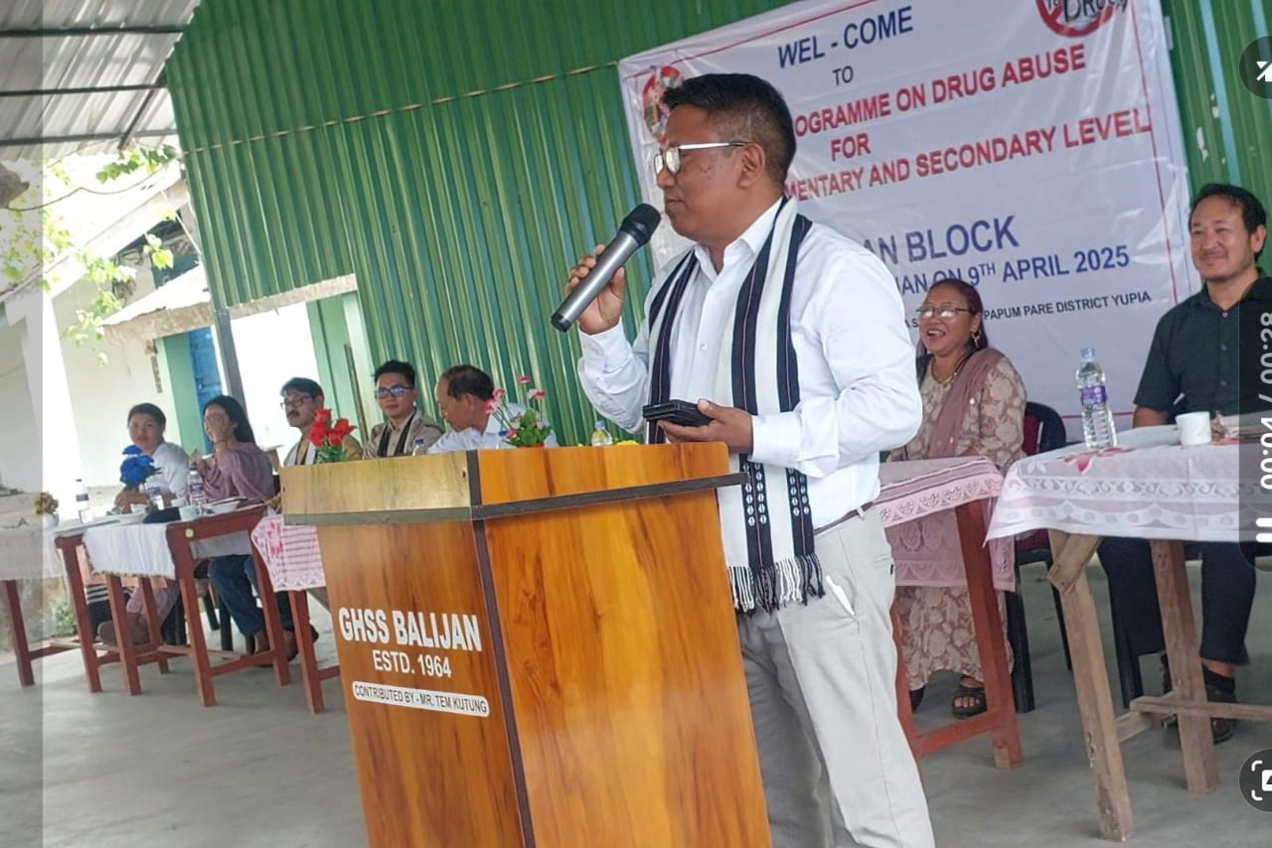
The Department of Education, Papum Pare District, under the Samagra Shiksha (ISSE) scheme, organized a Drug Abuse Awareness Programme on 9th April 2025 at Government Higher Secondary School, Balijan. The initiative targeted elementary and secondary school students in the Balijan Block to raise awareness about drug abuse, its harmful impacts, and prevention strategies.

The event was graced by Shri Jiken Bomjen, Deputy Commissioner of Papum Pare District (Rural), who urged students and other stakeholders to stay away from drugs, emphasizing that drug abuse not only destroys individuals but also weakens society. He encouraged the younger generation to embrace the principle of “Say No to Drugs” and to value their lives as future citizens of the nation.

Expert insights were shared by resource persons Shri Tasa Diri from the Police Department and Dr. Gekar Loyi from the Health Department. They elaborated on the various types of drugs, their sources, and the devastating impacts of addiction. The speakers also emphasized the importance of education and awareness programs in combating drug abuse and fostering a drug-free community.

The programme witnessed active participation from several dignitaries, including the Smt. Tem Pika, Zilla Parishad Member (ZPM) of Balijan, the District Deputy Director of Education (DDSE) Papum Pare Shri T.T.Tara, school principals, headmasters, Block Resource Center Coordinators (BRCCs), Cluster Resource Center Coordinators (CRCCs), teachers, and a large number of students.

This collective effort highlights the commitment of the community to ensure a brighter, drug-free future for its youth.

