GOVERNOR’S SECRETARIAT
ARUNACHAL PRADESH
ITANAGAR

Press Communiqué
Dated Apr 18th, 2025

Regional Workshop on Strengthening Farmer Producer Organisations Held in Tawang
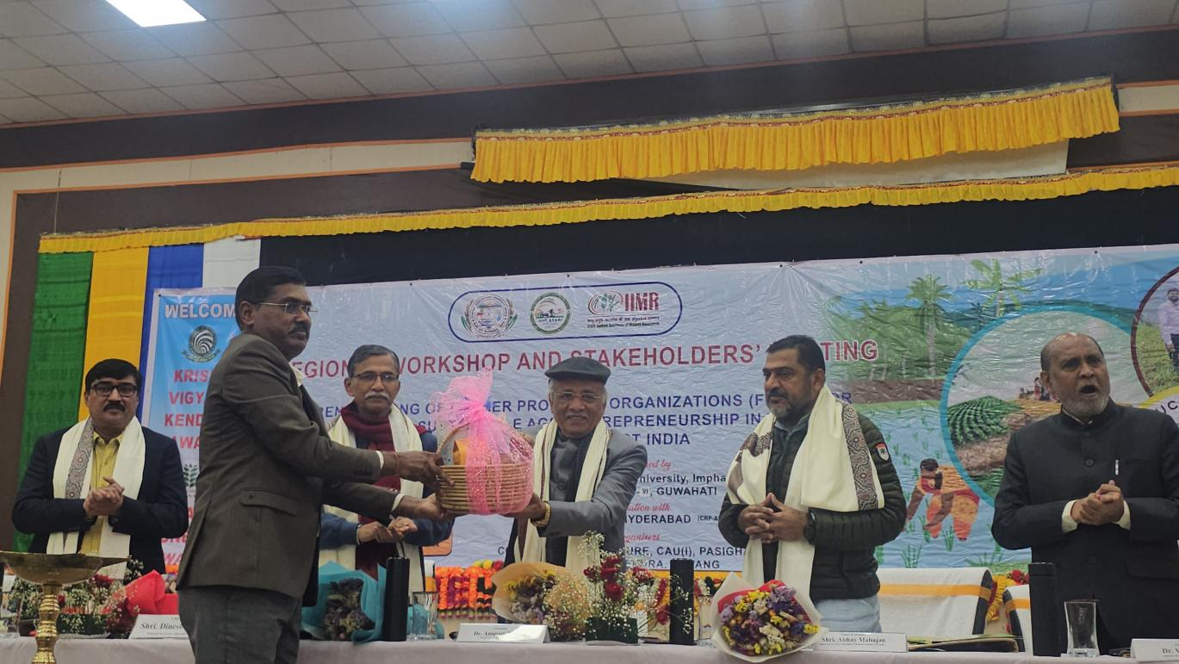
Tawang 18/04/2025 : A two-day Regional Workshop and Stakeholders Meeting on "Strengthening Farmer Producer Organisations (FPOs) for Efficient and Sustainable Agricultural Entrepreneurship in Vibrant Villages of North East India" commenced today at Kalawangpo Convention Hall, Tawang. The event is being jointly organized by Central Agricultural University (CAU), Imphal and ICAR-ATARI Zone VI, Guwahati, in collaboration with ICAR-IIMR Hyderabad. The local coordination has been undertaken by the College of Agriculture, Pasighat and Krishi Vigyan Kendra (KVK), Tawang.
The workshop was inaugurated by Dinesh

Kulkarni, National Organising Secretary of Bharatiya Kisan Sangh, who graced the occasion as Chief Guest. The event also witnessed the presence of eminent dignitaries including Dr. Anupam Mishra, Vice Chancellor, CAU Imphal; Dr. Rajbir Singh, Deputy Director General, ICAR, New Delhi; Ullas Kulkarni, Chhetra Pracharak for the NE Region and National Executive Member, RSS; Abhay Mahajan, Organising Secretary, Deen Dayal Research Institute, New Delhi; Dr. G. Kadirvel, Director, ICAR-ATARI Zone VI; and Deewan Mara, Circle Officer, Jemeithang, representing the Deputy Commissioner of Tawang.
A key highlight of the inaugural session was the official launch of the 'ARUNKISAN' App, a first-of-its-kind Android-based mobile application designed specifically for farmers in Arunachal Pradesh. Developed by a team of faculty members from Central Agricultural Universities including Dr. Senpon Ngomle and Dr. Y. Disco Singh, the app aims to bridge critical information gaps faced by farmers in remote border villages. Funded by the National Mission on Himalayan Studies, the app will empower farmers with timely agricultural knowledge to promote sustainable and resource-efficient farming practices.
In his presidential address, Dr. Anupam Mishra praised the natural wealth of Arunachal Pradesh, noting its unmatched environmental quality and the cultivation of high-value crops not found in other states. He highlighted the state's pioneering efforts, such as its own agricultural trading portal, and emphasized ongoing government initiatives to enhance storage infrastructure and road connectivity.
Dinesh Kulkarni, in his keynote speech, appreciated the improved infrastructure developments in Tawang, especially the Sela Tunnel, which ensures year-round connectivity. He also acknowledged the region's rich cultural and agricultural heritage, referencing his visit to the Tawang Monastery.
Other notable speakers included Ullas Kulkarni, Abhay Mahajan, and Dr. G. Kadirvel, who addressed the importance of community-driven agricultural development and the role of FPOs in uplifting rural economies.
As part of the event, Tawang Green Farmers Producer Company presented their packaged agricultural products to dignitaries as mementoes. The inaugural day concluded with a visit to exhibition stalls by various FPOs from across Arunachal Pradesh, followed by an interaction session chaired by Dr. Rajbir Singh, facilitating direct dialogue between stakeholders and farmer groups.
The workshop is expected to pave the way for enhanced collaboration, capacity building, and policy alignment to support sustainable agricultural entrepreneurship in the North East region.
