GOVERNOR’S SECRETARIAT
ARUNACHAL PRADESH
ITANAGAR

Press Communiqué
Dated Apr 18th, 2025

CM Pema Khandu Inaugurates 4th Arunachal State Games 2025, Unveils Major Sports Infrastructure Plans
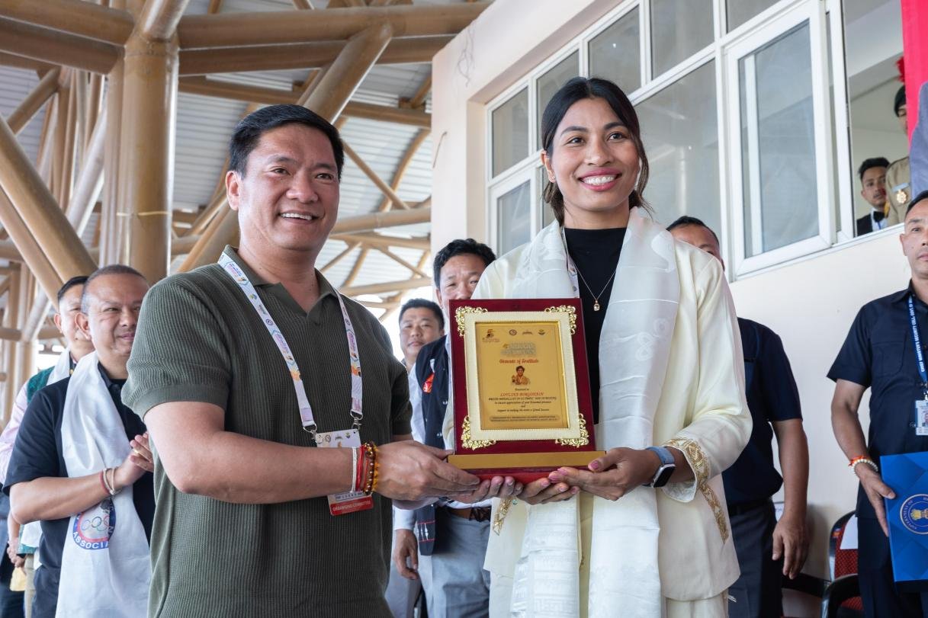
Chief Minister Pema Khandu this evening declared open the 4th Arunachal State Games 2025 in a glittering opening ceremony held at the Golden Jubilee Stadium here. Conveying best wishes to the athletes from across the state, Khandu lauded the dedication and hard work put in by them that has risen Arunachal Pradesh as one of the best sporting state in recent years.
“Arunachal Pradesh has recorded one of its best performances at the recently concluded 38th National Games, standing 2nd in the Northeast, with our sportspersons winning 13 medals at this prestigious event. As we strive for excellence, we are committed to intensify our efforts to secure a top 10 rank at the upcoming 39th National Games to be held in Meghalaya,” he said.
Khandu assured that the state government is committed to provide every facility to the state’s athletes so that they can excel in their chosen fields at national and international levels. He informed that under the ‘Mission Olympics’ being implemented by the state government provisions have been kept to provide quality training to athletes in top-notch training centers in the country. “If necessary, we will send our athletes to other countries offering best training facilities,” he said.

Terming sports infrastructure as one of the most important need for sportspersons to hone their talents, Khandu said that several quality stadiums have been constructed in recent years across the state including the Golden Jubilee Stadium of Yupia. He informed that the government has approved and construction of new stadiums would begin soon stadiums in Lower Dibang Valley, Lower Siang, Pakke Kessang and Longding districts. “Hosting the 77th Santosh Trophy finals at this very ground was a significant step forward in the state’s sports history. We are now going to host the South Asian Football Federation U-19 Championship 2025 next month. Just a few years ago this would have been just a dream,” he remarked.

Giving another boost the sports infrastructure in the state, Khandu informed that a new world-class stadium with 25000 capacity will come up in near future within the state capital. “We have already identified the site and construction will begin soon,” he added. The opening ceremony was also attended by Olympic Bronze medallist Lovlina Borgohain, Sports Minister Kento Jini, Advisor Zignu Namchoom, Itanagar legislator Techi Kaso, IMC Mayor Tame Phassang, BJP State President Kaling Moyong and the hosts Arunachal Olympic Association (AOA) President Taba Tedir, Secretary General Bamang Tago, officials and others.
