GOVERNOR’S SECRETARIAT
ARUNACHAL PRADESH
ITANAGAR

Press Communiqué
Dated Apr 17th, 2025

Deputy Chief Minister Chairs Review Meeting on Strengthening Transmission & Distribution System in Arunachal Pradesh
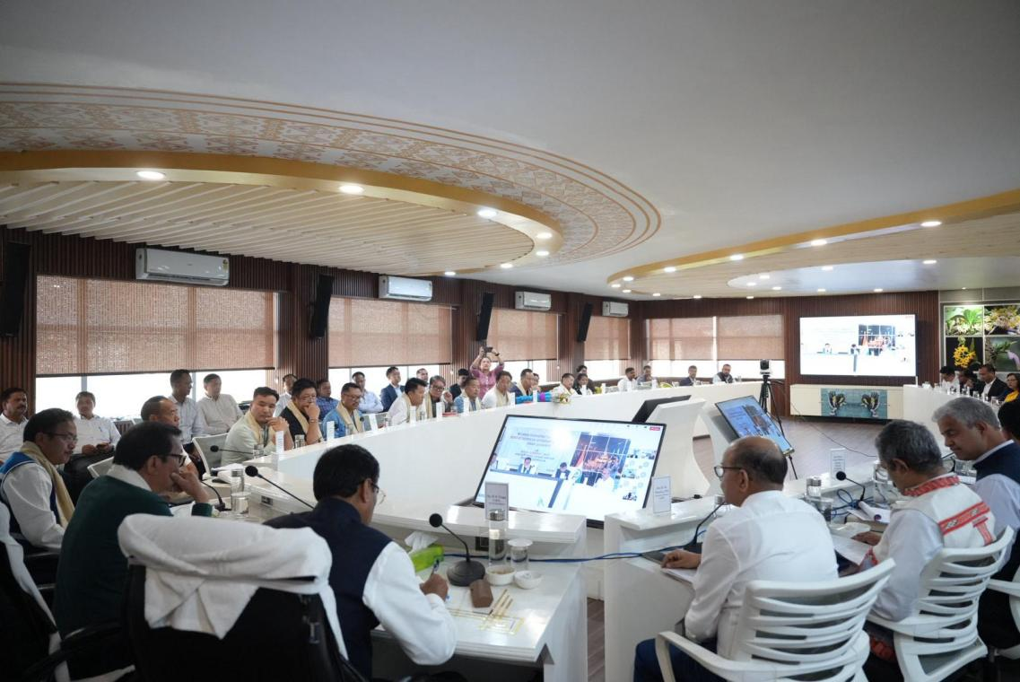
NAMSAI, April 17: Deputy Chief Minister of Arunachal Pradesh, Chowna Mein, chaired a high-level review meeting on the Comprehensive Scheme for Strengthening the Transmission and Distribution (T&D) System at the DC’s Conference Hall in Namsai today.
The 5 hours long meeting which began at 3 PM had ended on 8:30 PM after a detailed discussions on the implementation of Comprehensive Scheme for Strengthening the Transmission and Distribution System across the State as the scheme plays a crucial role in ensuring reliable and efficient power supply, particularly in remote and underserved regions. During the meeting, the Deputy Chief Minister reviewed the current status of the project, took stock of the progress and enquired about the reasons for delay. He underscored the importance of timely and coordinated approach for smooth implementation of the project to meet the State’s growing power demands.
Highlighting the government’s focus on the power sector, Deputy Chief Minister Mein stated, “In recent years, we have significantly accelerated the development of the power sector in Arunachal Pradesh. Recently, under the chairmanship of Chief Minister Pema Khandu, the Power Steering Committee held a meaningful discussion at Tawang to expedite development of hydropower projects in the State.”
He emphasized the need for a robust transmission and distribution network to complement the State’s upcoming hydropower projects.
“With several hydropower projects underway, it is vital that our Transmission and Distribution infrastructure is ready for immediate power evacuation and distribution. He said that the meeting was convened to resolve the pending issues in the implementation of this comprehensive scheme”, he said. He has asked PGCIL to expedite all remaining works and ensure timely completion of the Comprehensive Scheme for Strengthening the Transmission and Distribution (T&D) System.
He also urged the PGCIL to maintain close coordination with the District Administration and Power Department taking into confidence the local legislator for smooth and effective on-ground execution.
The meeting reaffirmed the government’s commitment to strengthening Arunachal Pradesh’s power infrastructure—laying a strong foundation for sustainable growth, energy security, and enhanced quality of life for all citizens.
It was informed that three crucial projects under the Comprehensive scheme, namely, 33 kV side of the 132 kV Niglok Sub-station, the 33 kV Niglok–Ruskin Line, and the 33 kV Oyan Sub-station were successfully commissioned today.
The meeting was attended by Minister Gabriel D. Wangsu, Deputy Speaker, Kardo Nyigyor, Advisor to Minister (Power), Jikke Tako, MLAs Chau Zingnu Namchoom, Mutchu Mithi, Hayeng Mangfi, Tenzin Nyima Glow, Tseten Chombay, Topin Ete, Pesi Jilen, Rotom Tebin, Nyabi Jini Dirchi, CMD PGCIL, R K Tyagi, PCCF P Subramanium, Advisor to DCM, Anupam Tangu, Secretary (Power), R K Sharma, DCs, Chief Engineers (Power) and Senior Officials from PowerGrid.
