GOVERNOR’S SECRETARIAT
ARUNACHAL PRADESH
ITANAGAR

Press Communiqué
Dated Apr 17th, 2025

Arunachal Pradesh to Launch Annual State Event for Children with Special Needs: WCD Minister Dasanglu Pul
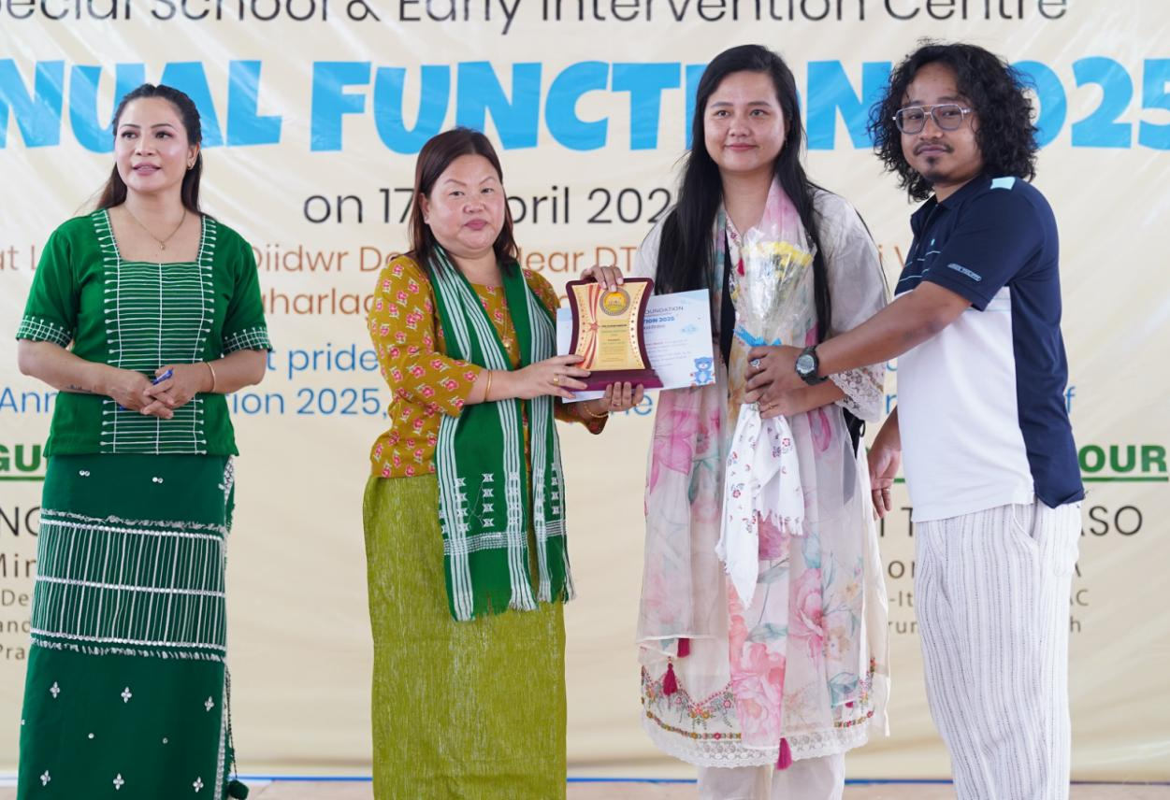

NAHARLAGUN 17 April : Women and Child Development minister Dasanglu Pul on Thursday announced that the Arunachal Pradesh government is considering instituting an annual calendar event dedicated to children with special needs.
The announcement was made at the annual function of April Blossom Foundation – Special School & Early Intervention Centre – held at its campus in Lekhi Village. The event was attended by students, parents, caregivers, educators, and local dignitaries, including Itanagar MLA Techi Kaso, who graced the occasion as guest of honour.
Pul said the proposed state-level platform, approved by Chief Minister Pema Khandu, would serve to celebrate the unique talents and journeys of differently-abled children while also drawing policy attention to their needs. The event, she added, will be institutionalised soon. Highlighting the importance of early intervention, awareness, and emotional support, Pul urged parents not to lose hope. “Don’t give up on your children. With the right care, encouragement, and belief, they can overcome barriers and reach their full potential,” she said. She lauded the April Blossom Foundation for its commitment to nurturing children with developmental and physical challenges in an inclusive and compassionate environment.
MLA Kaso, in his address, expressed appreciation for the efforts of educators and caregivers at the Foundation, and called for greater collaboration between government bodies, civil society, and families to create a more inclusive social fabric. Founded with the mission of early support and specialized education, the April Blossom Foundation, led by chairperson Binde Jini, currently caters to around 30 children. It has emerged as a key institution in the state in empowering children with special needs.
