GOVERNOR’S SECRETARIAT
ARUNACHAL PRADESH
ITANAGAR

Press Communiqué

Dated Apr 16th, 2025

Tourism Development Meeting Held in Tezu
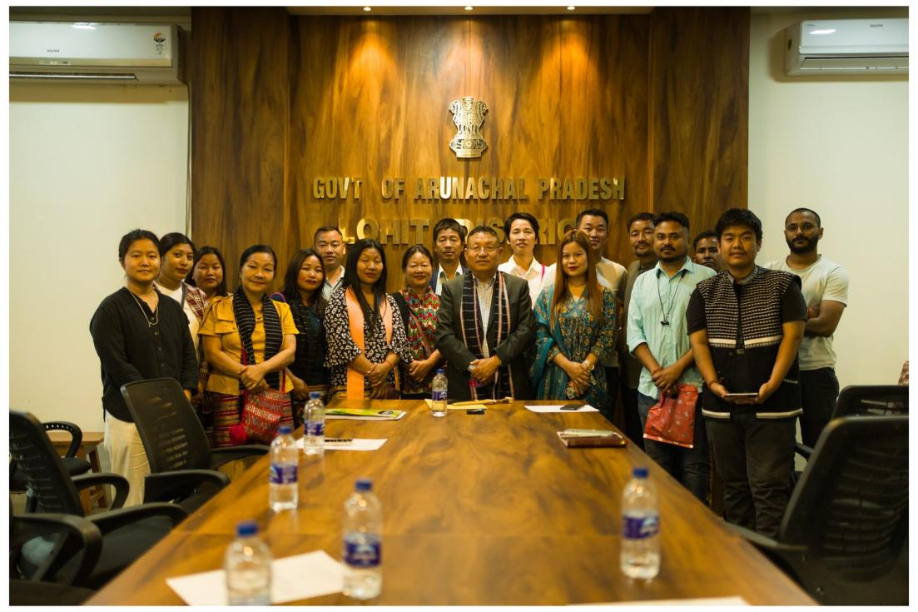

Tezu the 16th April 2025 : A meeting focused on the development of tourism in Lohit District was held today at the Deputy Commissioner’s Conference Hall, Tezu. The session was organized by the Dibroo Catherine Boo the District Tourism Officer, Lohit, and chaired by Shri Kesang Ngurup Damo, Deputy Commissioner, Lohit District.

The meeting saw enthusiastic participation from tourism stakeholders across the district, including homestay owners, hoteliers, resort operators, and tour operators.

In his address, the Deputy Commissioner underscored the vast potential of tourism in Lohit District and emphasized that its growth must be community-driven, inclusive, and sustainable. He urged stakeholders to proactively develop unique tourism experiences, drawing inspiration from models like Tawang, which is currently experiencing full tourist occupancy.

Key Highlights of the Discussion:
Active participation in the upcoming CCC, Tezu event, featuring Mishmi cuisines and cultural stalls
Promotion of vegetable gardens, wildlife and nature experiences, and other immersive rural tourism offerings
Video documentation of successful homestay stories to inspire and promote community-based tourism
Stakeholder Concerns & Suggestions:
Participants voiced the need for:

Empowerment of local tour guides through structured training and integration into tourism activities
Conservation of biodiversity, including local wildlife, flora, and fauna, as an integral part of eco-tourism
A strong emphasis was laid on cultural tourism rooted in Mishmi traditions, positioning it as a key pillar of Lohit’s tourism identity. The meeting encouraged the participation of local youth and women in offering authentic cultural experiences—including storytelling, Mishmi cuisine, traditional handicrafts, and homestay hospitality.

Stakeholders also noted the potential to thoughtfully integrate spiritual and heritage-based experiences into the district’s tourism offering.

