GOVERNOR’S SECRETARIAT
ARUNACHAL PRADESH
ITANAGAR

Press Communiqué
Dated Apr 28th, 2025

Deputy Commissioner Reviewed functioning of the District Level NCORD Committee

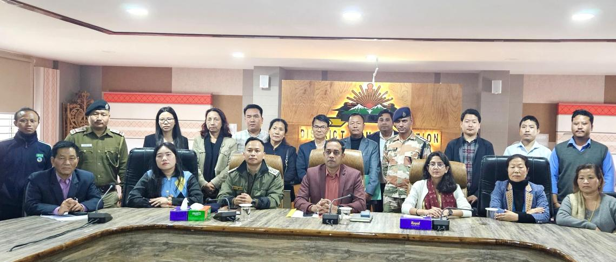

Secretariat Building, Ziro the 28th April, 2025 : Shri Vivek H.P, IAS, Deputy Commissioner of Lower Subansiri District has chaired the 8th District Level NCORD Committee Review Meeting in the presence of other members, CBOs and NGOs of the District at Secretariat Building, Ziro on Monday, 28th April, 2025. He appreciated the District Police for their relentless efforts to curb the drugs menace and further stressed on continuous joint & concerted efforts of all stakeholders to address the narcotics threat in the valley.
Shri Ojing Lego, Deputy Superintendent of Police, Lower Subansiri District has informed that the District Police has registered six (06) Narcotic Drugs and Psychotropic Substances (NDPS) cases and arrested ten (10) persons involved in the drugs related crime. Also, he displayed suspected heroin and cannabis prevalent in the district to other members present in the meeting to enable them identify banned narcotic substances.

