GOVERNOR’S SECRETARIAT
ARUNACHAL PRADESH
ITANAGAR

Press Communiqué
Dated Apr 28th, 2025

First Quarter District Level Monitoring Committee meeting held

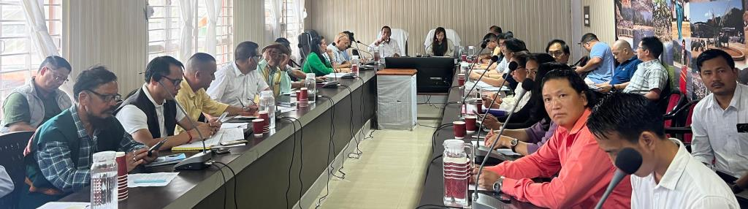

Aalo the 28th April 2025: First Quarter DLMC review meeting for the Financial Year 2025-26 was held under the chairmanship of Ms Mamu Hage IAS Deputy Commissioner West Siang District here at DC Conference Hall Aalo on 28th April 2025. The DLMC meeting is held to review the progress of project being implemented under CSS, SSS, and PM and CM flagships programme.
DC urged the department to prepare the specific action plan with timeline setup of the target being set up by the Govt to each departments. She directs all departments to submit a copy of updated achievements of each lien department immediately in order to reflect it in quarterly report format. After constant monitoring of all the projects being implementing in the district, she urged the health, education and urban departments to put more effort in achieving the targets.
ZPC West Siang Shri Tumpe Ete has also attended the meeting and lauded all department to work shoulder to shoulder with panchayat members to outreach the govt schemes/projects at rural level.
The meeting was attended by administrative Officers, HoD’s and other key stakeholders.
