GOVERNOR’S SECRETARIAT
ARUNACHAL PRADESH
ITANAGAR

Press Communiqué
Dated Apr 28th, 2025

National Youth Exposure Programme 2025 Inaugurated in Tawang

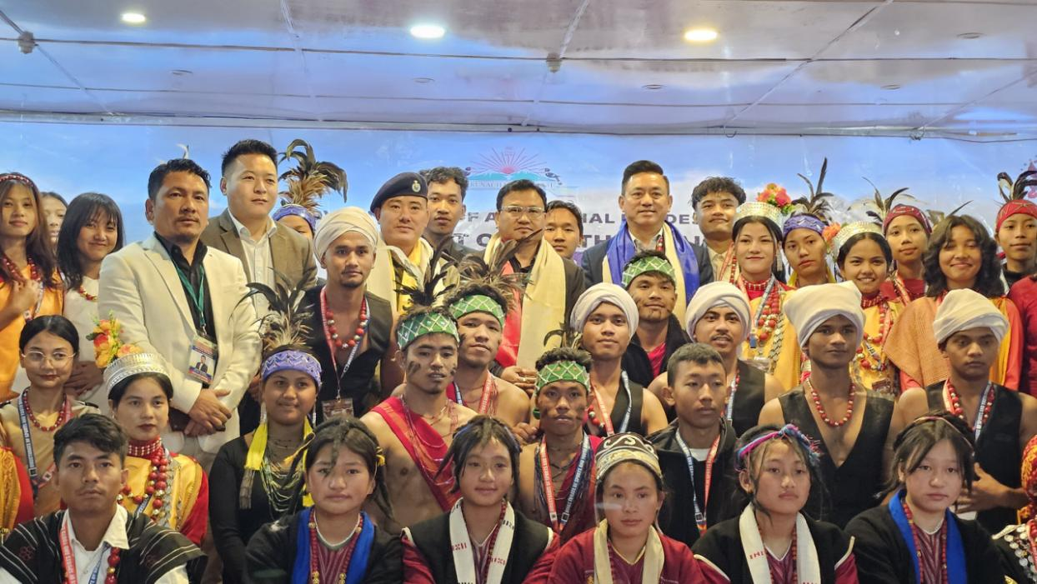
Tawang, 28/04/2025 : A group of 66 enthusiastic participants along with over 10 officials from Meghalaya are currently participating in the National Youth Exposure Programme 2025 being held in Tawang from 27th to 30th April. The programme is organized by the Directorate of Sports and Youth Affairs, Government of Meghalaya, in collaboration with the Department of Youth Affairs, Government of Arunachal Pradesh.
The inaugural ceremony took place this morning at Zomkhang Hall, Tawang, and was graced by Deputy Commissioner, Tawang, Kanki Darang, as the Chief Guest. Also present were Dr. D.W. Thongon, Superintendent of Police, Tawang; Bobby Wahlong, Youth Coordinator, Directorate of Sports and Youth Affairs, Meghalaya; Satrughan Gungli, Assistant Nodal Officer (Event) and In-charge Adventure Cell, Directorate of Youth Affairs, Arunachal Pradesh; Sange Tsering, District Sports Officer, Tawang, and other distinguished guests.
In his inaugural address, DC Kanki Darang spoke passionately about the beauty and diversity of Arunachal Pradesh, highlighting that the state is home to 26 major tribes and over 100 sub-tribes living harmoniously. Emphasizing the theme of unity in diversity, he encouraged the youth to embrace hard work and sincerity, reminding them that there is no substitute for dedication. He called upon the participants to strive to become good human beings and contribute positively to society.
SP Tawang, Dr. D.W. Thongon, provided the participants with insights into the rich history, culture, and strategic significance of Tawang. He urged the youth to stay away from anti-social activities, particularly drug abuse, quoting Swami Vivekananda on the vital role of youth in nation-building.
Earlier, Youth Coordinator Bobby Wahlong outlined the objectives of the National Youth Exposure Programme, expressing gratitude to the Government of Meghalaya for sponsoring the initiative. He noted that the programme, which began in 2014, has provided a platform for over ten thousand youths from Meghalaya to explore different parts of the country and experience India's diverse culture. He also extended heartfelt thanks to the Government of Arunachal Pradesh and invited participants to visit Meghalaya in the future.
Participants from Meghalaya and Arunachal Pradesh, including NSS volunteers from Dorjee Khandu Government College, Tawang, and members of Nehru Yuva Kendra, Tawang, enriched the inaugural function with vibrant cultural performances showcasing the traditional songs and dances of the Garo, Khasi, and Monpa tribes.
DSO Tawang Sange Tsering and Assistant Nodal Officer Satrughan Gungli also addressed the gathering, motivating the youth and stressing the importance of such exposure programmes for fostering national integration and personal growth. The National Youth Exposure Programme 2025 promises an enriching experience for all participants, offering them a unique opportunity to connect, learn, and celebrate the spirit of India's unity in diversity.
