GOVERNOR’S SECRETARIAT
ARUNACHAL PRADESH
ITANAGAR

Press Communiqué
Dated Apr 28th, 2025

Governor inaugurates Autism Awareness programme
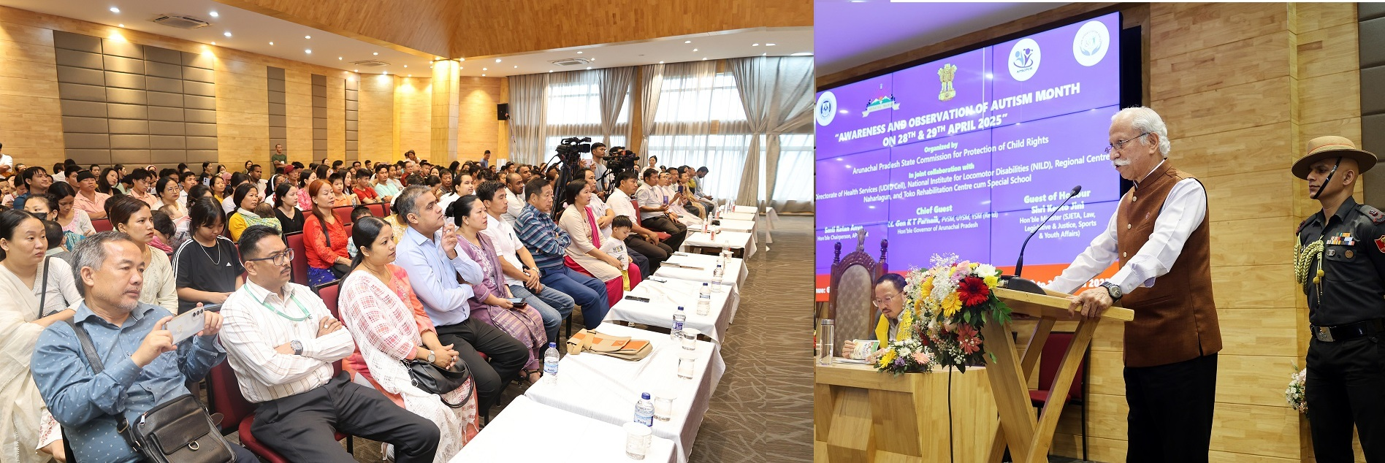
- Governor distributes teaching and learning kits and aids and appliances to children with special needs
- Governor assures the parents with autism children that the State government will address their challenges and will go beyond the normal means
- Governor calls for an in-depth review and mapping of the Children With Special Needs (CWSNs) in the State, emphasizes on conduct of intensive sensitization programs for all stakeholder departments
- Governor commends the Rehabilitation Centre cum Special Schools and officials of the Directorate of Health Services for their selfless service to the needs of individuals, providing support, guidance, and hope to those struggling with autism
The Governor of Arunachal Pradesh, Lt. General KT Parnaik, PVSM, UYSM, YSM (Retd.), participated in the ‘Awareness and Observation of Autism Month’ at Golden Jubilee State Banquet Hall, Niti Vihar, Itanagar on 28th April 2025. Inaugurating the two-day programme, the Governor, along with State Social Justice Minister Shri Kento Jini, distributed teaching and learning kits and aids and appliances to children with special needs. They also interacted with the parents and their autistic children, educators and medical specialists, and caretakers of rehabilitation and special centers on the occasion.
The Governor said that the event should be the beginning of our amplified understanding and celebration of neurodiversity, while committing to building a more inclusive world for everyone on the autism spectrum. Referring to autistic children as the ‘Shining Stars’ of Arunachal Pradesh, he highlighted the importance of embracing their unique talents, focus, and attention to detail. He called on everyone to listen to autistic voices, learn from their experiences, and work toward ensuring equal opportunities across education, employment, and social participation.
The Governor assured the parents that the State government will address their challenges and will go beyond the normal means. He said that Raj Bhavan will involve the Shining Stars in all the Raj Bhavan programmes and chalk out events for them. As Chancellor of the Universities in the State, he will initiate a PhD subject on autism for meaningful research, which will be useful in addressing this neurodiversity challenge.
The Governor called for an in-depth review and mapping of the Children With Special Needs (CWSNs) in the State to bring out an impactful policy for them. He emphasized on conduct of intensive sensitization programs for all stakeholder departments, especially Education, Health, Social Justice, and Women and Child Development. He emphasized that the frontline workers in these departments must be trained and encouraged to actively reduce stigma and foster a more inclusive, supportive environment for these children and their families.
The Governor suggested the proper and full implementation of inclusive education across all schools in the State by mandatory appointment of Special Educators, particularly during the early, formative years of a child's schooling. He also suggested exploring the possibility of establishing Government-run Model Special Schools, while recommending that the Health and Social Justice Departments work together to standardize the private centers and bring them under the umbrella of welfare programs provided by the State and Central Governments. This support would help ensure that therapy services are accessible, affordable, and of a high standard for all children who need them, he said.
The Governor commended the Rehabilitation Centre cum Special Schools and officials of the Directorate of Health Services for their selfless service to the needs of individuals, providing support, guidance, and hope to those struggling with autism. He also commended Smt Ratan Anya, Chairperson, APSCPCR, for her painstaking effort to pursue the issue at the State level.
The State Social Justice Minister, Shri Kento Jini, while highlighting the responsibilities towards the CWSNs, assured the parents that all central and State Government schemes or programmes to address the autism and other benefits for the children with special needs will reach every household in the State.
The Chairperson, Arunachal Pradesh State Commission for Protection of Child Rights (APSCPCR) Smt Ratan Anya and the Member Secretary APSCPCR Smt Khoda Rakhi highlighted on children affected by autism and recommended steps to address the issue.
One of the parents with an autistic child shared a heart-touching narration of the challenges on the occasion.
The two-day programme is being organized by the Arunachal Pradesh State Commission for Protection of Child Rights, in collaboration with the State Health Department, National Institute of Locomotor Disabilities and Toko Rehabilitation Centre cum Special School.
Large numbers of parents and their wards from the Capital Region participated in the programme. The highlight of the programme was a free disability assessment camp for Children with Special Needs and registration for future consultations and records.
