GOVERNOR’S SECRETARIAT
ARUNACHAL PRADESH
ITANAGAR

Press Communiqué
Dated Apr 26th, 2025

Siang Royal Academy conducts cleanliness drive at Komlighat
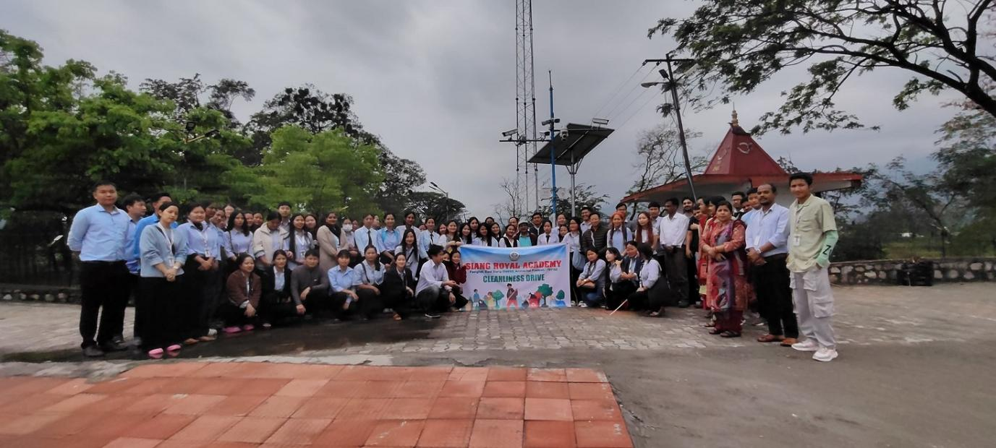

PASIGHAT, April 26: Siang Royal Academy, BED College, Pasighat Friday (April-25) conducted a social service drive at the Komlighat, Pasighat. During the drive students/trainees and faculty members were engaged in cleaning the area with the aim to bring in awareness among the community members about benefit and importance of cleanliness. In that area heaps of garbage accumulated over time.
Komlighat is well known for the river side natural scenery therefore it is essential to keep the area neat and clean. Students cleaned the entire area sincerely putting on great effort in grabbing the wastes. Pasighat ADC Tatting Pertin and Er. Tadar Tarang, Executive Engineer, Pasighat Municipal Corporation supervised the drive. ADC Pertin appreciated the initiative of the drive undertaken by Siang Royal Academy, Pasighat and praised the role and effort put on by the trainees. He emphasized that such drive should be initiated by the educational institutions at a regular interval in order to bring in Community Awareness for Cleanliness and make Pasighat a tourist hot spot for the greater benefit of the people. He also stressed the effort put on by Aroty Padung, Chairman, SRA; Mr. T. Panyang, College Management Committee Member; Dr. P. Chakrabarty, Principal and Faculty Members for such an essential and vital task.

